Talend Job: DC_E_Media_Load

Overview
Loads electronic-media/letter-status tracking records (logon, media/letter ID, status, waterfall step, content, update timestamps) for the DC site from an MSSQL table (DC-ElectronicsMedia) into the Snowflake DC_ELECTRONICSMEDIA warehouse table, using a direct UPSERT rather than the truncate-stage-merge pattern used by most other loads in this project. It first checks the current maximum UPDATEKEY already in Snowflake, apparently intending an incremental load, though the source query's filter clause is not visible in this metadata.

Detail table
Field | Value
Job name | DC_E_Media_Load
Version | 0.1
Project | EDW2SF
Author | jmach@harriscollect.com
Created | 2022-05-13T13:08:32.782-0700
Last Modified | 2025-09-24T11:00:23.327-0700

Step-by-step data flow
Setup subjob: tPrejob_1 → tDBConnection_1 opens the MSSQL connection using context.EDWProdHH_* variables (password and Active Directory auth redacted) → on success, tDBConnection_2 opens the Snowflake connection.
Main subjob:
- tDBInput_2 runs SELECT CAST(COALESCE(MAX(UPDATEKEY),0) AS VARCHAR(10)) AS MAXUPDATEKEY FROM DW.DC_ELECTRONICSMEDIA; against Snowflake.
- tJavaRow_1 captures that value into context.maxUpdateKey.
- On success, tDBInput_1 runs a fixed SELECT of 19 columns against the MSSQL table DC-ElectronicsMedia (logon, EMID, letter name, status fields, waterfall, content, source, UpdateKey, etc.). The captured query text is truncated after the column list and does not visibly reference `context.maxUpdateKey` — see Issues observed.
- tMap_1 passes the row through unchanged in shape (19 columns, UpdateKey normalized to UPDATEKEY).
- tFlowMeter_2 counts rows passing through (labeled "MyLabel", not renamed for this job).
- tDBOutput_1 upserts the rows directly into Snowflake table DC_ELECTRONICSMEDIA (UPSERT, no table-recreate action) — no separate staging table or merge-procedure call is used in this job.
Teardown subjob: tPostjob_1 → tDBClose_2 (close MSSQL) → tDBClose_1 (close Snowflake).
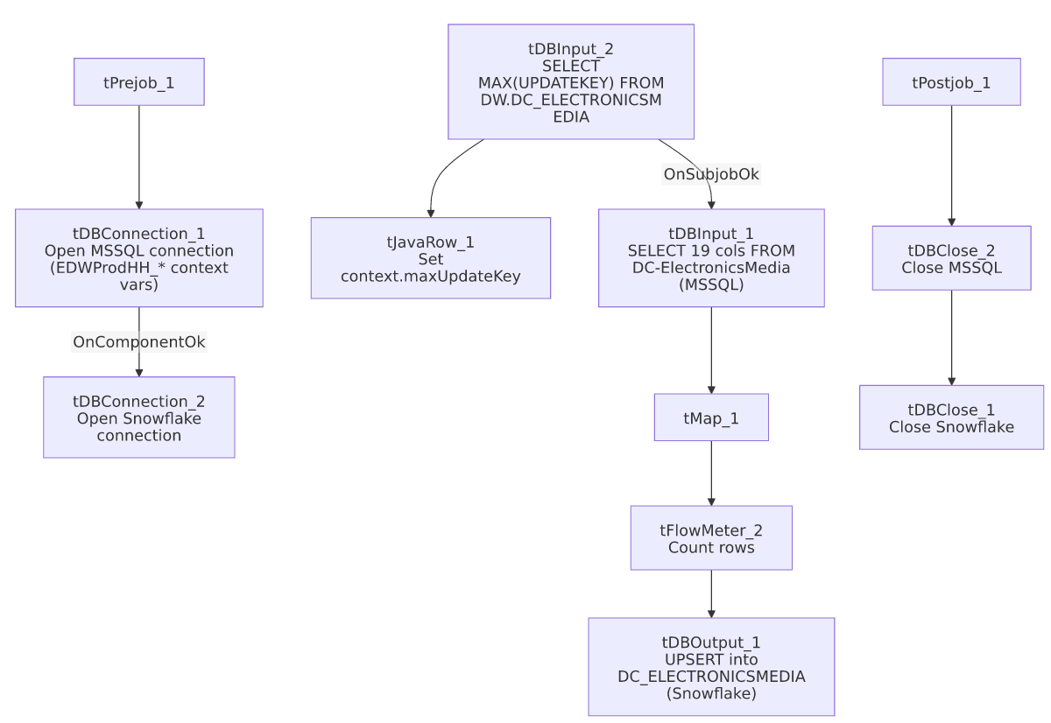

Settings tables

Source: `tDBInput_1` (`tMSSqlInput`)
Setting | Value | What it means
Connection | Shared tDBConnection_1 | Reuses the job's single MSSQL connection.
Table | DC-ElectronicsMedia | Source table name contains a hyphen — an unusual (though valid, if bracket-quoted) MSSQL identifier, consistent with a legacy-system naming convention.
Query | Fixed SELECT of 19 named columns (LOGON, EMID, EMID_IDX, LETTER_NAME, status/date fields, WATERFALL, CONTENT, SOURCE, SRC_NAME, UpdateKey) | Captured text is truncated after the column list; no WHERE clause is visible — see Issues observed.

Target: `tDBOutput_1` (`tSnowflakeOutput`)
Setting | Value | What it means
Table | DC_ELECTRONICSMEDIA | Same table name referenced by the earlier max-key check (DW.DC_ELECTRONICSMEDIA), so this upsert writes directly to the warehouse table, not a staging table.
Output action | UPSERT | Updates matching rows (presumably keyed on UPDATEKEY or a similar identity column configured in the component's key settings, not visible in this metadata) and inserts new ones — no separate merge-procedure step is needed because the upsert itself reconciles new/changed rows.
Table action | NONE | Table is not recreated/altered by this job.

Dependencies & configuration
- Triggers/depends on other jobs: none — no tRunJob links found.
- Context variables used: EDWProdHH_Server, EDWProdHH_Port, EDWProdHH_Schema, EDWProdHH_Database, EDWProdHH_Login (MSSQL connection), maxUpdateKey (computed internally from the Snowflake max-key query).
- No hardcoded developer-workstation paths found in this job.

Glossary
Component type | Plain-English meaning
tMSSqlConnection / tMSSqlInput / tMSSqlClose | Open a Microsoft SQL Server connection, run a query against it, and close it.
tSnowflakeConnection / tSnowflakeInput / tSnowflakeOutput / tSnowflakeClose | Open a Snowflake connection, run a query and return its rows, upsert rows into a table, and close the connection.
tMap | Maps/transforms columns from one schema to another.
tFlowMeter | Counts rows passing a point in the flow for logging/monitoring.
tJavaRow | Runs custom Java code once per input row — here used to unpack a single query result into a context variable.

Issues observed
- The incremental-load logic may not actually be applied. As with i3_CallDetail_40_Load, this job computes context.maxUpdateKey from Snowflake before reading the MSSQL source, suggesting an intent to pull only rows with a higher UpdateKey. However, the tDBInput_1.QUERY text captured in this metadata is truncated after the column list and shows no WHERE UpdateKey > ... clause referencing context.maxUpdateKey. Because the target write is an UPSERT (not a plain INSERT), re-reading the entire source table every run would not create duplicate rows the way it would in an append-only job — but it would mean unnecessary full-table extraction and reprocessing on every run if the filter isn't actually applied. Unable to determine from this metadata whether the query is filtered; verify directly in Talend Studio.
- No error/row-count logging specific to this job's business outcome (no tWarn/tDie/tSendMail) — a load failure here would only surface as a generic Talend execution error, with no job-specific message to distinguish it in a shared log. Beyond this, no other issues distinct from the project-wide patterns in 05_operational_runbook.md were found in this job's own metadata.

