Talend Job: DC_SSN_Extract

Overview
This job extracts DEBTOR_IDX and decrypted Social Security Numbers from the Snowflake DW.DIMDEBTOR table for DC-site debtors assigned before a hardcoded cutoff date (2025-08-21), splitting the population into 10 buckets by the last digit of DEBTOR_IDX and writing each bucket's decrypted SSNs to its own plain, unencrypted tab-delimited text file (SSN_0.txt through SSN_9.txt). This reads as a one-time or ad hoc compliance/legal/backfill extract (built 2025-09-15) rather than a recurring warehouse load — it has no target table, no tRunJob links, and a literal date embedded in every query rather than a context variable. Writing decrypted SSNs to plain flat files is a significant data-handling consideration — see Issues observed.

Detail table
Field | Value
Job name | DC_SSN_Extract
Version | 0.1
Project | EDW2SF
Author | jmach@harriscollect.com
Created | 2025-09-15T11:46:16.416-0700
Last Modified | 2025-09-24T11:00:34.405-0700

Step-by-step data flow
Setup: tPrejob_1 → tJava_1 opens a per-run log file at context.logDir + jobName + "_" + <timestamp> + ".log" → on success, tDBConnection_1 opens the Snowflake connection. No `tPostjob`/`tDBClose` exists anywhere in this job — see Issues observed.
Main subjob — tParallelize_1 starts 3 concurrent chains (rather than 10 fully parallel branches), each chain reading its digit-buckets one after another via OnSubjobOk:
- Chain A: digit 0 (tDBInput_1) → digit 3 (tDBInput_4) → digit 8 (tDBInput_9)
- Chain B: digit 1 (tDBInput_2) → digit 4 (tDBInput_5) → digit 7 (tDBInput_8) → digit 9 (tDBInput_10)
- Chain C: digit 2 (tDBInput_3) → digit 5 (tDBInput_6) → digit 6 (tDBInput_7)
For each of the 10 digit buckets (identical pattern, only the trailing-digit filter and output filename differ):
- tDBInput_<n> runs SELECT DEBTOR_IDX, SSN FROM DW.DIMDEBTOR WHERE LOGON='DC' AND DT_ASSIGNED < '2025-08-21' AND LEFT(REVERSE(TRIM(DEBTOR_IDX)),1) = '<digit>'; — the last-digit filter splits DIMDEBTOR into 10 roughly even slices.
- tDataDecrypt_<n> decrypts the SSN column using an AES key file at context.cryptoPath + "dimdbtr.crypt" (secret type, key, and password all redacted; ALGO_VERSION=2; DIE_ON_ERROR=false — a decryption failure does not fail the job, see Issues observed).
- tFlowMeter_<n> counts rows passing through (all labeled "MyLabel", not renamed per branch).
- tFileOutputDelimited_<n> writes the decrypted DEBTOR_IDX/SSN pairs, tab-delimited, no header, to context.outDir + "SSN_<digit>.txt" (FILE_EXIST_EXCEPTION=true — see Issues observed).
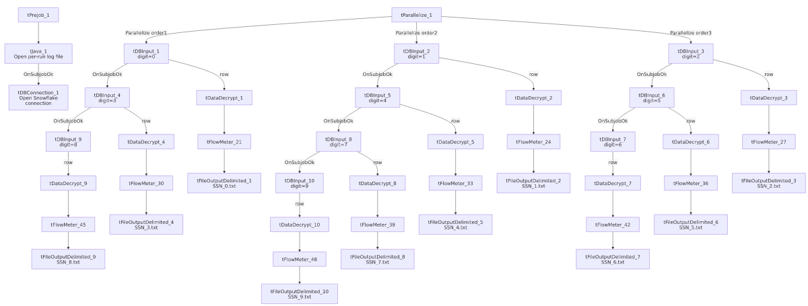

Settings tables

Source pattern: `tDBInput_1` through `tDBInput_10` (`tSnowflakeInput`)
Setting | Value | What it means
Query | SELECT DEBTOR_IDX, SSN FROM DW.DIMDEBTOR WHERE LOGON='DC' AND DT_ASSIGNED < '2025-08-21' AND LEFT(REVERSE(TRIM(DEBTOR_IDX)),1) = '<0-9>'; | Identical across all 10 components except the literal trailing digit. The cutoff date 2025-08-21 is hardcoded into every one of the 10 queries individually — see Issues observed.

Decrypt pattern: `tDataDecrypt_1` through `tDataDecrypt_10`
Setting | Value | What it means
CRYPTO_METHOD / ALGO_VERSION | AES / 2 | Symmetric decryption of the SSN column.
CRYPTO_FILE_PATH | context.cryptoPath + "dimdbtr.crypt" | Same key file used by all 10 branches.
SECRET_TYPE / SECRET_KEY / PASSWORD_M1 | ***REDACTED*** (all three) | Preserved as redacted; not guessable from this metadata.
DIE_ON_ERROR | false | A decryption failure on any row does not fail the job — see Issues observed.

Output pattern: `tFileOutputDelimited_1` through `tFileOutputDelimited_10`
Setting | Value | What it means
FILENAME | context.outDir + "SSN_<0-9>.txt" | 10 separate flat files, one per digit bucket.
FIELDSEPARATOR | \t (tab) | Tab-delimited, not comma.
INCLUDEHEADER | false | No header row — a file is just raw DEBTOR_IDX/SSN pairs, one per line.
FILE_EXIST_EXCEPTION | true | Re-running the job without first clearing out the previous run's SSN_*.txt files will throw an exception — see Issues observed.
Content | Decrypted (plaintext) SSN values | See Issues observed regarding data sensitivity.

Dependencies & configuration
- Triggers/depends on other jobs: none — no tRunJob links found.
- Context variables used: logDir, cryptoPath, outDir.
- No hardcoded developer-workstation paths found in this job's own components (the sensitive value here is the hardcoded date literal, not a path — see Issues observed).

Glossary
Component type | Plain-English meaning
tSnowflakeConnection / tSnowflakeInput | Open a Snowflake connection and run a query, returning its rows.
tDataDecrypt | Decrypts an encrypted column's values using a key file and algorithm configured on the component.
tFlowMeter | Counts rows passing a point in the flow for logging/monitoring.
tFileOutputDelimited | Writes rows to a delimited (CSV/TSV-style) text file according to a schema.
tParallelize | Runs its downstream branches at the same time rather than one after another — here used to run 3 sequential digit-bucket chains concurrently rather than fully serializing all 10 reads.

Issues observed
- This job writes decrypted, plaintext Social Security Numbers to 10 unencrypted flat files (SSN_0.txt through SSN_9.txt) in context.outDir, with no header and no indication in this metadata of any subsequent encryption, secure transfer, or automated cleanup step. Per this project's data-handling expectations, SSNs are sensitive PII that should not persist in plaintext on disk longer than operationally necessary — confirm with the team what downstream process consumes these files and whether they are deleted/archived securely afterward (no such step is wired into this job itself).
- The cutoff date `2025-08-21` is hardcoded as a literal string in all 10 of this job's queries individually, rather than being driven by a single context.* variable. Re-running this extract for a different cutoff (or making it recurring) would require editing all 10 queries by hand — a copy-paste-prone maintenance burden, and a sign this job was built as a one-off rather than a reusable pipeline component.
- `tDataDecrypt`'s `DIE_ON_ERROR=false` on all 10 branches means a decryption failure on any row is silently tolerated rather than failing the job — unable to determine from this metadata what a failed-to-decrypt row looks like in the output file (blank, null, or the still-encrypted value); verify directly in Talend Studio.
- No `tPostjob`/`tDBClose` exists anywhere in this job — tDBConnection_1 (Snowflake) is opened in the setup subjob but never explicitly closed within the job itself, unlike virtually every other job in this project (e.g. ADP_Payroll_Load, DC_E_Media_Load), which pair every connection open with a matching close in a teardown subjob. This likely relies on the Talend runtime/JVM shutdown to release the connection implicitly, which is a less controlled pattern than an explicit tDBClose.
- `FILE_EXIST_EXCEPTION=true` on all 10 output files means this job cannot be re-run against the same outDir without first manually removing the prior run's 10 output files — there is no cleanup or archive step for the previous run's outputs built into the job.
- The 3-chain-of-10 parallelization pattern (3 concurrent chains of length 3, 4, and 3) is an unusual, seemingly ad hoc way to split 10 independent digit-bucket queries — a straightforward 10-way tParallelize (as seen elsewhere in this project, e.g. DC_Call_Contact_Exceptions_1's 2-way split) would have been simpler; unable to determine from metadata why this specific 3/4/3 grouping was chosen (possibly to cap concurrent Snowflake connections/load).

