Talend Job: DEBTOR_UPDATES_20230807

Overview
This is a one-time, date-stamped debtor-field patch job (built and presumably run on 2023-08-07): it reads tab-delimited debtor update files — every file found in a hardcoded directory, plus one specific named file for the DC site — and inserts the rows (logon, debtor number, DEBTOR_IDX, and four legacy "misc"/date fields) into a Snowflake table named for the run date, DEBTOR_UPDATE_20230807. Both the date-stamped target table name and the complete absence of any connection-management components (tPrejob, tDBConnection, tPostjob, tDBClose) mark this as a single-use backfill/patch job rather than a recurring pipeline component.

Detail table
Field | Value
Job name | DEBTOR_UPDATES_20230807
Version | 0.1
Project | EDW2SF
Author | jmach@harriscollect.com
Created | 2023-08-07T11:27:18.302-0700
Last Modified | 2025-09-24T11:08:59.083-0700

Step-by-step data flow
This job has no tPrejob/tPostjob or explicit database connection component in its own metadata — see Issues observed.
- tFileList_1 lists files in the hardcoded directory /mnt/cubs/.
- For each file found, tJava_1 sets context.filePath to the current file path, then tFileInputDelimited_1 reads it (tab-delimited, header row present, DIE_ON_ERROR=false) with columns LOGON, DEBTOR, DEBTOR_IDX, _20_MISC3, _21_MISC4, _31_SRV_ST_DT, _1522_CLT_XFR_DT.
- tDBOutput_1 inserts those rows into Snowflake table DEBTOR_UPDATE_20230807 (INSERT, tableAction=CREATE_IF_NOT_EXISTS).
- Separately, once tFileList_1's subjob completes, tFileInputDelimited_2 reads one specific hardcoded file, /mnt/cubs_dc/DC_DEBTOR_SPECIAL_20230807.txt (same 7-column schema).
- tDBOutput_2 inserts those rows into the same Snowflake table, DEBTOR_UPDATE_20230807 (INSERT, tableAction=CREATE_IF_NOT_EXISTS).
Both file sources land in the same target table, so the table ends up holding the union of whatever files were in /mnt/cubs/ plus the one DC-specific file.
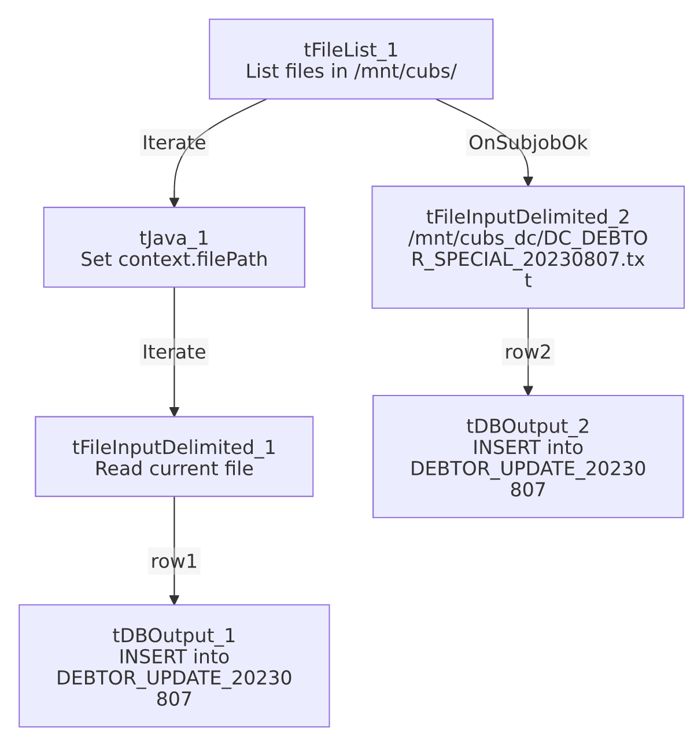

Settings tables

Source 1: `tFileList_1` / `tFileInputDelimited_1`
Setting | Value | What it means
DIRECTORY | "/mnt/cubs/" | Hardcoded literal path (not a context.* variable), unlike most file-driven jobs in this project.
FILENAME (read) | context.filePath (set from tFileList_1's current file) | Reads whatever file(s) are found in /mnt/cubs/ — no filter beyond the default file-list behavior.
Columns | LOGON, DEBTOR, DEBTOR_IDX, _20_MISC3, _21_MISC4, _31_SRV_ST_DT, _1522_CLT_XFR_DT | Legacy-numbered "misc" field names — their real business meaning is not documented in this metadata.

Source 2: `tFileInputDelimited_2`
Setting | Value | What it means
FILENAME | "/mnt/cubs_dc/DC_DEBTOR_SPECIAL_20230807.txt" | A single, specifically named DC-site file, hardcoded to this one run date.

Target: `tDBOutput_1` / `tDBOutput_2` (`tSnowflakeOutput`)
Setting | Value | What it means
Table | DEBTOR_UPDATE_20230807 (both) | A date-stamped, one-off table name — not a standing warehouse table reused across runs.
Output action | INSERT | Appends rows; no truncate step exists in this job.
Table action | CREATE_IF_NOT_EXISTS | Creates the table on first run if it doesn't already exist.

Dependencies & configuration
- Triggers/depends on other jobs: none — no tRunJob links found.
- Context variables used: filePath (set internally by tJava_1).
- 2 hardcoded developer-workstation paths in tFileInputDelimited_1.TEMP_DIR and tFileInputDelimited_2.TEMP_DIR (both C:/Talend-Studio-20211109_1610-V8.0.1/workspace) — same portability risk documented project-wide in 05_operational_runbook.md. In addition, the source directories /mnt/cubs/ and /mnt/cubs_dc/... are hardcoded Linux-style literals, not context.* variables.

Glossary
Component type | Plain-English meaning
tFileList | Lists files in a directory for the job to iterate over one at a time.
tFileInputDelimited | Reads a delimited (tab-separated, in this job) text file according to a schema.
tSnowflakeOutput | Writes rows to a Snowflake table.
tJava | Runs a small custom Java snippet — here, just captures the current file path into a context variable.

Issues observed
- This job has no `tPrejob`/`tPostjob`, and no `tDBConnection`/`tDBClose` component anywhere in its metadata, unlike essentially every other job in this project. How tDBOutput_1/tDBOutput_2 actually connect to Snowflake (a shared/default connection, or settings not captured by this extraction) is unable to determine from this metadata — verify directly in Talend Studio.
- The target table name (`DEBTOR_UPDATE_20230807`) is itself date-stamped, and the second source file is hardcoded to DC_DEBTOR_SPECIAL_20230807.txt — both are tied to a specific one-time run date embedded in literal strings. This job cannot be meaningfully re-run for a different date without editing its hardcoded table/file names by hand; it is a historical patch job, not a recurring pipeline component, and should likely be treated as inert/archival rather than part of the active job inventory.
- Both `tDBOutput` components target the same table with `CREATE_IF_NOT_EXISTS`, meaning a re-run of this job (if the source files still exist) would append duplicate rows into DEBTOR_UPDATE_20230807 rather than replace them — there is no truncate step. Given the job's one-off nature this is likely not a practical concern, but it's worth knowing if the table is ever queried under the assumption it reflects a single, deduplicated load.
- Source directories (`/mnt/cubs/`, `/mnt/cubs_dc/`) are hardcoded Linux-style literals, not context.* variables — inconsistent with the StandardFolders_0.1-driven pattern used by most other jobs in this project (see 06_dependency_matrix.md).

