Talend Job: DIMDEBTOR_FISCALS_20230713

Overview
This is a one-time historical backfill job (built 2023-07-13): it reads a single fixed file of HH-site "special debtor" garnishment/warrant history (X:/HH_SPECIAL_DEBTOR_HISTORY_20230713) and inserts the rows directly into the standing Snowflake warehouse table DIMDEBTOR_FISCALS. Unlike its sibling one-off job DEBTOR_UPDATES_20230807, this job's target table is not date-stamped — it loads straight into the live DIMDEBTOR_FISCALS table, meaning it directly affected production warehouse data rather than a scratch/staging table.

Detail table
Field | Value
Job name | DIMDEBTOR_FISCALS_20230713
Version | 0.1
Project | EDW2SF
Author | jmach@harriscollect.com
Created | 2023-07-13T14:28:06.462-0700
Last Modified | 2025-09-24T11:09:05.670-0700

Step-by-step data flow
This job has no tPrejob/tPostjob or explicit database connection component in its own metadata — see Issues observed. It is a single two-component chain:
- tFileInputDelimited_1 reads the fixed file X:/HH_SPECIAL_DEBTOR_HISTORY_20230713 (tab-delimited, header row present, DIE_ON_ERROR=false) with columns LOGON, DEBTOR, DEBTOR_IDX, COUNTY_OF_WARRANT, GARN_WORK_DT, WARRANT_SRV_DT.
- tDBOutput_1 inserts those rows into Snowflake table DIMDEBTOR_FISCALS (INSERT, tableAction=NONE — the table is expected to already exist).
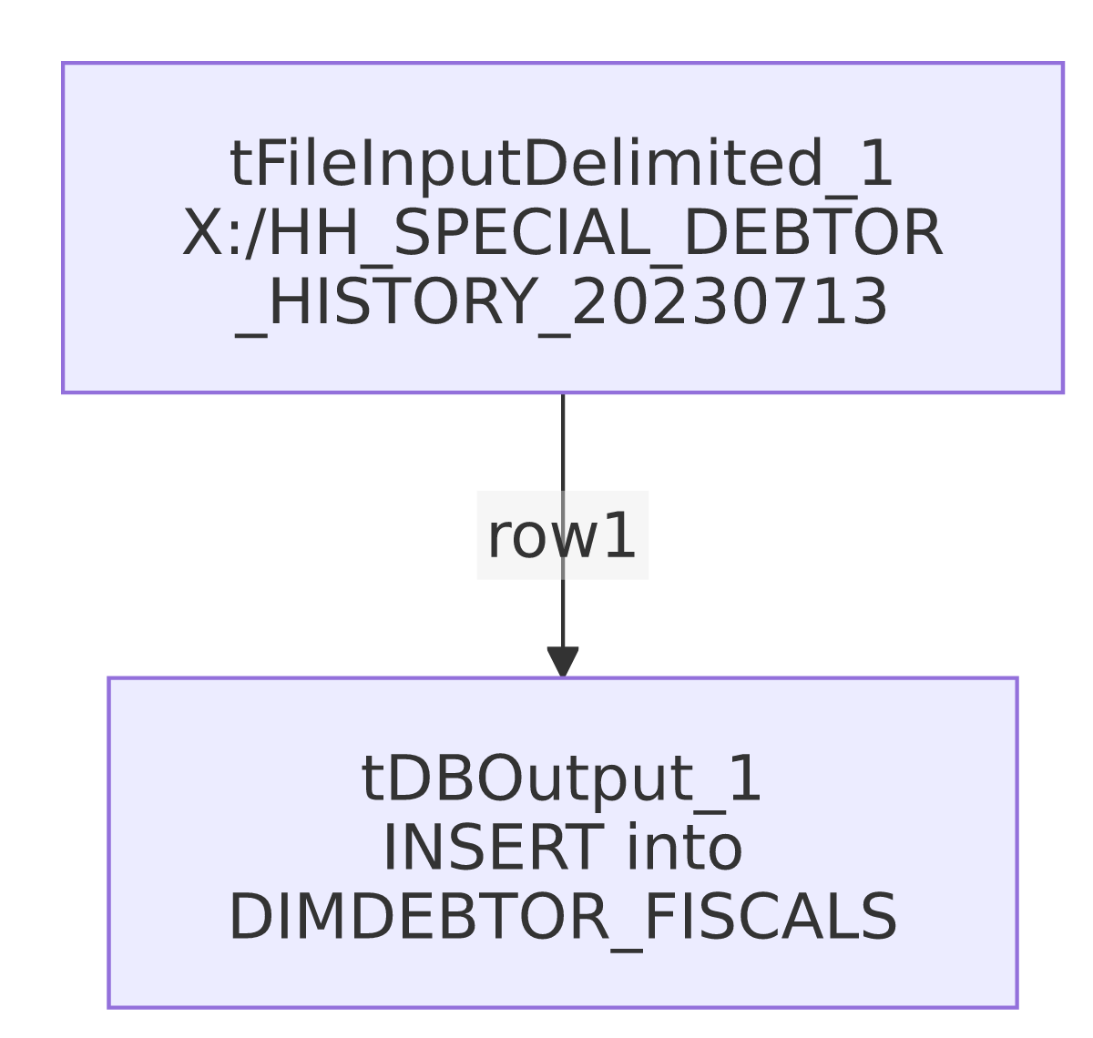

Settings tables

Source: `tFileInputDelimited_1`
Setting | Value | What it means
FILENAME | "X:/HH_SPECIAL_DEBTOR_HISTORY_20230713" | A fixed path on a mapped/network drive (X:), with no file extension — an unusual and clearly one-off, developer-specific reference rather than a repeatable operational path.
FIELDSEPARATOR / HEADER | \t / 1 header row | Tab-delimited with header.
Columns | LOGON, DEBTOR, DEBTOR_IDX, COUNTY_OF_WARRANT, GARN_WORK_DT, WARRANT_SRV_DT | Garnishment/warrant-related fiscal history fields for HH-site "special" debtors.

Target: `tDBOutput_1` (`tSnowflakeOutput`)
Setting | Value | What it means
Table | DIMDEBTOR_FISCALS | The standing (non-date-stamped) warehouse table — this job inserted historical records directly into live production data.
Output action | INSERT | Appends rows; no truncate step exists in this job.
Table action | NONE | Table is not created/altered by this job — it must already exist.

Dependencies & configuration
- Triggers/depends on other jobs: none — no tRunJob links found.
- Context variables used: none — this job uses no context.* variables at all, consistent with being a hardcoded one-time run.
- 1 hardcoded developer-workstation path: tFileInputDelimited_1.TEMP_DIR (C:/Talend-Studio-20211109_1610-V8.0.1/workspace) — same portability risk documented project-wide in 05_operational_runbook.md. The source file path itself (X:/HH_SPECIAL_DEBTOR_HISTORY_20230713) is also a hardcoded, developer-machine-specific literal, though it wasn't flagged by the extraction's hardcoded_path_findings (which appears to target the C:/Talend-Studio... pattern specifically).

Glossary
Component type | Plain-English meaning
tFileInputDelimited | Reads a delimited (tab-separated, in this job) text file according to a schema.
tSnowflakeOutput | Writes rows to a Snowflake table.

Issues observed
- This job has no `tPrejob`/`tPostjob`, and no `tDBConnection`/`tDBClose` component anywhere in its metadata — the same pattern seen in DEBTOR_UPDATES_20230807. How tDBOutput_1 actually connects to Snowflake is unable to determine from this metadata; verify directly in Talend Studio.
- The source file path (`X:/HH_SPECIAL_DEBTOR_HISTORY_20230713`) is a hardcoded, developer-machine-specific literal on a mapped drive letter, with no file extension and no context.* variable involved. This job cannot be re-run today unless that exact path still exists and is still mapped to X: on whatever machine runs it — strongly suggesting this was executed once, interactively, from a developer's own Talend Studio, rather than through the project's normal scheduled/context-driven execution pattern.
- This job writes directly into the standing `DIMDEBTOR_FISCALS` table with no truncate/staging step and no de-duplication logic — if it were ever accidentally re-run against the same source file, it would insert duplicate rows into a production dimension table. Given its one-off, historical nature this is a low ongoing risk, but it means this job should be treated as archival evidence of a past data fix, not as a component to schedule or re-trigger.

