Talend Job: DNIS_Load

Overview
Loads DNIS (Dialed Number Identification Service) routing reference data — phone extension, department, DNIS type, area code, exchange, toll-free flag, and subgroup — from an MSSQL source (via the EDWProdHH-labeled connection) into the Snowflake I3_DNIS table, truncating and fully reloading the table on every run. This job has a near-identical sibling, DNIS_Org_Load (documented separately), which reads the same shape of source data but loads a different target table (I3_DNIS_ORG) using UPSERT instead of truncate-and-insert — see that job's doc for the specific differences.

Detail table
Field | Value
Job name | DNIS_Load
Version | 0.1
Project | EDW2SF
Author | jmach@harriscollect.com
Created | 2022-01-25T13:27:37.100-0800
Last Modified | 2025-09-24T11:00:00.211-0700

Step-by-step data flow
Setup subjob: tPrejob_1 → tDBConnection_1 opens the Snowflake connection → on success, tDBConnection_2 opens the MSSQL connection using context.EDWProdHH_* variables (password and Active Directory auth redacted).
Main subjob:
- tDBInput_1 runs a fixed SELECT (using the shared MSSQL connection) pulling Extension, Department, DNISType, Areacode, Exchange, TollFree, SUBGROUP — the FROM clause is truncated in this metadata.
- tMap_1 passes the 7 columns through unchanged (uppercased column names).
- tFlowMeter_1 counts rows passing through (labeled "MyLabel", not renamed for this job).
- tDBOutput_1 writes the rows into Snowflake table I3_DNIS with outputAction=INSERT and `tableAction=TRUNCATE` — the table is cleared and fully reloaded every run.
Separately, tStatCatcher_1 and tFlowMeterCatcher_1 (standard Talend internal statistics/flow-meter catchers) feed two tLogRow components that print job statistics to the log — these run automatically and aren't part of the business data path.
Teardown subjob: tPostjob_1 → tDBClose_1 (close Snowflake) → tDBClose_2 (close MSSQL).
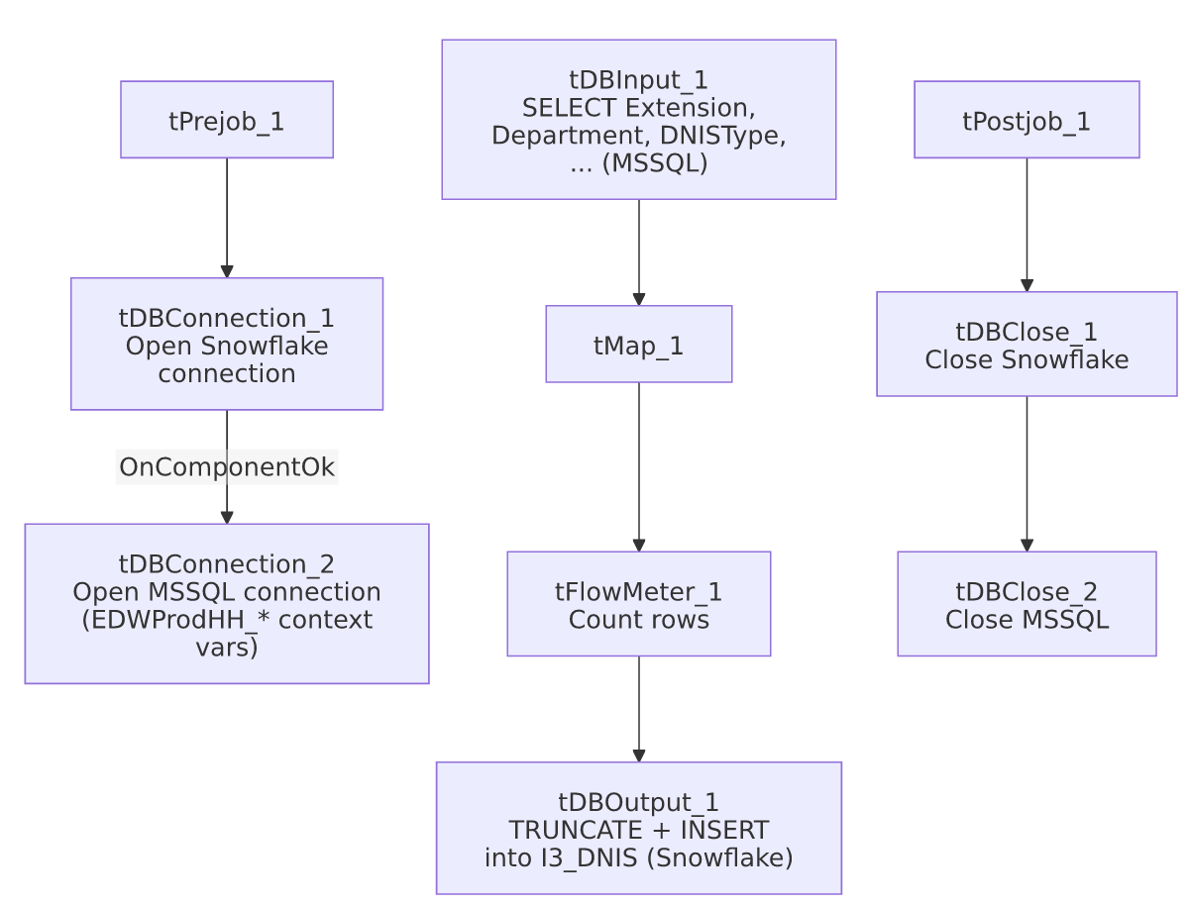

Settings tables

Source: `tDBInput_1` (`tMSSqlInput`)
Setting | Value | What it means
Connection | Shared tDBConnection_2 (EDWProdHH context vars) | Reuses the job's single MSSQL connection.
Query | SELECT CAST([Extension] AS varchar(10)) AS Extension, [Department], [DNISType], CAST([Areacode] AS varchar(10)) AS Areacode, CAST([Exchange] AS varchar(10)) AS Exchange, [TollFree], [SUBGROUP] FROM [dbo].... (truncated) | Table name is cut off in this metadata — unable to determine from metadata which specific source table this reads.

Target: `tDBOutput_1` (`tSnowflakeOutput`)
Setting | Value | What it means
Table | I3_DNIS | Destination table for DNIS routing reference data.
Output action | INSERT | Appends rows after the table is cleared.
Table action | TRUNCATE | Table is fully cleared immediately before load — a true "truncate and reload" every run, unlike jobs that truncate a separate staging table and merge into a warehouse table.

Dependencies & configuration
- Triggers/depends on other jobs: none — no tRunJob links found.
- Context variables used: EDWProdHH_Server, EDWProdHH_Port, EDWProdHH_Schema, EDWProdHH_Database, EDWProdHH_Login (MSSQL connection).
- No hardcoded developer-workstation paths found in this job.

Glossary
Component type | Plain-English meaning
tMSSqlConnection / tMSSqlInput / tMSSqlClose | Open a Microsoft SQL Server connection, run a query against it, and close it.
tSnowflakeConnection / tSnowflakeOutput / tSnowflakeClose | Open a Snowflake connection, write rows to a table (with table-level truncate/create options), and close the connection.
tMap | Maps/transforms columns from one schema to another.
tFlowMeter | Counts rows passing a point in the flow for logging/monitoring.
tStatCatcher / tFlowMeterCatcher / tLogRow | Talend's built-in job-statistics and flow-meter capture components, which print execution stats to the log; not part of the business data flow.

Issues observed
- The source query's `FROM` clause is truncated in this metadata, so the exact source table (only [dbo]....) can't be confirmed — verify directly in Talend Studio if the specific MSSQL table name matters for an audit or migration.
- This job truncates and fully reloads `I3_DNIS` on every run with no result-count logging, `tWarn`, or `tDie` — a failed or partial load (e.g. a mid-run MSSQL error after truncate) could leave I3_DNIS empty or partially populated with no job-specific alert; only a generic Talend execution error would surface. No other issues distinct from the project-wide patterns in 05_operational_runbook.md were found in this job's own metadata.
- Sibling comparison: DNIS_Org_Load reads the same shape of source columns but loads a different table (I3_DNIS_ORG) via UPSERT with no truncate step — see that job's own doc for the specific difference; whether the two jobs' source queries pull from the same or different underlying MSSQL tables/views is unable to determine from either job's (truncated) query text.

