Talend Job: DNIS_Org_Load

Overview
Loads the same shape of DNIS (Dialed Number Identification Service) routing reference data as its sibling job DNIS_Load — extension, department, DNIS type, area code, exchange, toll-free flag, subgroup — from an MSSQL source (via the EDWProdHH-labeled connection) into Snowflake, but here the target is I3_DNIS_ORG and the write is an UPSERT rather than a truncate-and-reload. This job is otherwise structurally identical to DNIS_Load (documented separately) — same source column shape, same connection setup, same lack of business-specific error handling.

Detail table
Field | Value
Job name | DNIS_Org_Load
Version | 0.1
Project | EDW2SF
Author | jmach@harriscollect.com
Created | 2022-01-25T14:04:20.428-0800 (about 37 minutes after DNIS_Load)
Last Modified | 2025-09-24T11:00:20.527-0700

Step-by-step data flow
Setup subjob: tPrejob_1 → tDBConnection_1 opens the Snowflake connection → on success, tDBConnection_2 opens the MSSQL connection using context.EDWProdHH_* variables (password and Active Directory auth redacted).
Main subjob:
- tDBInput_1 runs a fixed SELECT (using the shared MSSQL connection) pulling Extension, Department, DNISType, Areacode, Exchange, TollFree, SUBGROUP — the FROM clause is truncated in this metadata, and its visible text is byte-for-byte the same as DNIS_Load's query up to the truncation point.
- tMap_1 passes the 7 columns through unchanged (uppercased column names).
- tFlowMeter_3 counts rows passing through (labeled "MyLabel", not renamed for this job).
- tDBOutput_1 upserts the rows into Snowflake table I3_DNIS_ORG (UPSERT, tableAction=NONE) — no truncate step, unlike DNIS_Load.
Separately, tStatCatcher_1 and tFlowMeterCatcher_1 feed two tLogRow components that print job statistics to the log — not part of the business data path.
Teardown subjob: tPostjob_1 → tDBClose_1 (close Snowflake) → tDBClose_2 (close MSSQL).
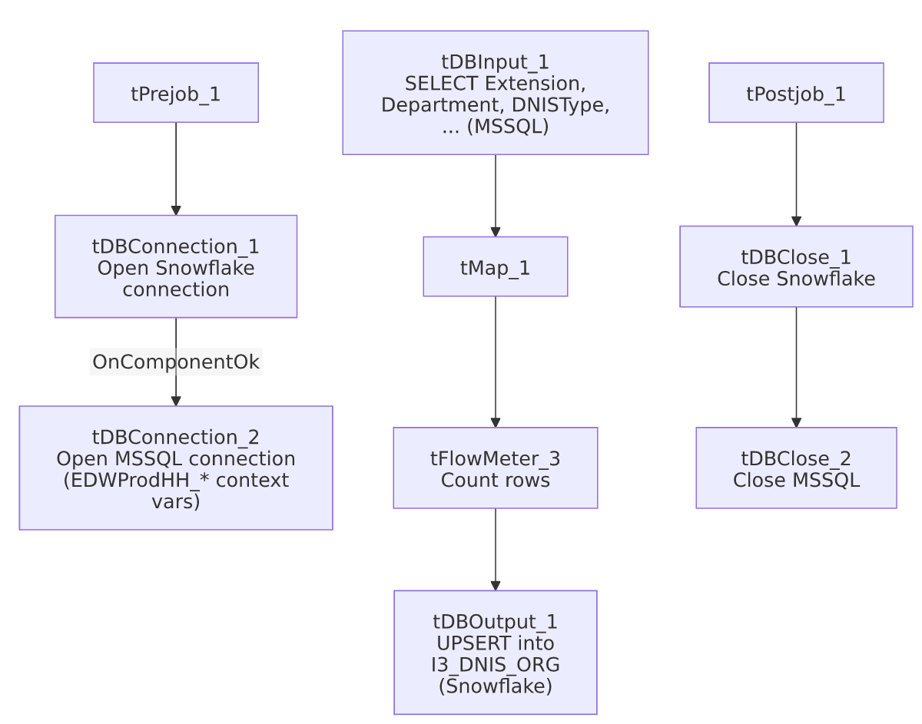

Settings tables

Source: `tDBInput_1` (`tMSSqlInput`)
Setting | Value | What it means
Connection | Shared tDBConnection_2 (EDWProdHH context vars) | Reuses the job's single MSSQL connection.
Query | SELECT CAST([Extension] AS varchar(10)) AS Extension, [Department], [DNISType], CAST([Areacode] AS varchar(10)) AS [Areacode], CAST([Exchange] AS varchar(10)) AS [Exchange], [TollFree], [SUBGROUP] FROM [d... (truncated) | Visible text matches DNIS_Load's query up to the truncation point (aside from minor bracket-quoting differences on the AS aliases); the actual source table/view name and any WHERE clause are not visible in either job's metadata.

Target: `tDBOutput_1` (`tSnowflakeOutput`)
Setting | Value | What it means
Table | I3_DNIS_ORG | A different target table than DNIS_Load's I3_DNIS.
Output action | UPSERT | Updates matching rows and inserts new ones — no separate truncate/staging step.
Table action | NONE | Table is not created/altered by this job.

Dependencies & configuration
- Triggers/depends on other jobs: none — no tRunJob links found.
- Context variables used: EDWProdHH_Server, EDWProdHH_Port, EDWProdHH_Schema, EDWProdHH_Database, EDWProdHH_Login (MSSQL connection).
- No hardcoded developer-workstation paths found in this job.

Glossary
Component type | Plain-English meaning
tMSSqlConnection / tMSSqlInput / tMSSqlClose | Open a Microsoft SQL Server connection, run a query against it, and close it.
tSnowflakeConnection / tSnowflakeOutput / tSnowflakeClose | Open a Snowflake connection, upsert rows into a table, and close the connection.
tMap | Maps/transforms columns from one schema to another.
tFlowMeter | Counts rows passing a point in the flow for logging/monitoring.
tStatCatcher / tFlowMeterCatcher / tLogRow | Talend's built-in job-statistics and flow-meter capture components, which print execution stats to the log; not part of the business data flow.

Issues observed
- Sibling comparison with `DNIS_Load`: the two jobs were built 37 minutes apart on the same day and share an identical source-query shape (same 7 columns, same visible query text up to truncation), but load different target tables with different strategies — DNIS_Load truncates and fully reloads I3_DNIS, while this job upserts into I3_DNIS_ORG with no truncate. Whether I3_DNIS and I3_DNIS_ORG are meant to hold the same data at different grains (e.g. one row per extension vs. one row per organizational unit), or whether this job is a variant built for a different consumer, is unable to determine from metadata — the "_Org" suffix suggests an organizational/department-level view of the same DNIS data, but that is inferred from naming, not confirmed by the (truncated) query text.
- The source query's `FROM` clause is truncated in this metadata, so it can't be confirmed whether this job reads the exact same source table as DNIS_Load or a different one — verify directly in Talend Studio.
- No result-count logging, `tWarn`, or `tDie` — a failed or partial upsert would only surface as a generic Talend execution error. No other issues distinct from the project-wide patterns in 05_operational_runbook.md were found in this job's own metadata.

