Talend Job: Daily_Fee_Projection_Load

Overview
Loads a manually-prepared fee-projection CSV (grouping code and projected month-end value, per PL_GROUP) into the Snowflake TRANSFORM_DAILY_FEE_MANUALS table, stamping each row with an UPLOAD_DATE. The job only proceeds if the expected input file is present (tFileExist_1 gates the read), and is wired to archive/rename the source file afterward — though that archive step is configured but disabled in this job, so the file is not actually moved (see Issues observed).

Detail table
Field | Value
Job name | Daily_Fee_Projection_Load
Version | 0.1
Project | EDW2SF
Author | jmach@harriscollect.com
Created | 2026-01-12T14:40:17.733-0800
Last Modified | 2026-01-30T09:40:45.878-0800

Step-by-step data flow
Setup subjob: tPrejob_1 → tJava_1 opens a per-run log file at context.logDir + jobName + "_" + <timestamp> + ".log" (the captured code is truncated after that point — see Issues observed for what else it may do) → on success, tSetKeystore_1 configures SSL trust/keystore from context.keystorePath (all passwords redacted) → on success, tDBConnection_1 opens the Snowflake connection. No `tPostjob`/`tDBClose` component exists in this job — see Issues observed.
Main subjob:
- tFileExist_1 checks whether context.filePath exists.
- If it does (RUN_IF), tFileInputDelimited_1 reads it (comma-delimited, header row present, DIE_ON_ERROR=false) with columns PL_GROUP, PROJECTED_MONTH_END.
- tMap_1 adds an UPLOAD_DATE column, producing a 3-column output.
- tDBOutput_1 inserts the rows into Snowflake table TRANSFORM_DAILY_FEE_MANUALS (INSERT, tableAction=NONE).
- On tFileInputDelimited_1's subjob success, tFileCopy_1 is wired to copy/rename the source file to context.archiveDir + "manual-fees-" + <CCYYMMDD> + ".csv" and remove the original (REMOVE_FILE=true) — but `ACTIVATE=false` on this component means it does not actually run; see Issues observed.
If tFileExist_1 finds no file, the job simply does nothing further — no warning or error is raised for a missing input file.
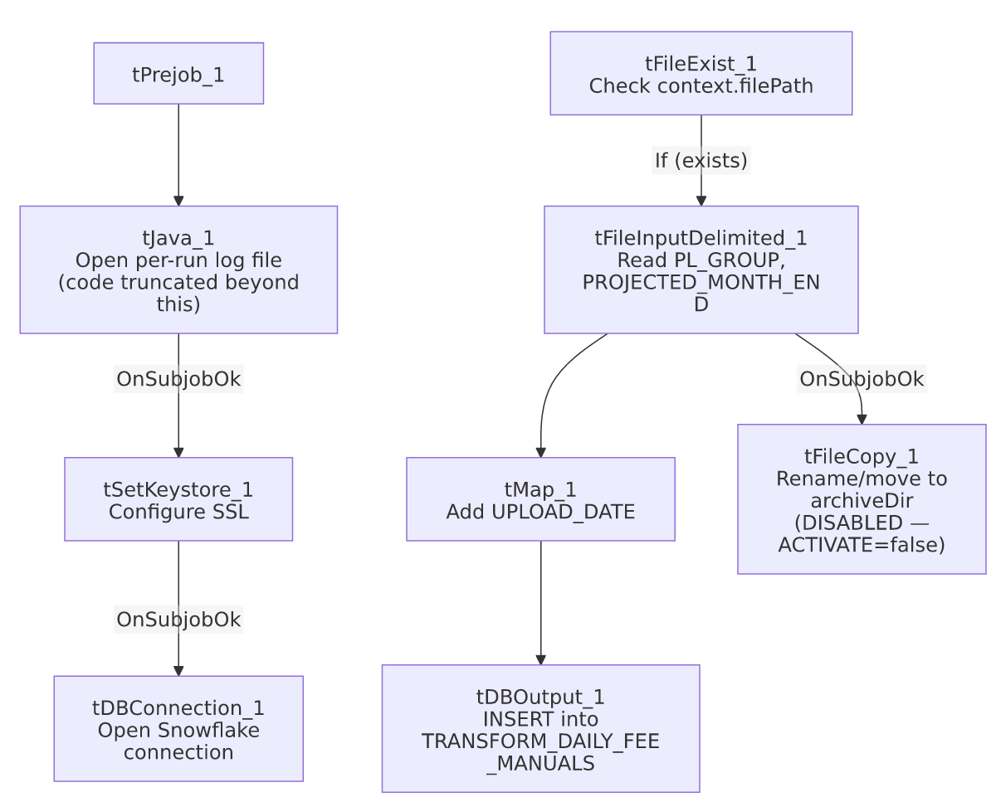

Settings tables

Source: `tFileInputDelimited_1`
Setting | Value | What it means
FILENAME | context.filePath | A single expected file path, not a directory iteration — this job processes one specific file per run.
FIELDSEPARATOR / HEADER | , / 1 header row | Comma-delimited with header.
DIE_ON_ERROR | false | Malformed rows don't fail the job; no reject flow is wired either (rejected rows are silently dropped).

Target: `tDBOutput_1` (`tSnowflakeOutput`)
Setting | Value | What it means
Table | TRANSFORM_DAILY_FEE_MANUALS | Destination table for the fee-projection rows.
Output action | INSERT | Appends rows; no truncate step in this job.
Table action | NONE | Table is not created/altered by this job.

Archive step (disabled): `tFileCopy_1`
Setting | Value | What it means
ACTIVATE | false | This component is disabled — despite being wired into the flow, it does not execute at runtime.
FILENAME | context.filePath | The file that would be moved, if enabled.
DESTINATION / DESTINATION_RENAME | context.archiveDir / "manual-fees-" + <CCYYMMDD> + ".csv" | Intended target name for the archived file.
REMOVE_FILE | true | Intended to delete the original after copying (i.e., a move, not a copy) — moot while disabled.
FAILON | false | Even if enabled, a failure here would not fail the job.

Dependencies & configuration
- Triggers/depends on other jobs: none — no tRunJob links found.
- Context variables used: logDir, keystorePath, filePath, archiveDir, sourceDir (referenced per the extracted context list, though not visibly used in any captured parameter — likely used in the truncated portion of tJava_1's code).
- 3 hardcoded paths: tSetKeystore_1.SSL_TRUSTSERVER_TRUSTSTORE (C:/clientTrustStore.trustStore), tFileInputDelimited_1.TEMP_DIR, and tFileCopy_1.SOURCE_DERECTORY (both C:/Talend-Studio-20211109_1610-V8.0.1/workspace) — same portability risk documented project-wide in 05_operational_runbook.md.

Glossary
Component type | Plain-English meaning
tFileExist | Checks whether a specific file exists on disk before proceeding.
tFileInputDelimited | Reads a delimited (CSV-style) text file according to a schema.
tMap | Maps/transforms columns from one schema to another.
tSnowflakeOutput | Writes rows to a Snowflake table.
tFileCopy | Copies (and optionally renames/moves) a file to a destination directory.
tSetKeystore | Configures SSL trust/keystore settings used by the subsequent Snowflake connection.

Issues observed
- The file-archive step (`tFileCopy_1`) is wired into the job but disabled (`ACTIVATE=false`). The design clearly intends to rename the processed file to manual-fees-<date>.csv and remove it from the source location after a successful load, but as configured this never happens — the source file is left in place after every run. If this job is re-run (or the scheduler doesn't clear the source file), the same manually-dropped fee file could be re-loaded and re-inserted on a subsequent run, since there's no truncate/dedup step on the target table either. Verify with the team whether disabling this step was intentional (e.g., archival handled by a separate manual process) or an oversight.
- `tJava_1`'s captured code is truncated after the log-file-opening logic (ending in "Path s..."), so this job's setup step may do more than just open a log file — unable to determine the rest of its logic from this metadata; verify directly in Talend Studio, especially since context.sourceDir is referenced in the job's context-variable list but not visibly used elsewhere.
- No `tPostjob`/`tDBClose` component exists in this job — the Snowflake connection opened by tDBConnection_1 is never explicitly closed within the job itself, consistent with a pattern already seen in other jobs in this batch (e.g. Debtor_Deleted_Load).
- No target-table truncate/dedup logic and no `tDie`/`tWarn` — combined with the disabled archive step above, there is a real risk of the same fee-projection file being loaded more than once with no automated safeguard against it.

