Talend Job: Debtor_Derived_Load

Overview
This is a pure SQL-orchestration job with no file or table inputs of its own: it runs four independent Snowflake merge/stored-procedure operations in parallel against data already staged by other jobs, deriving downstream tracking and fact tables — an "Evergreen desk" transfer tracker, a legacy debtor-dimension merge, a debtor-status fact table, and a daily debtor-status rollup. It then logs a simple completion message once all four finish. This job is a useful source of concrete site-code mappings (see Settings tables) not otherwise spelled out in the project's shared documentation.

Detail table
Field | Value
Job name | Debtor_Derived_Load
Version | 0.1
Project | EDW2SF
Author | jmach@harriscollect.com
Created | 2022-12-01T10:01:32.480-0800
Last Modified | 2025-11-19T07:48:17.214-0800

Step-by-step data flow
Setup subjob: tPrejob_1 → tJava_1 opens a per-run log file at context.logDir + jobName + "_" + <timestamp> + ".log" → on success, tSetKeystore_1 configures SSL trust/keystore from context.keystorePath (all passwords redacted) → on success, tDBConnection_1 opens the Snowflake connection.
Main subjob — tParallelize_1 starts four independent Snowflake operations concurrently, with no data or dependency links between them:
- tDBRow_1 merges STAGING.LEGACY_DIMDEBTOR rows tagged with the "Evergreen" desk (DESK='EVG', OLD_DSK_NAME='EVG', or a client code ending in 'EV') into DW.EVERGREEN_TRACKER, inserting new (never-seen) DEBTOR_IDX values only — no update branch.
- tDBRow_2 calls the stored procedure STAGING.MERGE_INTO_LEGACY_DIMDEBTOR().
- tDBRow_3 merges STAGING.DEBTOR_STATUS_CURRENT into DW.FACT_DEBTOR_STATUS, deriving a numeric DIMLOGON from the site-code prefix of DEBTOR_IDX via a hardcoded CASE mapping (see Settings tables), inserting a new fact row only when the exact combination of DEBTOR_IDX/CLIENT/STATUS/STATUS_DATE isn't already present (an append-only status-history pattern).
- tDBRow_4 calls the stored procedure MERGE_INTO_DAILY_DEBTOR_STATUS().
None of the four capture or log their result codes (see Issues observed). Once all four report OnSubjobOk, tParallelize_2 synchronizes and triggers tSystem_2, which runs a shell command (echo 'job <jobName> complete.') purely for log output.
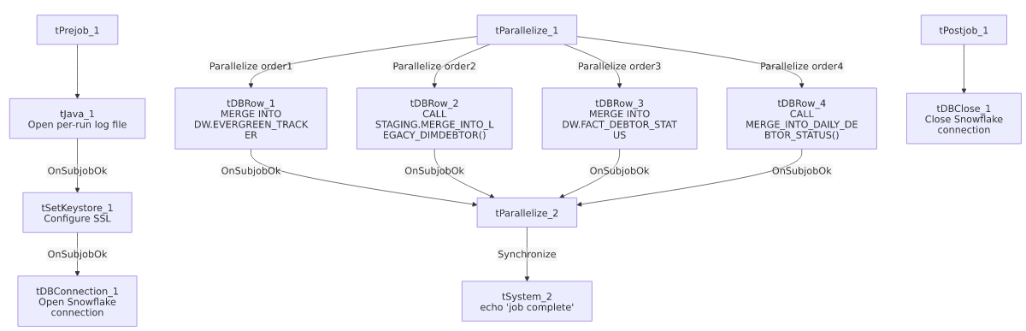

Settings tables

Evergreen tracker: `tDBRow_1`
Setting | Value | What it means
Query | MERGE INTO DW.EVERGREEN_TRACKER TGT USING (SELECT DEBTOR_IDX, CLIENT, DESK AS CURR_DESK, OLD_DSK_NAME AS PREV_DESK, OLD_DSK_DT AS DESK_CHANGE_DT FROM STAGING.LEGACY_DIMDEBTOR WHERE (DESK='EVG' OR OLD_DSK_NAME='EVG' OR RIGHT(TRIM(CLIENT),2)='EV') AND LENGTH(TRIM(DEBTOR_IDX))>10 AND COALESCE(CHARINDEX('-',DEBTOR_IDX),0) > 0) SRC ON TGT.DEBTOR_IDX = SRC.DEBTOR_IDX WHEN NOT MATCHED THEN INSERT (...) | Tracks debtors ever assigned to (or transferred from) an "Evergreen" desk/client, inserting each DEBTOR_IDX only once (no update on re-match), splitting LOGON/DEBTOR out of the DEBTOR_IDX composite key via string functions.

Legacy dimension merge: `tDBRow_2`
Setting | Value | What it means
Query | CALL STAGING.MERGE_INTO_LEGACY_DIMDEBTOR(); | Calls a stored procedure (not shown in this metadata) that presumably merges newly staged legacy debtor-dimension rows.

Debtor-status fact merge: `tDBRow_3`
Setting | Value | What it means
Query | MERGE INTO DW.FACT_DEBTOR_STATUS AS TGT USING (SELECT ..., CASE LEFT(DEBTOR_IDX,CHARINDEX('-',DEBTOR_IDX)-1) WHEN 'CHI' THEN 400 WHEN 'CO' THEN 200 WHEN 'DC' THEN 600 WHEN 'HH' THEN 100 WHEN 'PRE' THEN 300 WHEN 'TOL' THEN 700 ELSE 0 END AS DIMLOGON, ... FROM STAGING.DEBTOR_STATUS_CURRENT) AS SRC ON (DEBTOR_IDX, CLIENT, STATUS, STATUS_DATE match) WHEN NOT MATCHED THEN INSERT (...) | Appends a new fact row only for combinations of DEBTOR_IDX/CLIENT/STATUS/STATUS_DATE not already present — an append-only status-history table, not an upsert. This query's hardcoded `CASE` statement is a concrete site-code-to-`DIMLOGON` mapping: CHI=400, CO=200, DC=600, HH=100, PRE=300, TOL=700 (else 0) — useful ground truth for the site-code glossary entry in 01_system_architecture.md, which does not otherwise define the numeric codes.

Daily status rollup: `tDBRow_4`
Setting | Value | What it means
Query | CALL MERGE_INTO_DAILY_DEBTOR_STATUS(); | Calls a stored procedure (not shown in this metadata; note the absence of a schema prefix, unlike the other three operations which reference DW./STAGING. explicitly).

Dependencies & configuration
- Triggers/depends on other jobs: none — no tRunJob links found. This job reads from STAGING.LEGACY_DIMDEBTOR and STAGING.DEBTOR_STATUS_CURRENT, which are presumably populated by other jobs not identified in this job's own metadata (likely staging jobs for Debtor_Status_Load/Debtor_Status_Load_MSSQL or similar) — verify the actual producer job(s) with the team.
- Context variables used: keystorePath, logDir.
- 2 hardcoded paths: tSetKeystore_1.SSL_TRUSTSERVER_TRUSTSTORE (C:/clientTrustStore.trustStore) and tSystem_2.DIRECTORY (C:/Talend-Studio-20211109_1610-V8.0.1/workspace) — same portability risk documented project-wide in 05_operational_runbook.md.

Glossary
Component type | Plain-English meaning
tSnowflakeRow | Runs an arbitrary SQL statement or stored-procedure call against Snowflake.
tParallelize | Runs its downstream branches at the same time rather than one after another; a second tParallelize here is used purely to synchronize/wait for all four branches before proceeding.
tSystem | Runs an OS-level shell command — here, just an echo statement for a completion log line.
tSetKeystore | Configures SSL trust/keystore settings used by the subsequent Snowflake connection.

Issues observed
- None of the four SQL operations capture or log their result/error status. tDBRow_2 and tDBRow_4's stored procedures return result columns (RESULT, DDSRESULT), but no tJavaRow or similar component captures them into a context variable, and none of the four branches has a tWarn/tDie reacting to success or failure — unlike this project's other merge-heavy jobs (ADP_Payroll_Load, CO_Master_Load), a failure in any of these four operations would only surface as a generic Talend execution error, with no job-specific diagnostic.
- The four merge/procedure calls run fully in parallel with no visible dependency ordering, even though they read from what appear to be related staging tables (STAGING.LEGACY_DIMDEBTOR, STAGING.DEBTOR_STATUS_CURRENT). Unable to determine from this metadata whether that's safe (e.g., each reads a fully-independent staging table with no cross-dependency) or whether there's an implicit ordering requirement not enforced by the job itself — verify with the team, particularly whether tDBRow_2's MERGE_INTO_LEGACY_DIMDEBTOR() needs to complete before tDBRow_1's read of STAGING.LEGACY_DIMDEBTOR.
- `tDBRow_4`'s procedure call has no schema prefix (MERGE_INTO_DAILY_DEBTOR_STATUS()), unlike the other three operations, which explicitly reference DW. or STAGING. — this relies on the Snowflake session's default schema being correct at call time; worth confirming that's reliable across environments.
- The `tSystem_2` completion step is a plain `echo` shell command with no actual operational effect (no email, no semaphore file, no external signal) — it only writes to the job's own console/log output, so it provides no externally visible completion signal for downstream monitoring.

