Talend Job: Debtor_Status_Load

Overview
Loads debtor status-change records (logon, debtor number, DEBTOR_IDX, status) from tab-delimited files found in a shared source directory into the Snowflake DEBTOR_STATUS_UPDATE table. This job has a near-identical sibling, Debtor_Status_Load_MSSQL (documented separately), which reads the exact same source files and schema but writes to an MSSQL table of the same name instead of Snowflake — the two appear to be parallel loaders feeding the same logical data to two different downstream systems.

Detail table
Field | Value
Job name | Debtor_Status_Load
Version | 0.1
Project | EDW2SF
Author | jmach@harriscollect.com
Created | 2023-05-22T12:47:40.005-0700
Last Modified | 2025-09-24T11:08:10.516-0700

Step-by-step data flow
This job has no tPrejob/tPostjob or explicit database connection component in its own metadata — see Issues observed.
- tFileList_1 lists files in the hardcoded directory /mnt/cubs/.
- For each file, tJava_1 sets context.sourceFile to the current file path.
- tFileInputDelimited_1 reads it (tab-delimited, header row present, DIE_ON_ERROR=false) using a repository schema labeled "debtor_status", with columns LOGON, DEBTOR, DEBTOR_IDX, STATUS.
- tDBOutput_1 inserts the rows into Snowflake table DEBTOR_STATUS_UPDATE (INSERT, tableAction=CREATE_IF_NOT_EXISTS).
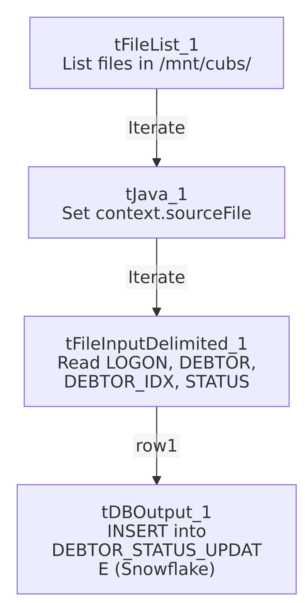

Settings tables

Source: `tFileList_1` / `tFileInputDelimited_1`
Setting | Value | What it means
DIRECTORY | "/mnt/cubs/" | Hardcoded literal path (not a context.* variable).
SCHEMA | Repository schema "debtor_status" | Standardized 4-column layout shared with the MSSQL sibling job.
FIELDSEPARATOR / HEADER | \t / 1 header row | Tab-delimited with header.
DIE_ON_ERROR | false | Malformed rows don't fail the job; no reject flow is wired (rejected rows silently dropped).

Target: `tDBOutput_1` (`tSnowflakeOutput`)
Setting | Value | What it means
Table | DEBTOR_STATUS_UPDATE | Destination table in Snowflake.
Output action | INSERT | Appends rows; no truncate step.
Table action | CREATE_IF_NOT_EXISTS | Creates the table on first run if it doesn't already exist.

Dependencies & configuration
- Triggers/depends on other jobs: none — no tRunJob links found. Likely feeds Debtor_Derived_Load's STAGING.DEBTOR_STATUS_CURRENT-driven merge into DW.FACT_DEBTOR_STATUS, though that relationship is not expressed via tRunJob in either job's metadata — verify with the team.
- Context variables used: sourceFile (set internally by tJava_1).
- 1 hardcoded developer-workstation path: tFileInputDelimited_1.TEMP_DIR (C:/Talend-Studio-20211109_1610-V8.0.1/workspace) — same portability risk documented project-wide in 05_operational_runbook.md. The source directory /mnt/cubs/ is also a hardcoded literal, not a context.* variable.

Glossary
Component type | Plain-English meaning
tFileList | Lists files in a directory for the job to iterate over one at a time.
tFileInputDelimited | Reads a delimited (tab-separated) text file according to a schema.
tSnowflakeOutput | Writes rows to a Snowflake table.

Issues observed
- This job has no `tPrejob`/`tPostjob`, and no `tDBConnection`/`tDBClose` component anywhere in its metadata — the same pattern already seen in several other jobs in this batch (DEBTOR_UPDATES_20230807, Debtor_Deleted_Load). How tDBOutput_1 actually connects to Snowflake is unable to determine from this metadata; verify directly in Talend Studio.
- No truncate or dedup logic — re-processing a file already loaded (if not removed from /mnt/cubs/ between runs) would insert duplicate status records with no automated safeguard.
- Sibling comparison with `Debtor_Status_Load_MSSQL`: both jobs were built the same day (about 1h40m apart), read the identical source directory and schema, but this job targets Snowflake while the sibling targets MSSQL (EDWProdHH-labeled connection) — see that job's doc for the specific configuration differences (notably, batch/commit sizing and DIE_ON_ERROR settings that exist on the MSSQL output but have no equivalent visible on this job's Snowflake output).

