Talend Job: Debtor_Status_Load_MSSQL

Overview
Loads the same debtor status-change records (logon, debtor number, DEBTOR_IDX, status) from the same tab-delimited source files as its sibling job Debtor_Status_Load, but writes them into an MSSQL table (DEBTOR_STATUS_UPDATE, via the EDWProdHH-labeled connection) instead of Snowflake. Built about 1 hour 40 minutes after the Snowflake version on the same day, this is very likely a parallel loader feeding the same status data to a second consuming system (an operational MSSQL database) alongside the warehouse.

Detail table
Field | Value
Job name | Debtor_Status_Load_MSSQL
Version | 0.1
Project | EDW2SF
Author | jmach@harriscollect.com
Created | 2023-05-22T14:26:03.203-0700
Last Modified | 2025-08-28T08:57:21.076-0700

Step-by-step data flow
This job has no tPrejob/tPostjob or explicit database connection component in its own metadata — see Issues observed.
- tFileList_1 lists files in the hardcoded directory /mnt/cubs/ (identical to Debtor_Status_Load).
- For each file, tJava_1 sets context.sourceFile to the current file path.
- tFileInputDelimited_1 reads it (tab-delimited, header row present, DIE_ON_ERROR=false) with columns LOGON, DEBTOR, DEBTOR_IDX, STATUS — same shape as the sibling job, though this component has no repository-schema reference captured (inline schema instead).
- tDBOutput_1 (tMSSqlOutput) inserts the rows into MSSQL table DEBTOR_STATUS_UPDATE using context.EDWProdHH_* connection variables (INSERT, TABLE_ACTION=NONE, DIE_ON_ERROR=false, batched in groups of 10,000).
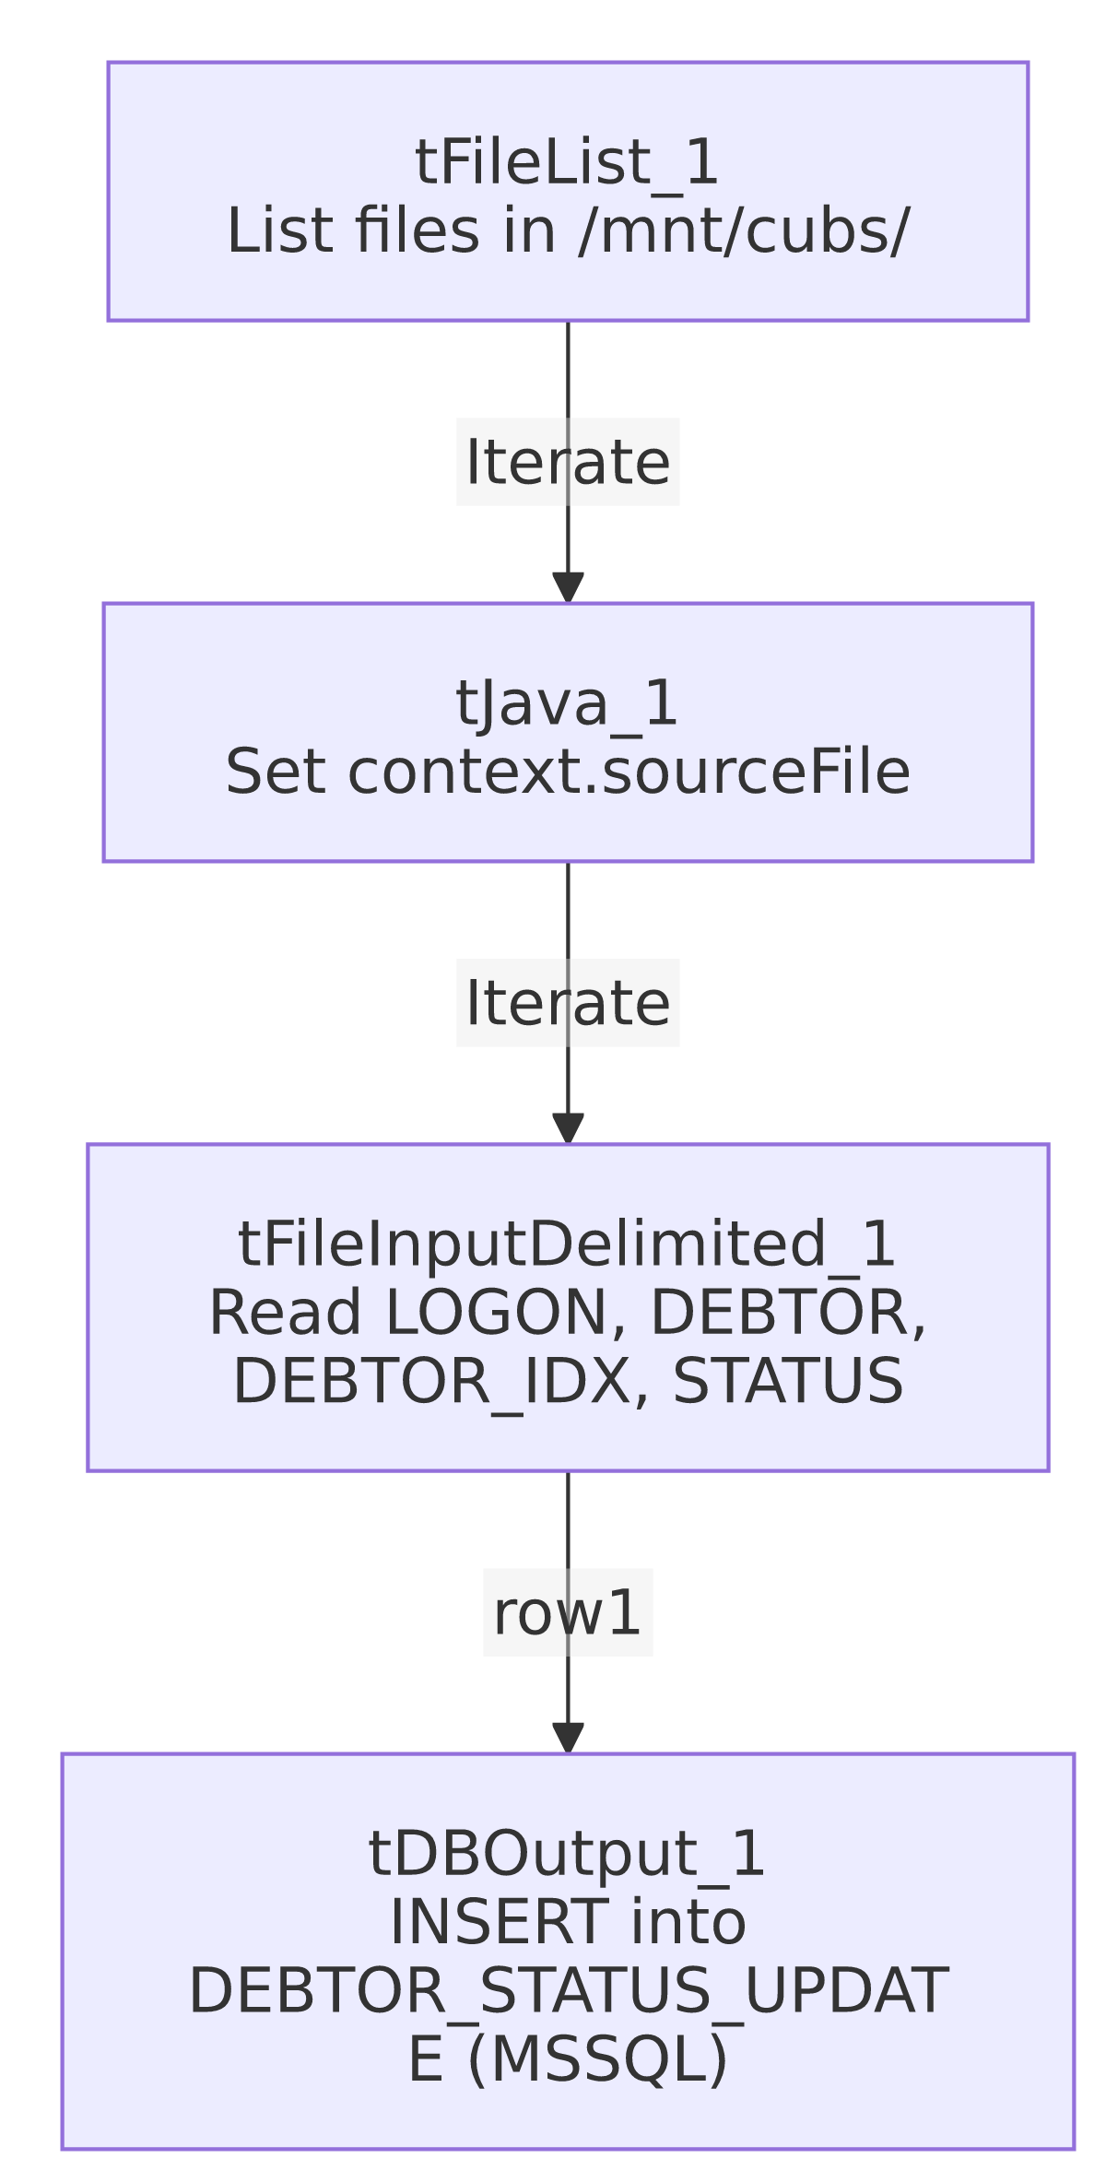

Settings tables

Source: `tFileList_1` / `tFileInputDelimited_1`
Setting | Value | What it means
DIRECTORY | "/mnt/cubs/" | Identical source directory to Debtor_Status_Load.
FIELDSEPARATOR / HEADER | \t / 1 header row | Tab-delimited with header — same layout as the sibling job.
DIE_ON_ERROR | false | Malformed rows don't fail the job; no reject flow is wired.

Target: `tDBOutput_1` (`tMSSqlOutput`)
Setting | Value | What it means
Connection | context.EDWProdHH_Server/Port/Schema/Database/Login (password redacted) | A dedicated (not shared) MSSQL connection opened inline on this component (USE_EXISTING_CONNECTION=false), rather than a separate tDBConnection in the job.
Table | DEBTOR_STATUS_UPDATE | Same table name as the Snowflake sibling's target, but a different physical database/system.
Data action / Table action | INSERT / NONE | Appends rows; table must already exist (no create-if-not-exists here, unlike the Snowflake sibling).
DIE_ON_ERROR | false | A row-level or connection error does not fail the job outright.
COMMIT_EVERY / BATCH_SIZE | 10000 / 10000 | Batches inserts in groups of 10,000 rows for performance — a setting with no equivalent visible on the Snowflake sibling's output component.

Dependencies & configuration
- Triggers/depends on other jobs: none — no tRunJob links found.
- Context variables used: EDWProdHH_Server, EDWProdHH_Port, EDWProdHH_Schema, EDWProdHH_Database, EDWProdHH_Login (MSSQL connection), sourceFile (set internally by tJava_1).
- 1 hardcoded developer-workstation path: tFileInputDelimited_1.TEMP_DIR (C:/Talend-Studio-20211109_1610-V8.0.1/workspace) — same portability risk documented project-wide in 05_operational_runbook.md. The source directory /mnt/cubs/ is also a hardcoded literal.

Glossary
Component type | Plain-English meaning
tFileList | Lists files in a directory for the job to iterate over one at a time.
tFileInputDelimited | Reads a delimited (tab-separated) text file according to a schema.
tMSSqlOutput | Writes rows to a Microsoft SQL Server table, using its own inline connection settings.

Issues observed
- This job has no `tPrejob`/`tPostjob`, and no `tDBConnection`/`tDBClose` component anywhere in its metadata — the connection is instead opened inline on tDBOutput_1 itself (USE_EXISTING_CONNECTION=false). This means the MSSQL connection is opened and (implicitly) closed around this single component rather than managed at the job level — a less consistent pattern than most other MSSQL-writing jobs in this project.
- No truncate or dedup logic, and TABLE_ACTION=NONE (the table must already exist) — re-processing a file already loaded would insert duplicate status records into the MSSQL table with no automated safeguard, same risk as the Snowflake sibling.
- Sibling comparison with `Debtor_Status_Load`: both jobs read the exact same source directory and (visually) the same 4-column schema, but this job's tFileInputDelimited_1 has no repository-schema reference captured (the Snowflake sibling explicitly uses a repository schema labeled "debtor_status"), and this job's target uses TABLE_ACTION=NONE rather than CREATE_IF_NOT_EXISTS. Whether these two jobs are both scheduled to run against the same source files (each independently consuming/leaving the files, potentially causing a race if one deletes what the other expects to read) is unable to determine from either job's metadata — verify the scheduling relationship and file-handling behavior with the team, since neither job shows a file-archive/delete step after reading.

