Talend Job: Debtor_Strat_Backfill

Overview
Loads historical debtor collection-strategy records (strategy test numbers, first/second actions, strategy events, "side-strategy" scheduling fields) from tab-delimited files found in two separate source directories — a general drop location and a DC-specific one — into a shared Snowflake staging table, TMP_DIMDEBTOR_BACKFILL. The TMP_ prefix and lack of any downstream merge step in this job's own metadata indicate this is a backfill/staging job whose output is presumably consumed by a separate merge process not shown here.

Detail table
Field | Value
Job name | Debtor_Strat_Backfill
Version | 0.1
Project | EDW2SF
Author | jmach@harriscollect.com
Created | 2023-01-18T10:25:14.366-0800
Last Modified | 2025-09-24T11:06:32.580-0700

Step-by-step data flow
This job has no tPrejob/tPostjob component, but does include an explicit Snowflake connection open/close pair — see Issues observed for the mix of patterns.
- tDBConnection_1 opens the Snowflake connection; on success, tFileList_1 lists files in /mnt/cubs/.
- For each file, tFileInputDelimited_1 reads it (tab-delimited, header row present, repository schema labeled "metadata") with 14 business columns (LOGON, DEBTOR, DEBTOR_IDX, STRAT_TEST_NUMBER, STRAT_1ST_ACTION, STRAT_EVENT, STRAT_2ND_ACTION, STRAT_NEXT_STRAT_DATE, STRAT_NEXT_STRAT_TEST, SIDESTRAT_DATE, SIDESTRAT_START_TIME, SIDESTRAT_NAME, SIDESTRAT_TEST_NUMBER, SIDESTRAT_ACTION).
- tMap_1 renames DEBTOR to DEBTOR_NUMBER and passes the rest through unchanged.
- tDBOutput_1 inserts the rows into Snowflake table TMP_DIMDEBTOR_BACKFILL (INSERT, tableAction=NONE).
- On tFileList_1's subjob success, tFileList_3 lists files in a second, DC-specific directory, /mnt/cubs_dc/.
- For each file found there, tFileInputDelimited_2 reads it with the identical schema, tMap_2 performs the same rename, and tDBOutput_2 inserts into the same target table, TMP_DIMDEBTOR_BACKFILL.
- Once tDBOutput_2 completes, tDBClose_1 closes the Snowflake connection.
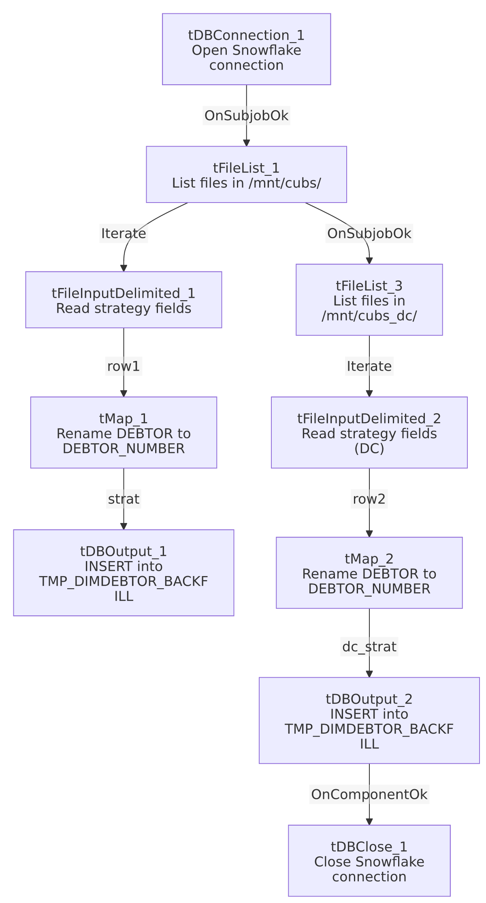

Settings tables

Sources: `tFileList_1`/`tFileInputDelimited_1` and `tFileList_3`/`tFileInputDelimited_2`
Setting | Value | What it means
DIRECTORY | "/mnt/cubs/" and "/mnt/cubs_dc/" | Two hardcoded literal directories — a general source and a DC-site-specific one — both feeding the same target table.
SCHEMA | Repository schema "metadata" (both) | A generically-named schema label for a strategy-specific column set — see Issues observed.
FIELDSEPARATOR / HEADER | \t / 1 header row | Tab-delimited with header, identical between both sources.
DIE_ON_ERROR | false (both) | Malformed rows don't fail the job; no reject flow is wired on either input.

Target: `tDBOutput_1` / `tDBOutput_2` (`tSnowflakeOutput`)
Setting | Value | What it means
Table | TMP_DIMDEBTOR_BACKFILL (both) | Both source directories load into the same staging table — its TMP_ prefix indicates this is intermediate/scratch data for a further merge step not present in this job.
Output action | INSERT (both) | Appends rows; no truncate step in this job.
Table action | NONE (both) | Table is not created/altered by this job — it must already exist.

Dependencies & configuration
- Triggers/depends on other jobs: none — no tRunJob links found. Whatever job merges TMP_DIMDEBTOR_BACKFILL into a permanent warehouse table is not identified in this job's own metadata — verify with the team.
- Context variables used: none — this job uses no context.* variables at all; both source directories and the Snowflake connection details appear to be hardcoded or configured directly on the component.
- 2 hardcoded developer-workstation paths: tFileInputDelimited_1.TEMP_DIR and tFileInputDelimited_2.TEMP_DIR (both C:/Talend-Studio-20211109_1610-V8.0.1/workspace) — same portability risk documented project-wide in 05_operational_runbook.md. The source directories /mnt/cubs/ and /mnt/cubs_dc/ are also hardcoded literals.

Glossary
Component type | Plain-English meaning
tFileList | Lists files in a directory for the job to iterate over one at a time.
tFileInputDelimited | Reads a delimited (tab-separated) text file according to a schema.
tMap | Maps/transforms columns from one schema to another.
tSnowflakeConnection / tSnowflakeOutput / tSnowflakeClose | Open a Snowflake connection, write rows to a table, and close the connection.

Issues observed
- No `tPrejob`/`tPostjob` component exists, though this job does explicitly open (tDBConnection_1) and close (tDBClose_1) its Snowflake connection — a partial version of the pattern used by most other jobs in this project (which wrap connection management in tPrejob/tPostjob subjobs). This inconsistency (connection managed, but not inside a prejob/postjob) is a minor structural deviation worth noting if this job is ever used as a template for a new one.
- Both the general and DC-specific source loads write into the same staging table with no distinguishing site/source column added by either `tMap` — once loaded, TMP_DIMDEBTOR_BACKFILL doesn't retain which of the two source directories a given row came from (unless LOGON itself encodes the site, which is plausible but not confirmed by this metadata). If the downstream merge process needs to treat DC rows differently, it would have to infer that from LOGON rather than an explicit source flag.
- No truncate step before either load — since TMP_DIMDEBTOR_BACKFILL is only appended to (INSERT, no truncate), and the job's own metadata shows no cleanup of previously-loaded files from /mnt/cubs///mnt/cubs_dc/, re-running this job against files that were already processed (if not removed) would insert duplicate rows into the temp table.
- The repository schema label ("metadata") is generic rather than something like "debtor_strat", despite the schema itself being specific to strategy/side-strategy fields — a minor naming inconsistency, though not something that affects job behavior.

