Talend Job: DimCellphone_Load

Overview
This is an orchestrator job for the DimCellphone dimension: it truncates the shared CUBS_CELLPHONE_RAW staging table, then waits for each site's daily CUBS extract to land (via per-site CHI/CO/DC/HH/PRE-EDW-COMPLETE.txt semaphore files) before triggering the same child job, CUBS_Raw_Cellphone_Load, once per site. Once all site branches finish, it calls a stored procedure to merge the accumulated raw cellphone data into the DimCellphone dimension and reports the row count via a warning or fails the job on error. A sixth site branch, for TOL, exists in the design but is disabled — see Issues observed.

Detail table
Field | Value
Job name | DimCellphone_Load
Version | 0.1
Project | EDW2SF
Author | jmach@harriscollect.com
Created | 2023-03-23T19:46:39.921-0700
Last Modified | 2026-08-07T11:42:31.383-0700

Step-by-step data flow
Setup subjob: tPrejob_1 → tJava_1 opens a per-run log file → on success, tSetKeystore_1 configures SSL trust/keystore from context.keystorePath (all passwords redacted) → on success, tDBConnection_1 opens the Snowflake connection.
Main subjob:
- tDBRow_1 runs TRUNCATE TABLE CUBS_CELLPHONE_RAW;.
- On success, tParallelize_1 starts 6 branches, one per site, each polling context.sourceDir (or context.sourceDCDir for DC) every 30 seconds for up to 720 iterations for that site's completion marker, then — once found — triggering the same child job via tRunJob:
- tWaitForFile_1 → CHI-EDW-COMPLETE.txt → tRunJob_1 → CUBS_Raw_Cellphone_Load
- tWaitForFile_2 → CO-EDW-COMPLETE.txt → tRunJob_2 → CUBS_Raw_Cellphone_Load
- tWaitForFile_3 → DC-EDW-COMPLETE.txt (in context.sourceDCDir, not sourceDir) → tRunJob_3 → CUBS_Raw_Cellphone_Load
- tWaitForFile_4 → HH-EDW-COMPLETE.txt → tRunJob_4 → CUBS_Raw_Cellphone_Load
- tWaitForFile_5 → PRE-EDW-COMPLETE.txt → tRunJob_5 → CUBS_Raw_Cellphone_Load
- tWaitForFile_6 → TOL-EDW-COMPLETE.txt → tRunJob_6 → CUBS_Raw_Cellphone_Load — both components have `ACTIVATE=false`, so this branch never runs.
All 6 tRunJob calls invoke the exact same child job (CUBS_Raw_Cellphone_Load) with TRANSMIT_ORIGINAL_CONTEXT=true but TRANSMIT_WHOLE_CONTEXT=false and no dynamic context switch — how the child job distinguishes which site it's processing on each of the 5 active calls is not visible in this job's own metadata; see Issues observed.
- Once tParallelize_1 synchronizes (waits for all branches, active or not), tDBRow_2 calls CALL UPDATE_DIMCELLPHONE().
- tJavaRow_1 captures the procedure's RETVALUE into context.rowCount.
- The flow branches on two ordered RUN_IF conditions (conditions themselves not captured, but component wiring/messages make the intent clear):
- Success: tWarn_1 logs "<rowCount> rows added to DimCellphone" (severity 42) — a warning, not a failure.
- Failure: tDie_1 fails the job with message "<rowCount>: an error occurred during UPDATE or INSERT" and exit code = context.rowCount.
Teardown subjob: tPostjob_1 → tDBClose_1 closes the Snowflake connection.
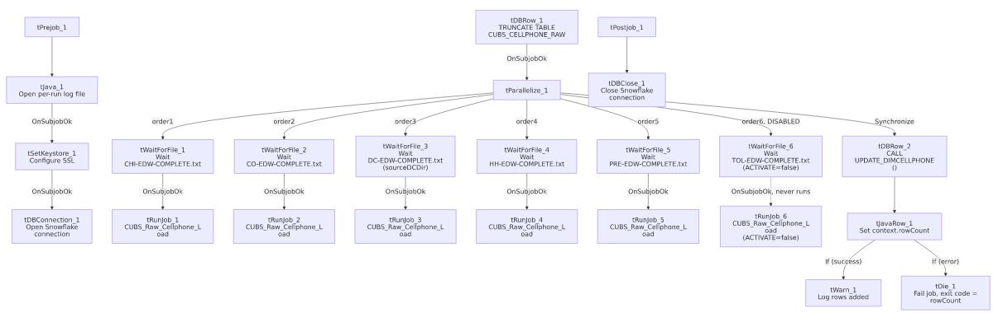

Settings tables

Gates: `tWaitForFile_1` through `tWaitForFile_6`
Setting | Value | What it means
WAIT / MAX_ITERATIONS | 30 (seconds) / 720 (all 6) | Polls every 30 seconds for up to 720 tries (6 hours max) per site.
DIRECTORY | context.sourceDir (CHI, CO, HH, PRE, TOL) / context.sourceDCDir (DC only) | DC uses a distinct context variable for its source directory — consistent with context.sourceDCDir also appearing in DimCellphone_Load's sibling orchestrators elsewhere in this project.
FILEMASK | "<SITE>-EDW-COMPLETE.txt" | Site-specific semaphore filename, same pattern as Semaphore_Check and CO_Master_Load.
ACTIVATE | true (5 of 6) / `false` for `tWaitForFile_6` (TOL) | The TOL branch is disabled — see Issues observed.

Orchestration: `tRunJob_1` through `tRunJob_6`
Setting | Value | What it means
PROCESS | CUBS_Raw_Cellphone_Load (all 6) | Every branch calls the identical child job — no per-site job variant.
DIE_ON_CHILD_ERROR | true (all 6) | If the child job fails, DimCellphone_Load fails too.
TRANSMIT_ORIGINAL_CONTEXT / TRANSMIT_WHOLE_CONTEXT | true / false (all 6) | The child receives the parent's original context values but not necessarily every variable — how site-specific behavior is achieved inside CUBS_Raw_Cellphone_Load isn't visible here.
ACTIVATE | true (5 of 6) / `false` for `tRunJob_6` (TOL) | The TOL call is disabled — see Issues observed.

Merge step: `tDBRow_2`
Setting | Value | What it means
Query | CALL UPDATE_DIMCELLPHONE() | Merges accumulated CUBS_CELLPHONE_RAW data (populated by however many of the 6 CUBS_Raw_Cellphone_Load calls actually ran) into the DimCellphone dimension. Its RETVALUE drives the success/failure branch.

Dependencies & configuration
- This job calls `CUBS_Raw_Cellphone_Load` via `tRunJob` up to 6 times (5 active: CHI, CO, DC, HH, PRE; 1 disabled: TOL) — matches the 6-call count in 06_dependency_matrix.md, though that count does not distinguish the disabled TOL call from the 5 active ones.
- Context variables used: keystorePath, logDir, sourceDir, sourceDCDir, rowCount (set internally from the merge procedure's return value).
- 1 hardcoded path: tSetKeystore_1.SSL_TRUSTSERVER_TRUSTSTORE (C:/clientTrustStore.trustStore) — same pattern documented project-wide in 05_operational_runbook.md.

Glossary
Component type | Plain-English meaning
tWaitForFile | Polls a directory for a specific file to appear, for up to a configured number of attempts, before letting the job continue — used here as an active per-site gate.
tRunJob | Runs another Talend job as a sub-process, optionally waiting for it to finish before continuing.
tParallelize | Runs its downstream branches at the same time rather than one after another; here also used with a Synchronize connector to wait for all 6 branches (active or not) before proceeding.
tSnowflakeRow | Runs an arbitrary SQL statement or stored-procedure call against Snowflake.
tJavaRow | Runs custom Java code once per input row — here used to unpack a stored procedure's return value into a context variable.
tWarn / tDie | Logs a warning without failing the job, or ends the job with a specific failure message and exit code.

Issues observed
- The TOL branch (`tWaitForFile_6`/`tRunJob_6`) is present in the job design but disabled (`ACTIVATE=false` on both components). This means DimCellphone_Load never waits for TOL's semaphore file and never triggers CUBS_Raw_Cellphone_Load for TOL — if TOL cellphone data is supposed to be included in the DimCellphone dimension, it is not being loaded by this job as currently configured. This is consistent with the project-wide observation in 05_operational_runbook.md that only CO has a fully-fledged _Master_Load orchestrator and other sites' pipeline coverage is inconsistent — verify with the team whether TOL cellphone data is loaded some other way, or whether this is a gap.
- All 6 (5 active) `tRunJob` calls invoke the exact same child job with no visible per-site context override (USE_DYNAMIC_CONTEXT=false, TRANSMIT_WHOLE_CONTEXT=false). How CUBS_Raw_Cellphone_Load knows which site's data to process on each of the 5 active calls is not visible in this job's own metadata — per 06_dependency_matrix.md, confirming exactly what differs per call requires opening each tRunJob component's context settings individually in Talend Studio, which this extraction did not capture.
- A failed `UPDATE_DIMCELLPHONE()` merge does fail the job (via tDie_1), which is a stronger safety net than CO_Master_Load's warning-only FACTTRANS merge failure — worth noting as a positive contrast when comparing error-handling maturity across this project's orchestrator jobs.
- If `DimCellphone_Load` fails, its own error won't say which of the (up to 5 active) site branches actually broke — same diagnostic limitation documented for CO_Master_Load in 05_operational_runbook.md.

