Talend Job: DimClient_Load

Overview
Loads three related client-hierarchy dimension tables from the EDWProdHH MSSQL source into Snowflake — DIMCLIENT (client master, upserted), DIMDEPARTMENT, and DIMGLCODE (both fully truncated and reloaded reference tables) — running all three in parallel, then combines them into a single denormalized staging table, STG_DIM_CLIENT, joining client-to-department-to-GL-code with default "Unassigned" fallbacks and explicitly excluding the '0' and 'TRAIN' test/placeholder client codes.

Detail table
Field | Value
Job name | DimClient_Load
Version | 0.1
Project | EDW2SF
Author | jmach@harriscollect.com
Created | 2022-01-04T15:07:06.234-0800
Last Modified | 2022-05-24T09:48:29.496-0700

Step-by-step data flow
Setup subjob: tPrejob_1 → tDBConnection_1 opens a Snowflake connection → on success, tDBConnection_2 opens the MSSQL connection using context.EDWProdHH_* variables (password and Active Directory auth redacted) → on success, tDBConnection_3 opens a second, separate Snowflake connection.
Main subjob — tParallelize_1 starts three independent branches, all of which must finish (tParallelize_2, WAIT_FOR=All) before the final staging step runs:
- DimClient branch: tDBInput_2 (Snowflake) runs SELECT CAST(COALESCE(MAX(UPDATEKEY),0) AS VARCHAR(10)) AS MAX_UPDATE_KEY FROM DW.DIMCLIENT;, capturing the result into context.maxUpdateKey via tJavaRow_1. On success, tDBInput_1 (MSSQL) reads the DimClient table (34 columns — client codes, name/address fields, desk, series, multiple grouping codes, DIALER_GRP, UPDATEKEY, etc.; query text truncated, so any WHERE filter using context.maxUpdateKey is not visible). tMap_1 passes columns through (uppercased); tFlowMeter_4 counts rows; tDBOutput_1 upserts into Snowflake DIMCLIENT (UPSERT, tableAction=NONE).
- DimDepartment branch: tDBInput_3 (MSSQL) runs a fixed SELECT DimDepartment, DepartmentName, Description, Logon, DimGLCode FROM dbo.DimDepartment; tMap_2 passes columns through; tFlowMeter_6 counts rows; tDBOutput_2 inserts into Snowflake DIMDEPARTMENT (INSERT, tableAction=TRUNCATE — full reload).
- DimGLCode branch: tDBInput_4 (MSSQL) runs SELECT CAST(DimGLCode AS numeric(38,0)) AS DimGLCode, Description FROM dbo.DimGLCODE; tMap_3 passes columns through; tFlowMeter_7 counts rows; tDBOutput_3 inserts into Snowflake DIMGLCODE (INSERT, tableAction=TRUNCATE — full reload).
Once all three branches signal tParallelize_2, it synchronizes and triggers the final staging step:
- tDBInput_5 (Snowflake) runs a join of the just-reloaded DW.DIMCLIENT, DW.DIMDEPARTMENT, and DW.DIMGLCODE, defaulting missing department/GL associations to 'Unassigned' (department ID 11, GL code 4), and excluding client codes `'0'` and `'TRAIN'`. tMap_4 renames CLIENT to CLIENT_ID; tFlowMeter_15 counts rows; tDBOutput_4 inserts into Snowflake STG_DIM_CLIENT (INSERT, tableAction=TRUNCATE).
Teardown subjob: tPostjob_1 → tDBClose_1 → tDBClose_2 → tDBClose_3 (closing both Snowflake connections and the MSSQL connection).
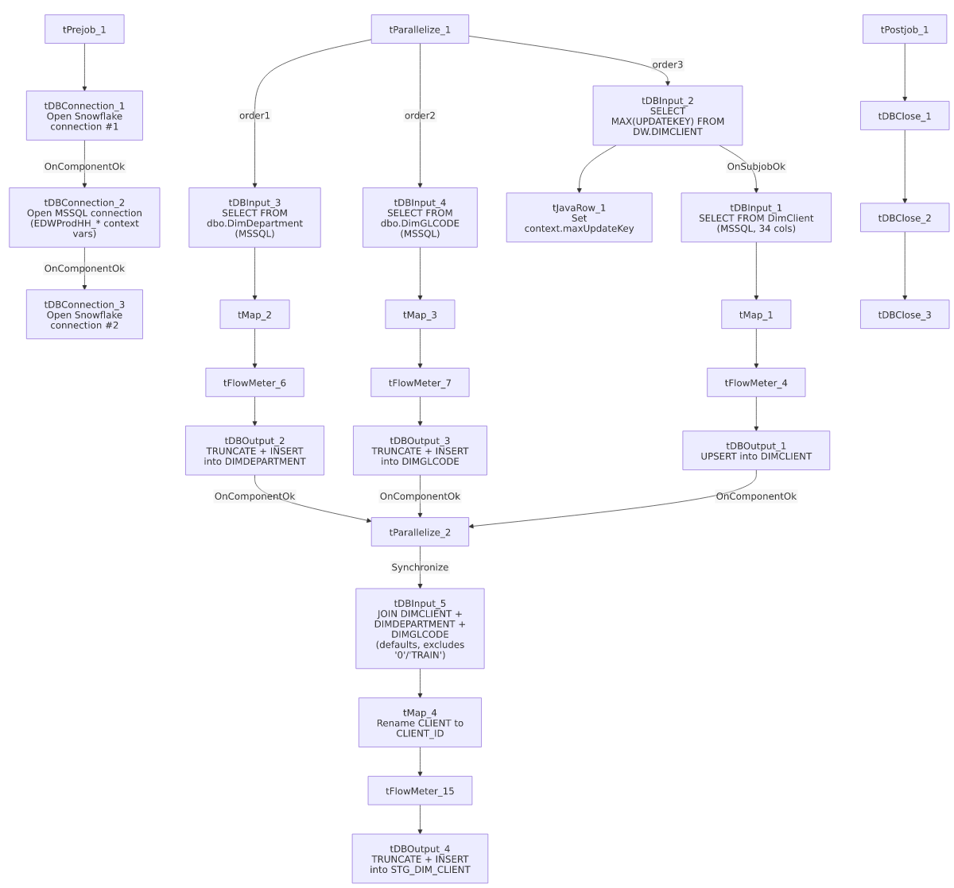

Settings tables

Source: `tDBInput_1` (`tMSSqlInput`, DimClient)
Setting | Value | What it means
Table | DimClient | Source client-master table, 34 columns (client codes, address, desk/series, multiple grouping fields, DIALER_GRP/DLR_GRP, UPDATEKEY).
Query | Truncated in this metadata after the column list | No WHERE clause is visible — same "unable to confirm incremental filter" pattern seen in other max-key jobs in this project (e.g. i3_CallDetail_40_Load, DC_E_Media_Load).

Target: `tDBOutput_1` (Snowflake `DIMCLIENT`)
Setting | Value | What it means
Output action / Table action | UPSERT / NONE | Updates matching rows and inserts new ones directly into the standing DIMCLIENT table — no staging/merge step needed.

DimDepartment / DimGLCode sources and targets
Setting | Value | What it means
tDBInput_3 query | SELECT DimDepartment, DepartmentName, Description, Logon, DimGLCode FROM dbo.DimDepartment | Small reference table — department code, name, and its associated GL code.
tDBInput_4 query | SELECT CAST(DimGLCode AS numeric(38,0)) AS DimGLCode, Description FROM dbo.DimGLCODE | Small reference table — GL code and description.
tDBOutput_2 / tDBOutput_3 | INSERT / TRUNCATE (both) | Both are small enough to fully reload every run rather than upsert.

Staging join: `tDBInput_5` (Snowflake)
Setting | Value | What it means
Query | SELECT 'CUBS' AS SOURCE_SYSTEM, C.LOGON, C.CLIENT, ..., COALESCE(C.DIMDEPARTMENT,11) AS DEPARTMENT_ID, COALESCE(D.DEPARTMENTNAME,'Unassigned') AS DEPARTMENT_NAME, COALESCE(D.DESCRIPTION,'Unassigned') AS DEPARTMENT_DESC, COALESCE(G.DIMGLCODE,4) AS GL_CODE, COALESCE(G.DESCRIPTION,'Unassigned') AS GL_DESC, ... FROM DW.DIMCLIENT C LEFT JOIN DW.DIMDEPARTMENT D ON ... LEFT JOIN DW.DIMGLCODE G ON ... WHERE C.CLIENT NOT IN ('0','TRAIN'); | Joins the three just-reloaded dimensions with LEFT JOINs and explicit fallback defaults (department 11/"Unassigned", GL code 4/"Unassigned") for clients with no department/GL mapping. Explicitly excludes client codes `'0'` and `'TRAIN'` — a hardcoded business rule filtering out placeholder/test client records from this staging view.

Target: `tDBOutput_4` (Snowflake `STG_DIM_CLIENT`)
Setting | Value | What it means
Output action / Table action | INSERT / TRUNCATE | Full reload of the denormalized staging table every run.

Dependencies & configuration
- Triggers/depends on other jobs: none — no tRunJob links found.
- Context variables used: EDWProdHH_Server, EDWProdHH_Port, EDWProdHH_Schema, EDWProdHH_Database, EDWProdHH_Login (MSSQL connection), maxUpdateKey (computed internally from the Snowflake max-key query, though its use in filtering the source query is unconfirmed — see Issues observed).
- No hardcoded developer-workstation paths found in this job.

Glossary
Component type | Plain-English meaning
tMSSqlConnection / tMSSqlInput / tMSSqlClose | Open a Microsoft SQL Server connection, run a query against it, and close it.
tSnowflakeConnection / tSnowflakeInput / tSnowflakeOutput / tSnowflakeClose | Open a Snowflake connection, read/write rows, and close the connection.
tMap | Maps/transforms columns from one schema to another.
tFlowMeter | Counts rows passing a point in the flow for logging/monitoring.
tJavaRow | Runs custom Java code once per input row — here used to unpack a query result into a context variable.
tParallelize | Runs its downstream branches at the same time; a second instance here (tParallelize_2) is used purely to synchronize all three branches before the final staging step.

Issues observed
- The incremental-load logic for `DIMCLIENT` may not actually be applied. As with i3_CallDetail_40_Load and DC_E_Media_Load, this job computes context.maxUpdateKey before reading the MSSQL source, but the tDBInput_1.QUERY text is truncated after the column list with no visible WHERE clause. Because the write is an UPSERT, an unfiltered full-table pull wouldn't create duplicates, but it would mean unnecessary full-table reprocessing every run if the filter isn't actually applied — unable to confirm from this metadata; verify directly in Talend Studio.
- Two separate Snowflake connections are opened (tDBConnection_1 and tDBConnection_3) rather than one shared connection — the same pattern already flagged in Dialer_Grp_Transform_Inputs_Load, likely to avoid a threading conflict across the job's three parallel branches, but worth confirming intent.
- The `STG_DIM_CLIENT` staging query's exclusion of `CLIENT NOT IN ('0','TRAIN')` is a hardcoded business rule embedded directly in SQL text, not a configurable list — if a new placeholder/test client code is ever introduced, it would need a manual edit to this query to be excluded from downstream reporting consumers of STG_DIM_CLIENT.
- No error/row-count logging specific to this job's business outcome (no tWarn/tDie/tSendMail) — a load failure in any of the three parallel branches, or in the final staging step, would only surface as a generic Talend execution error, with no job-specific message to distinguish which branch failed.

