Talend Job: DimDate_Load

Overview
Loads the standard date-dimension table (calendar attributes: day/week/month/quarter/year breakdowns, day-of-week, holiday text, etc.) from the EDWProdHH MSSQL source's DimDate table into the Snowflake DIMDATE table, fully truncating and reloading it every run. This is a simple, self-contained reference-table load with no incremental logic — appropriate for a slowly-changing calendar dimension.

Detail table
Field | Value
Job name | DimDate_Load
Version | 0.1
Project | EDW2SF
Author | jmach@harriscollect.com
Created | 2021-12-31T10:52:46.108-0800
Last Modified | 2025-09-24T11:00:51.244-0700

Step-by-step data flow
Setup subjob: tPrejob_1 → tDBConnection_1 opens a Snowflake connection → on success, tDBConnection_2 opens the MSSQL connection using context.EDWProdHH_* variables (password and Active Directory auth redacted).
Main subjob:
- tDBInput_1 runs a fixed SELECT against MSSQL table DimDate, pulling 18 calendar-attribute columns (DATESK, DATE, DAY, DAYSUFFIX, DAYOFWEEK, DOWINMONTH, DAYOFYEAR, WEEKOFYEAR, WEEKOFMONTH, FIRSTDAYOFWEEK, MONTH, MONTHNAME, QUARTER, QUARTERNAME, YEAR, STANDARDDATE, HOLIDAYTEXT, DAYSINWEEK) — query text truncated after DOWInMonth, but the schema shows the full 18-column result.
- tMap_1 passes all 18 columns through unchanged.
- tDBOutput_1 inserts the rows into Snowflake table DIMDATE (INSERT, tableAction=TRUNCATE — a full reload every run). The target table's own schema includes 4 additional columns (BUSINESSDAY, HOLIDAY, BUS_DAY_OF_MONTH, BUS_DAY_OF_YEAR) that are not present in the source query or the map's output — see Issues observed.
Teardown subjob: tPostjob_1 → tDBClose_1 (close MSSQL) → tDBClose_2 (close Snowflake).
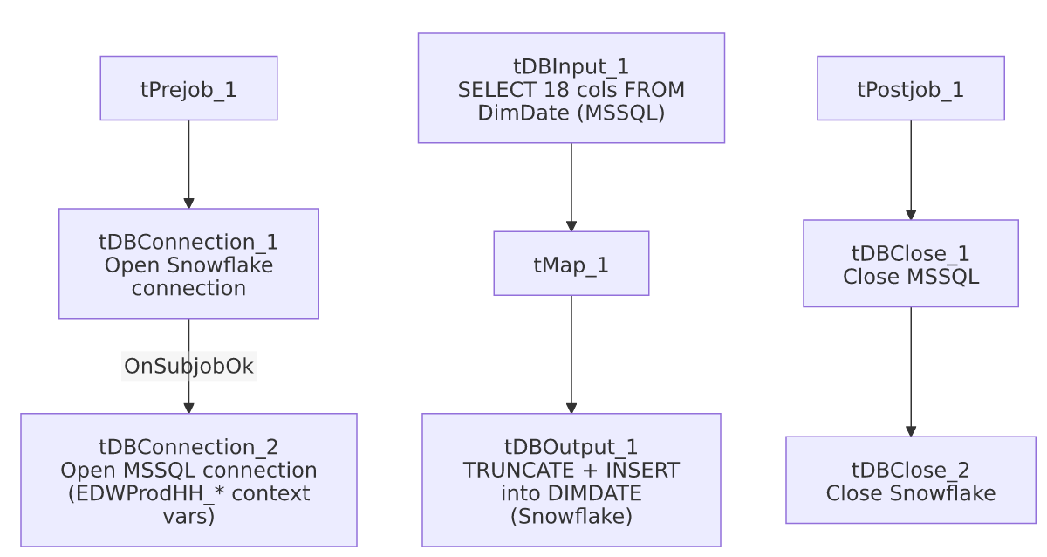

Settings tables

Source: `tDBInput_1` (`tMSSqlInput`)
Setting | Value | What it means
Table | DimDate | Standard calendar-dimension source table.
Query | SELECT CAST([DateSK] AS numeric(38,0)) AS DATESK, CONVERT(date,[Date],23) AS [DATE], CAST([Day] AS numeric(38,0)) AS [DAY], [DaySuffix] AS DAYSUFFIX, [DayOfWeek] AS [DAYOFWEEK], CAST([DOWInMonth] AS numeric(38,0)... (truncated) | Standard calendar breakdown fields; the visible portion shows type-casting to numeric/date but no filtering — this is expected to be a full-table pull, not incremental, which is appropriate for a static/slowly-changing date dimension.

Target: `tDBOutput_1` (`tSnowflakeOutput`)
Setting | Value | What it means
Table | DIMDATE | Destination calendar-dimension table.
Output action | INSERT | Appends rows after truncation.
Table action | TRUNCATE | Table is fully cleared and reloaded every run.
Extra target columns | BUSINESSDAY, HOLIDAY, BUS_DAY_OF_MONTH, BUS_DAY_OF_YEAR | Present in the target table's schema but not sourced or mapped by this job — see Issues observed.

Dependencies & configuration
- Triggers/depends on other jobs: none — no tRunJob links found.
- Context variables used: EDWProdHH_Server, EDWProdHH_Port, EDWProdHH_Schema, EDWProdHH_Database, EDWProdHH_Login (MSSQL connection).
- No hardcoded developer-workstation paths found in this job.

Glossary
Component type | Plain-English meaning
tMSSqlConnection / tMSSqlInput / tMSSqlClose | Open a Microsoft SQL Server connection, run a query against it, and close it.
tSnowflakeConnection / tSnowflakeOutput / tSnowflakeClose | Open a Snowflake connection, write rows to a table (with truncate/insert options), and close the connection.
tMap | Maps/transforms columns from one schema to another.

Issues observed
- The Snowflake `DIMDATE` table's own schema includes 4 columns this job never populates: BUSINESSDAY, HOLIDAY, BUS_DAY_OF_MONTH, BUS_DAY_OF_YEAR. None of these appear in the source MSSQL query or in tMap_1's mapped output. Because the load action is TRUNCATE + INSERT (not a partial column update), these 4 columns would be left at their column-default (likely NULL) on every single run unless Talend's insert behavior implicitly carries forward previous values — which a TRUNCATE explicitly rules out. Unable to determine from this metadata whether these columns are: (a) genuinely unused/vestigial in the target table, (b) populated by a separate downstream process after this job runs, or (c) a sign this job's mapping was never updated after the target table was extended with business-day/holiday-flag columns. Verify directly in Talend Studio and with the team, since any report relying on BUSINESSDAY/HOLIDAY flags being populated could be silently working with NULLs.
- No error/row-count logging specific to this job's business outcome (no tWarn/tDie/tSendMail) — a load failure would only surface as a generic Talend execution error. Beyond the column-mismatch finding above, no other issues distinct from the project-wide patterns in 05_operational_runbook.md were found in this job's own metadata.

