Talend Job: DimDebtor_Load

Overview
Loads the debtor dimension from the "EDWProdHH" MSSQL DimDebtor table into Snowflake, populating three destinations: a full-width DIMDEBTOR table (upserted), a narrower STG_DIM_DEBTOR staging table (truncated and reloaded every run), and a slowly-changing-dimension (SCD Type 2) DIM_DEBTOR table built from a DIM_DEBTOR_DELTA source via a dedicated JDBC/SCD component. The job also computes the current max UPDATEKEY already in Snowflake before pulling from MSSQL, suggesting an intended incremental design (see Issues observed for whether that's actually applied).

Detail table
Field | Value
Job name | DimDebtor_Load
Version | 0.1
Project | EDW2SF
Author | jmach@harriscollect.com
Created | 2022-01-11T09:49:39.139-0800
Last Modified | 2022-02-28T11:03:08.530-0800

Step-by-step data flow
Setup subjob: tPrejob_1 → tDBConnection_1 (Snowflake) → tDBConnection_2 (MSSQL, "EDWProdHH" context variables) → tDBConnection_3 (a second Snowflake connection) → tDBConnection_4 (a generic JDBC connection, used only by the SCD component below).
Main subjob:
- tDBInput_2 runs SELECT CAST(COALESCE(MAX(UPDATEKEY),0) AS VARCHAR(10)) AS MAX_UPDATEKEY FROM DW.DIMDEBTOR; against Snowflake.
- tJavaRow_1 captures that value into context.maxUpdateKey.
- On success, tDBInput_1 runs a SELECT (query text truncated in this metadata) against the MSSQL DimDebtor table, pulling ~44 columns (debtor number, logon, client, balances, activity dates, promise-to-pay fields, etc.). The visible portion does not show a WHERE clause referencing context.maxUpdateKey — see Issues observed.
- tMap_1 maps the source row to a combined output schema (adds SOURCE_SYSTEM, renames/derives DEBTOR_NUMBER, DEBTOR_IDX, PACKET_ID, PRIMARY_DEBTOR_NUM, DEBTOR_ZIP, DEBTOR_STATE, BATCH, STATUS) and fans out to two flows.
- Flow A: tFlowMeter_5 counts rows → tDBOutput_1 upserts into Snowflake DIMDEBTOR (all ~44 columns, outputAction=UPSERT, tableAction=NONE).
- Flow B: tFlowMeter_8 counts rows → tDBOutput_2 inserts into Snowflake STG_DIM_DEBTOR (narrower column set plus standard reject columns, outputAction=INSERT, tableAction=TRUNCATE — cleared and reloaded every run).
- On tDBInput_1's subjob success, tDBRow_1 runs CALL MERGE_INTO_DIM_DEBTOR(); against Snowflake.
- On that subjob's success, tJDBCSCDELT_1 (a Talend SCD Type 2 component) reads from DIM_DEBTOR_DELTA and writes to DIM_DEBTOR in the EDWPRODHH database / DM schema, using its own JDBC connection (tDBConnection_4) — see Settings table for its hardcoded connection URL and surrogate-key setup.
Teardown subjob: tPostjob_1 → tDBClose_1 (Snowflake) → tDBClose_2 (MSSQL) → tDBClose_3 (second Snowflake) → tDBClose_4 (JDBC).
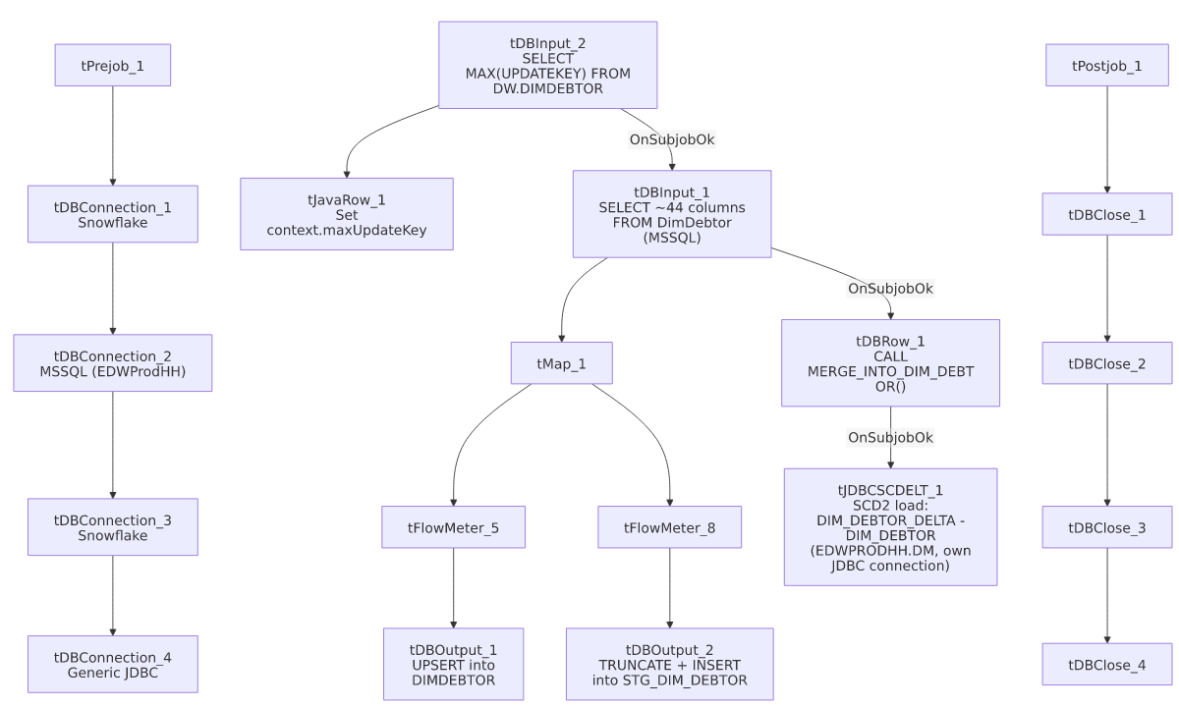

Settings tables

Source: `tDBInput_1` (`tMSSqlInput`)
Setting | Value | What it means
Connection | Shared tDBConnection_2 | MSSQL "EDWProdHH" connection.
Table | DimDebtor | Source debtor table.
Query | SELECT [DebtorNumber],[LOGON],CAST([DimLogon]...),... (truncated at ~column 9 in this metadata) | Full column list and any WHERE clause are not visible — see Issues observed.

Target A: `tDBOutput_1` (`tSnowflakeOutput`)
Setting | Value | What it means
Table | DIMDEBTOR | Full dimension table.
Output action | UPSERT | Updates existing rows / inserts new ones by key — safer against duplication than a plain INSERT even if the incremental filter isn't applied upstream.
Table action | NONE | Table structure untouched.

Target B: `tDBOutput_2` (`tSnowflakeOutput`)
Setting | Value | What it means
Table | STG_DIM_DEBTOR | Narrower staging table (11 business columns + reject columns).
Output action / Table action | INSERT / TRUNCATE | Classic truncate-and-reload staging pattern feeding the merge/SCD steps below.

Merge + SCD: `tDBRow_1` / `tJDBCSCDELT_1`
Setting | Value | What it means
Query (tDBRow_1) | CALL MERGE_INTO_DIM_DEBTOR(); | Merges staged rows into a Snowflake target (not shown in this metadata) before the SCD step runs.
tJDBCSCDELT_1 connection URL | "jdbc:snowflake://xca26579.us-east-1.snowflakecomputing.com?db=EDWPRODHH&schema=DM" | A hardcoded Snowflake account/host and database/schema, distinct from the job's other (context-driven) Snowflake connections — see Issues observed.
tJDBCSCDELT_1 user | "TALEND" (hardcoded, not a context variable) | Password is ***REDACTED***.
Source / target table | DIM_DEBTOR_DELTA → DIM_DEBTOR | Reads a delta/change table and writes the SCD2 dimension.
Surrogate key | DEBTOR_KEY, generated via DB_SEQUENCE SEQ_DEBTOR | New surrogate key per SCD version.
SCD tracking columns | EFF_DT (job start time), EXP_DT (fixed 2199-12-31 for open records), IS_CURRENT, VERSION | Standard Type-2 history columns.

Dependencies & configuration
- Triggers/depends on other jobs: none — no tRunJob links found.
- Context variables used: EDWProdHH_Database, EDWProdHH_Login, EDWProdHH_Port, EDWProdHH_Schema, EDWProdHH_Server, maxUpdateKey (computed internally).
- No hardcoded developer-workstation paths found in this job's file-based components (it has none) — but see Issues observed regarding the hardcoded JDBC connection details in tJDBCSCDELT_1/tDBConnection_4.

Glossary
Component type | Plain-English meaning
tMSSqlInput / tMSSqlConnection / tMSSqlClose | Query a Microsoft SQL Server source / open and close that connection.
tSnowflakeInput / tSnowflakeOutput / tSnowflakeConnection / tSnowflakeClose / tSnowflakeRow | Query, write to, connect to, close, or run arbitrary SQL against Snowflake.
tMap | Maps/transforms columns from one schema to another.
tFlowMeter | Counts rows passing a point in the flow for logging/monitoring.
tJavaRow | Runs custom Java code once per input row — here used to unpack a single query result into a context variable.
JDBCConnection / JDBCClose | A generic (non-Snowflake-labeled) JDBC connection/close pair — here pointed at the same Snowflake account via a raw JDBC URL, used only by the SCD component.
tJDBCSCDELT | Talend's Slowly Changing Dimension (Type 2 "ELT" variant) component: builds a versioned dimension table with effective/expiration dates and a current-row flag from a delta/change source.

Issues observed
- The incremental-load logic may not actually be applied. The job computes context.maxUpdateKey from Snowflake before reading the MSSQL source (the same pattern used in i3_CallDetail_40_Load), but the tDBInput_1.QUERY text captured in this metadata is truncated after the ninth column and does not show a WHERE clause referencing context.maxUpdateKey. Unable to determine from this metadata whether the query is actually filtered — however, unlike a pure INSERT-only job, tDBOutput_1's UPSERT action would at least avoid duplicating rows in DIMDEBTOR even on a full re-read; STG_DIM_DEBTOR is truncated every run regardless, so it's unaffected either way. Verify the actual WHERE clause directly in Talend Studio.
- `tJDBCSCDELT_1` connects to Snowflake through a separate, hardcoded JDBC URL (jdbc:snowflake://xca26579.us-east-1.snowflakecomputing.com?db=EDWPRODHH&schema=DM) with a hardcoded username ("TALEND"), rather than reusing the job's context-driven tDBConnection_1/tDBConnection_3 Snowflake connections or a context.* variable. If the Snowflake account, host, or database name ever changes, this component would need to be updated by hand and could easily be missed since it doesn't follow the rest of the job's connection pattern.
- Two separate Snowflake connections are opened in this job (tDBConnection_1/tDBConnection_3) in addition to the JDBC one used by the SCD step — unable to determine from metadata why a single shared connection wasn't reused for all three; this triples the number of Snowflake sessions/logins per run compared to a single-connection design.

