Talend Job: DimDebtor_NewFields_Load

Overview
Pulls a small set of sensitive personal fields (name, address, city, phone, date of birth, SSN) for debtors with any non-null contact/PII data from the "EDWProdHH" MSSQL DIMDEBTOR table, encrypts the row with AES before it ever reaches Snowflake, and appends it to a dedicated DIMDEBTOR_NEWFIELDS table. This is a narrower, PII-focused companion to DimDebtor_Load rather than a full dimension refresh.

Detail table
Field | Value
Job name | DimDebtor_NewFields_Load
Version | 0.1
Project | EDW2SF
Author | jmach@harriscollect.com
Created | 2022-04-29T14:39:47.160-0700
Last Modified | 2025-09-24T11:07:33.476-0700

Step-by-step data flow
Setup subjob: tPrejob_1 → tDBConnection_1 (Snowflake) → tDBConnection_2 (MSSQL, "EDWProdHH" context variables) → tDBConnection_3 (a second Snowflake connection, opened but not shown as feeding any component directly in this metadata).
Main subjob:
- tDBInput_1 runs a SELECT against MSSQL DIMDEBTOR: DEBTOR_IDX, NAME1, NAME2, ADD1, ADD2, CITY, PHONE, TRY_CAST(DOB AS DATE) AS DOB, SSN, filtered WHERE (NAME1 IS NOT NULL OR NAME2 IS NOT NULL OR ADD1 IS NOT NULL OR ADD2 IS NOT NULL OR CITY IS NOT NULL OR PHONE IS NOT NUL... (condition list truncated in this metadata, but clearly a "any PII field populated" filter).
- tDataEncrypt_1 encrypts the row using AES (secret type, key, and password all ***REDACTED***), writing a crypto-controller file reference to "/home/talenduser/dimdbtr.crypt" (a Linux path, notably different from this project's usual Windows workstation paths — see Issues observed).
- tDBOutput_1 inserts the encrypted rows into Snowflake DIMDEBTOR_NEWFIELDS (INSERT, tableAction=NONE — no truncate, so this table accumulates across runs).
Teardown subjob: tPostjob_1 → tDBClose_1 (Snowflake) → tDBClose_2 (MSSQL) → tDBClose_3 (second Snowflake).
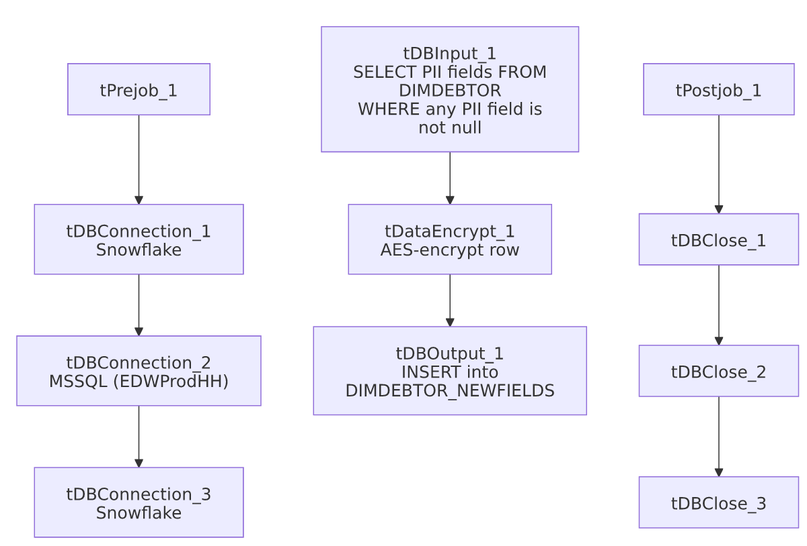

Settings tables

Source: `tDBInput_1` (`tMSSqlInput`)
Setting | Value | What it means
Query | SELECT DEBTOR_IDX, NAME1, NAME2, ADD1, ADD2, CITY, PHONE, TRY_CAST(DOB AS DATE) AS DOB, SSN FROM DIMDEBTOR WHERE (...) | Pulls only the PII fields, filtered to rows where at least one contact/identity field is populated (full condition truncated in this metadata).

Transform: `tDataEncrypt_1`
Setting | Value | What it means
CRYPTO_METHOD | AES | Symmetric encryption applied to the row before it's written anywhere.
SECRET_TYPE / SECRET_KEY / PASSWORD_M1 | ***REDACTED*** | Preserved as redacted — never guess the real values.
CRYPTO_FILE_PATH | "/home/talenduser/dimdbtr.crypt" | A Linux-style path for a crypto controller file — see Issues observed.

Target: `tDBOutput_1` (`tSnowflakeOutput`)
Setting | Value | What it means
Table | DIMDEBTOR_NEWFIELDS | Destination for the encrypted PII rows.
Output action | INSERT | Appends rows.
Table action | NONE | No truncate before load — this table is not cleared each run, so it accumulates rather than reflecting a point-in-time snapshot; see Issues observed.

Dependencies & configuration
- Triggers/depends on other jobs: none — no tRunJob links found.
- Context variables used: EDWProdHH_Database, EDWProdHH_Login, EDWProdHH_Port, EDWProdHH_Schema, EDWProdHH_Server.
- No hardcoded developer-workstation paths were flagged by the extraction for this job (the one absolute path present, tDataEncrypt_1.CRYPTO_FILE_PATH, is a Linux runtime path rather than the usual C:/Talend-Studio-... pattern — see Issues observed).

Glossary
Component type | Plain-English meaning
tMSSqlInput / tMSSqlConnection / tMSSqlClose | Query a Microsoft SQL Server source / open and close that connection.
tDataEncrypt | Encrypts one or more columns (or the whole row) using a configured algorithm and key before it continues downstream.
tSnowflakeOutput / tSnowflakeConnection / tSnowflakeClose | Write rows to Snowflake / open and close the Snowflake connection.

Issues observed
- `DIMDEBTOR_NEWFIELDS` has no `TRUNCATE` before load (`tableAction=NONE`, `outputAction=INSERT`). Unlike the truncate-and-reload pattern used throughout most of this project's dimension loads, this table accumulates every run's output. Since the source query has no incremental filter (no context.max* variable referenced), re-running this job would append the same PII rows again, producing duplicates unless something downstream deduplicates — unable to determine from metadata whether that's intended or whether DIMDEBTOR_NEWFIELDS is meant to be a full-refresh table that's truncated by a process not captured here.
- The crypto file path (`/home/talenduser/dimdbtr.crypt`) is a Linux path, unlike the C:/Talend-Studio-20211109_1610-V8.0.1/... Windows workstation paths hardcoded throughout most of this project (see 05_operational_runbook.md). This suggests this job (or at least this component's configuration) may run on a different, Linux-based execution host than most of the project — worth confirming with the team which runtime actually executes this job, since a mismatched path here would cause a runtime file-not-found error specific to this component.
- A third connection (`tDBConnection_3`, Snowflake) is opened in the setup subjob but doesn't appear to feed any component in this job's wiring — it may be vestigial from a copy-paste of another job's template, or its usage may not have been captured in this extraction. Unable to determine from metadata.
- A PII-handling job with no visible error/reject handling: tDBInput_1's truncated WHERE clause and the encrypted output make it hard to audit from metadata alone whether all intended debtor PII rows are captured; per this project's data-handling expectations, confirm this job's row counts/coverage are validated elsewhere.

