Talend Job: DimDepartment_and_GL_Load

Overview
Loads two small reference/lookup dimensions in parallel from the "EDWProdHH" MSSQL database into Snowflake: the collections department table (DimDepartment) and the general-ledger code table (DimGLCODE). Both are simple truncate-and-reload jobs with no merge or incremental logic — every run replaces the full contents of both Snowflake tables.

Detail table
Field | Value
Job name | DimDepartment_and_GL_Load
Version | 0.1
Project | EDW2SF
Author | jmach@harriscollect.com
Created | 2022-01-04T11:06:39.580-0800
Last Modified | 2025-09-24T10:59:31.961-0700

Step-by-step data flow
Setup subjob: tPrejob_1 → tDBConnection_1 (Snowflake) → tDBConnection_2 (MSSQL, "EDWProdHH" context variables).
Main subjob — tParallelize_1 runs two independent branches at the same time:
- Department branch: tDBInput_1 runs SELECT CAST(DimDepartment AS NUMERIC(38,0)) AS DimDepartment, DepartmentName, Description, Logon, CAST(DimGLCode AS NUMERIC(38,0)) AS DimGLCode FROM dbo.DimDepartment → tMap_1 passes the row through → tFlowMeter_5 counts rows → tDBOutput_1 truncates and inserts into Snowflake DIMDEPARTMENT.
- GL branch: tDBInput_2 runs SELECT CAST(DimGLCode AS numeric(38,0)) AS DimGLCode, Description FROM dbo.DimGLCODE → tMap_2 passes the row through → tFlowMeter_8 counts rows → tDBOutput_2 truncates and inserts into Snowflake DIMGLCODE.
Teardown subjob: tPostjob_1 → tDBClose_1 (Snowflake) → tDBClose_2 (MSSQL).
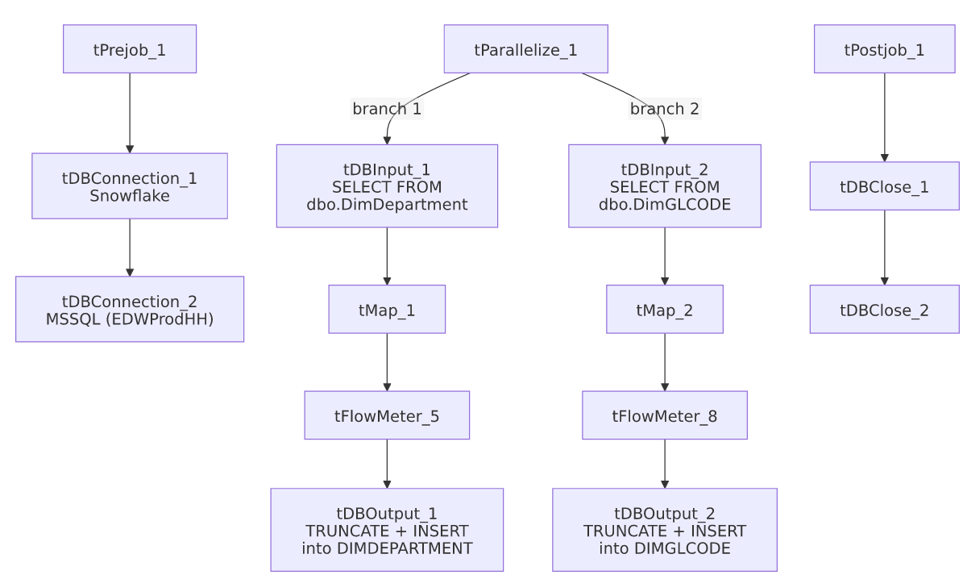

Settings tables

Branch 1: `tDBInput_1` / `tDBOutput_1`
Setting | Value | What it means
Query | SELECT CAST(DimDepartment AS NUMERIC(38,0)) AS DimDepartment, DepartmentName, Description, Logon, CAST(DimGLCode AS NUMERIC(38,0)) AS DimGLCode FROM dbo.DimDepartment | Small reference table — department key, name, description, logon, and its linked GL code.
Target table | DIMDEPARTMENT
Output action / Table action | INSERT / TRUNCATE | Full replace every run.

Branch 2: `tDBInput_2` / `tDBOutput_2`
Setting | Value | What it means
Query | SELECT CAST(DimGLCode AS numeric(38,0)) AS DimGLCode, Description FROM dbo.DimGLCODE | GL code lookup: code and description only.
Target table | DIMGLCODE
Output action / Table action | INSERT / TRUNCATE | Full replace every run.

Dependencies & configuration
- Triggers/depends on other jobs: none — no tRunJob links found.
- Context variables used: EDWProdHH_Database, EDWProdHH_Login, EDWProdHH_Port, EDWProdHH_Schema, EDWProdHH_Server.
- No hardcoded developer-workstation paths found in this job.

Glossary
Component type | Plain-English meaning
tMSSqlInput / tMSSqlConnection / tMSSqlClose | Query a Microsoft SQL Server source / open and close that connection.
tMap | Maps/transforms columns from one schema to another (here, effectively pass-through).
tFlowMeter | Counts rows passing a point in the flow for logging/monitoring.
tSnowflakeOutput / tSnowflakeConnection / tSnowflakeClose | Write rows to Snowflake / open and close the Snowflake connection.
tParallelize | Runs its downstream branches at the same time rather than one after another.

Issues observed
- `tDBOutput_1`'s target schema names the `LOGON` column `DIMLOGON` in its own schema_columns list (distinct from tMap_1's output, which names it LOGON), while a separate LOGON column also exists in the same schema. This looks like a leftover/duplicate column definition from a prior schema revision rather than two genuinely different fields — unable to determine from metadata which one Talend actually populates at runtime; verify the live mapping in Talend Studio if department-logon data looks inconsistent in Snowflake.
- No other findings beyond the project-wide patterns already documented in 05_operational_runbook.md (e.g. no incremental load, no merge step, no error handling beyond default Talend behavior) — this is a simple, low-risk reference-data refresh job.

