Talend Job: DimDeskInfo_Load

Overview
A thin orchestrator that runs the shared CUBS_Raw_File_Load job to land a desk-information extract file, then merges the staged data into the DIMDESKINFO dimension via a Snowflake stored procedure. It does not read or write any business data directly itself — everything data-related happens inside the called CUBS_Raw_File_Load job and the merge procedure.

Detail table
Field | Value
Job name | DimDeskInfo_Load
Version | 0.1
Project | EDW2SF
Author | jmach@harriscollect.com
Created | 2022-06-17T08:56:17.920-0700
Last Modified | 2022-06-17T08:58:55.025-0700

Step-by-step data flow
Setup subjob: tPrejob_1 → tDBConnection_1 (Snowflake).
Main subjob:
- tRunJob_1 runs `CUBS_Raw_File_Load` (USE_INDEPENDENT_PROCESS=false — runs inside this job's own JVM rather than as a separate process; DIE_ON_CHILD_ERROR=true, TRANSMIT_ORIGINAL_CONTEXT=true).
- On that sub-job's success, tDBRow_1 runs CALL STAGING.MERGE_INTO_DIMDESKINFO(); against Snowflake (TSTATCATCHER_STATS=true).
- tJavaRow_1 captures the procedure's RETVALUE into context.rowCount.
- The flow branches on two ordered RUN_IF conditions off tJavaRow_1 (the branch conditions themselves aren't captured in this metadata, but the component wiring makes the intent clear):
- Failure branch: tDie_1 fails the job with message context.rowCount + ": an error occurred during MERGE" and exit code = context.rowCount.
- Success/logging branch: tWarn_1 logs context.rowCount + " rows added to FACT_ELECTRONIC_MEDIA" (severity 42) — note this message names the wrong table, see Issues observed.
Teardown subjob: tPostjob_1 → tDBClose_1 (Snowflake).
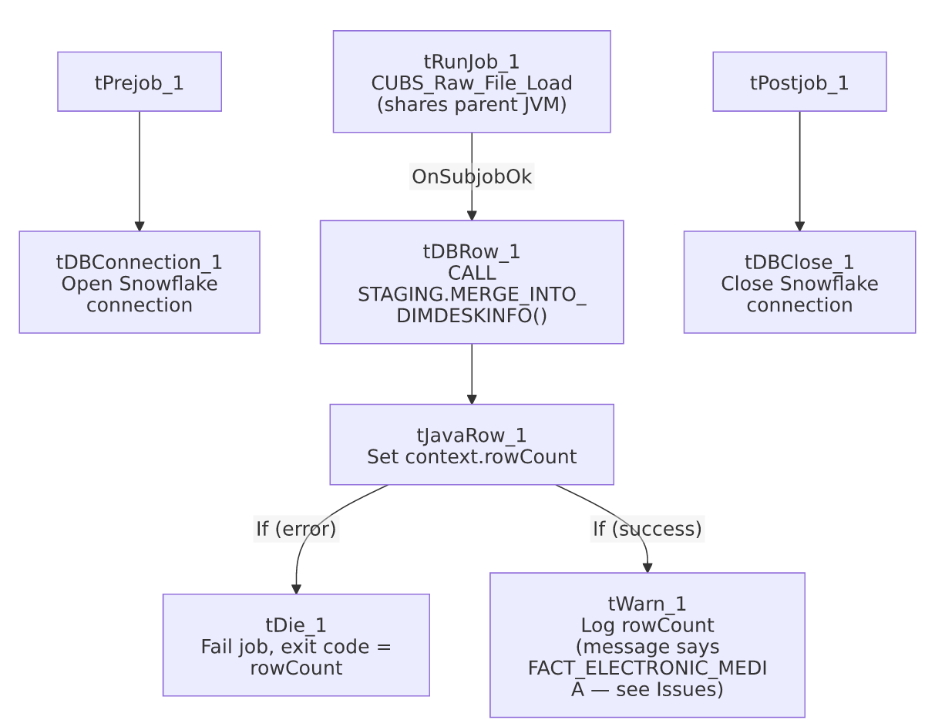

Settings tables

Orchestration: `tRunJob_1`
Setting | Value | What it means
PROCESS | CUBS_Raw_File_Load | Delegates the actual file landing/parsing to this shared job.
USE_INDEPENDENT_PROCESS | false | Runs inside DimDeskInfo_Load's own JVM rather than as a separate process — same non-default pattern seen on CO_Master_Load's call to DimFiscal_CO_Load.
DIE_ON_CHILD_ERROR | true | If CUBS_Raw_File_Load fails, this job fails too.

Merge + result handling: `tDBRow_1` / `tJavaRow_1` / `tDie_1` / `tWarn_1`
Setting | Value | What it means
Query | CALL STAGING.MERGE_INTO_DIMDESKINFO(); | Merges the file data staged by CUBS_Raw_File_Load into the DIMDESKINFO dimension.
tDie_1 message | context.rowCount + ": an error occurred during MERGE" | Fails the job loudly with the procedure's return code as the exit code.
tWarn_1 message | context.rowCount + " rows added to FACT_ELECTRONIC_MEDIA" | Mislabeled — this job merges into DIMDESKINFO, not FACT_ELECTRONIC_MEDIA. See Issues observed.

Dependencies & configuration
- Triggers/depends on other jobs: calls CUBS_Raw_File_Load via tRunJob_1 (see 06_dependency_matrix.md — this same shared job is also called by DimEmployeeInfo_Load, Fact_Electronic_Media_Load, and PaymentPlan_Load).
- Context variables used: rowCount (set internally from the merge procedure's return value).
- No hardcoded developer-workstation paths found in this job's own components (though CUBS_Raw_File_Load itself may have some — not covered by this job's own metadata).

Glossary
Component type | Plain-English meaning
tRunJob | Runs another Talend job as a sub-process (or, if configured not to use an independent process, inline in the same JVM).
tSnowflakeRow | Runs an arbitrary SQL statement or stored-procedure call against Snowflake.
tJavaRow | Runs custom Java code once per input row — here used to unpack a stored procedure's return value.
tDie / tWarn | tDie ends the job with a specific failure message and exit code; tWarn logs a warning without stopping the job.

Issues observed
- `tWarn_1`'s success message says `"... rows added to FACT_ELECTRONIC_MEDIA"`, but this job merges into `DIMDESKINFO`. This is a copy-paste artifact — DimEmployeeInfo_Load (also in this batch) has the *identical* tWarn_1 message text, and Fact_Electronic_Media_Load (referenced in 05_operational_runbook.md as a job with explicit tDie/tWarn logic) is presumably where this message text actually originated. It's a cosmetic/log-message bug only — the real merge call (CALL STAGING.MERGE_INTO_DIMDESKINFO();) is correctly targeted — but it would mislead anyone reading this job's run log about which table was actually updated.
- `CUBS_Raw_File_Load` runs with `USE_INDEPENDENT_PROCESS=false`, sharing this job's JVM rather than running as a separate process. Same non-default pattern flagged as worth confirming in CO_Master_Load's call to DimFiscal_CO_Load — unable to determine intent from metadata.
- This job's own metadata contains no file paths, table names, or business logic beyond the merge call — the actual source file location, format, and target staging table are entirely defined inside CUBS_Raw_File_Load, which is outside the scope of this job's own JSON. Anyone debugging a DimDeskInfo_Load data issue will need to look at CUBS_Raw_File_Load's own documentation.

