Talend Job: DimEmployeeInfo_Load

Overview
A thin orchestrator, structurally identical to DimDeskInfo_Load, that runs the shared CUBS_Raw_File_Load job to land an employee-information extract file, then merges the staged data into the DIMEMPLOYEEINFO dimension via a Snowflake stored procedure. It does not read or write any business data directly itself.

Detail table
Field | Value
Job name | DimEmployeeInfo_Load
Version | 0.1
Project | EDW2SF
Author | jmach@harriscollect.com
Created | 2022-05-24T17:34:49.967-0700
Last Modified | 2022-05-24T17:37:27.563-0700

Step-by-step data flow
Setup subjob: tPrejob_1 → tDBConnection_1 (Snowflake).
Main subjob:
- tRunJob_1 runs `CUBS_Raw_File_Load` (USE_INDEPENDENT_PROCESS=false — runs inside this job's own JVM; DIE_ON_CHILD_ERROR=true, TRANSMIT_ORIGINAL_CONTEXT=true).
- On that sub-job's success, tDBRow_1 runs CALL STAGING.MERGE_INTO_DIMEMPLOYEEINFO(); against Snowflake (TSTATCATCHER_STATS=true).
- tJavaRow_1 captures the procedure's RETVALUE into context.rowCount.
- Branches on two RUN_IF conditions off tJavaRow_1:
- Failure branch: tDie_1 fails the job with message context.rowCount + ": an error occurred during MERGE" and exit code = context.rowCount.
- Success/logging branch: tWarn_1 logs context.rowCount + " rows added to FACT_ELECTRONIC_MEDIA" (severity 42) — again names the wrong table, see Issues observed.
Teardown subjob: tPostjob_1 → tDBClose_1 (Snowflake).
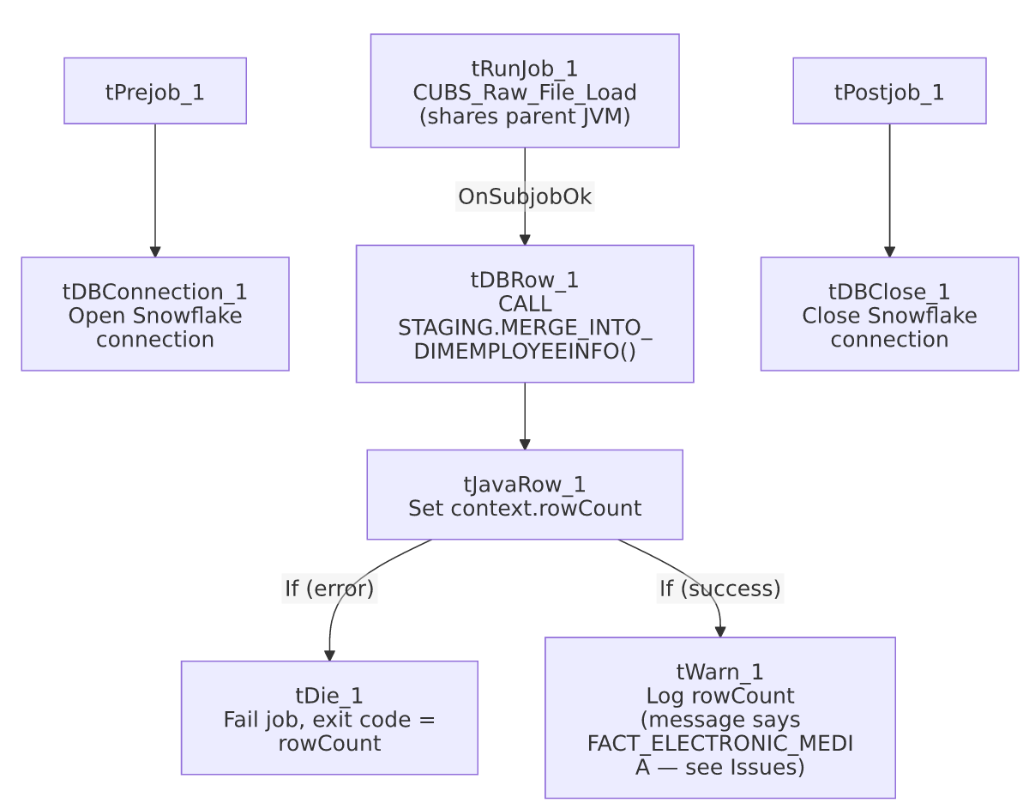

Settings tables

Orchestration: `tRunJob_1`
Setting | Value | What it means
PROCESS | CUBS_Raw_File_Load | Delegates the actual file landing/parsing to this shared job.
USE_INDEPENDENT_PROCESS | false | Runs inside DimEmployeeInfo_Load's own JVM rather than as a separate process.
DIE_ON_CHILD_ERROR | true | If CUBS_Raw_File_Load fails, this job fails too.

Merge + result handling: `tDBRow_1` / `tJavaRow_1` / `tDie_1` / `tWarn_1`
Setting | Value | What it means
Query | CALL STAGING.MERGE_INTO_DIMEMPLOYEEINFO(); | Merges the file data staged by CUBS_Raw_File_Load into the DIMEMPLOYEEINFO dimension.
tDie_1 message | context.rowCount + ": an error occurred during MERGE" | Fails the job loudly with the procedure's return code as the exit code.
tWarn_1 message | context.rowCount + " rows added to FACT_ELECTRONIC_MEDIA" | Mislabeled — this job merges into DIMEMPLOYEEINFO, not FACT_ELECTRONIC_MEDIA. See Issues observed.

Dependencies & configuration
- Triggers/depends on other jobs: calls CUBS_Raw_File_Load via tRunJob_1 (see 06_dependency_matrix.md — this same shared job is also called by DimDeskInfo_Load, Fact_Electronic_Media_Load, and PaymentPlan_Load).
- Context variables used: rowCount (set internally from the merge procedure's return value).
- No hardcoded developer-workstation paths found in this job's own components.

Glossary
Component type | Plain-English meaning
tRunJob | Runs another Talend job as a sub-process (or, if configured not to use an independent process, inline in the same JVM).
tSnowflakeRow | Runs an arbitrary SQL statement or stored-procedure call against Snowflake.
tJavaRow | Runs custom Java code once per input row — here used to unpack a stored procedure's return value.
tDie / tWarn | tDie ends the job with a specific failure message and exit code; tWarn logs a warning without stopping the job.

Issues observed
- This job is functionally and structurally identical to `DimDeskInfo_Load` except for the target table names (DIMEMPLOYEEINFO vs. DIMDESKINFO) — same tRunJob target, same component wiring, same RUN_IF branching, and the same copy-paste bug: tWarn_1's success message reads "... rows added to FACT_ELECTRONIC_MEDIA" regardless of which dimension is actually being loaded. Since three sibling jobs (DimDeskInfo_Load, DimEmployeeInfo_Load, and presumably the template they were copied from) all carry this exact same mislabeled string, it strongly suggests all three were built from a single Fact_Electronic_Media_Load-derived template and the log message was never updated per job. It's a cosmetic/log-message bug only — the actual CALL STAGING.MERGE_INTO_DIMEMPLOYEEINFO(); is correctly targeted.
- `CUBS_Raw_File_Load` runs with `USE_INDEPENDENT_PROCESS=false`, sharing this job's JVM rather than running as a separate process — same non-default pattern as its DimDeskInfo_Load sibling; unable to determine intent from metadata.
- As with its sibling, this job's own metadata contains no file paths, table names, or business logic beyond the merge call — the source file location, format, and target staging table are entirely defined inside the shared CUBS_Raw_File_Load job.

