Talend Job: DimFiscal_CHI_Load

Overview
A merge-only orchestrator for the "CHI" site's fiscal/patient-billing dimension: it runs two Snowflake stored-procedure merges (DIMFISCAL_CHI_A and DIMFISCAL_CHI_B) in parallel to fold previously-staged CHI fiscal data into its final tables. It is part of a six-job family (DimFiscal_<SITE>_Load for CHI, CO, DC, HH, PRE, TOL) that share an identical template but differ in how many merge sub-tables (_A through _E) each site actually has — CHI is the smallest member of the family, with only two merges where CO/DC/PRE/TOL have three and HH has five (see Issues observed for the full comparison).

Detail table
Field | Value
Job name | DimFiscal_CHI_Load
Version | 0.1
Project | EDW2SF
Author | jmach@harriscollect.com
Created | 2022-07-08T11:25:11.869-0700
Last Modified | 2025-11-04T11:08:07.102-0800

Step-by-step data flow
Setup subjob: tPrejob_1 → tJava_1 opens a per-run log file at context.logDir + jobName + "_" + <timestamp> + ".log" and redirects System.out/System.err to it → on subjob success, tSetKeystore_1 configures SSL trust/keystore (truststore path hardcoded, see Settings) → on subjob success, tDBConnection_1 opens the Snowflake connection.
Main subjob: tParallelize_1 runs two branches at the same time:
- tDBRow_1 runs CALL STAGING.MERGE_INTO_DIMFISCAL_CHI_B();
- tDBRow_2 runs CALL STAGING.MERGE_INTO_DIMFISCAL_CHI_A();
Neither merge component captures a return value or branches on success/failure in this job — both simply run and the job either succeeds or fails on a raw Talend execution error.
Teardown subjob: tPostjob_1 → tDBClose_1 (Snowflake).
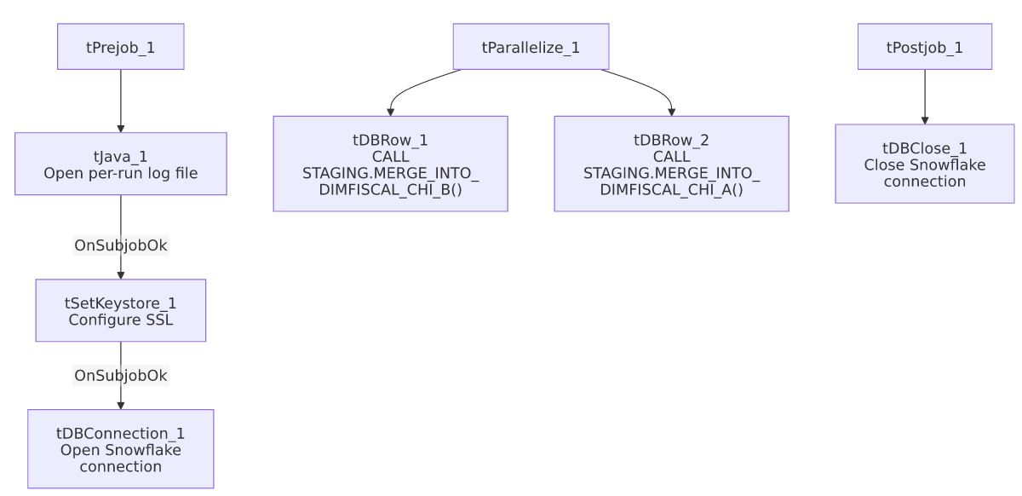

Settings tables

SSL setup: `tSetKeystore_1`
Setting | Value | What it means
SSL_TRUSTSERVER_TRUSTSTORE | "C:/clientTrustStore.trustStore" (hardcoded) | A fixed Windows path to the SSL truststore file — see Issues observed.
SSL_KEYSTORE | context.keystorePath | Keystore path is context-driven, unlike the truststore path above.
SSL_TRUSTSERVER_PASSWORD / SSL_KEYSTORE_PASSWORD | ***REDACTED*** | Preserved as redacted.

Merges: `tDBRow_1` / `tDBRow_2`
Setting | Value | What it means
Query 1 | CALL STAGING.MERGE_INTO_DIMFISCAL_CHI_B(); | Merges the "B" fiscal sub-table for the CHI site.
Query 2 | CALL STAGING.MERGE_INTO_DIMFISCAL_CHI_A(); | Merges the "A" fiscal sub-table for the CHI site.
Result handling | None captured | Unlike some other merge jobs in this project (e.g. DimDeskInfo_Load), neither tDBRow here has a downstream tJavaRow/tWarn/tDie — see Issues observed.

Dependencies & configuration
- Triggers/depends on other jobs: none — no tRunJob links found in this job's own metadata. (Note: CO_Master_Load calls the CO sibling, DimFiscal_CO_Load, via tRunJob — see 06_dependency_matrix.md — but nothing in this project's captured orchestration calls DimFiscal_CHI_Load itself; how/when it's triggered is not visible in this metadata.)
- Context variables used: keystorePath, logDir.
- 1 hardcoded path finding: tSetKeystore_1.SSL_TRUSTSERVER_TRUSTSTORE = "C:/clientTrustStore.trustStore".

Glossary
Component type | Plain-English meaning
tJava | Runs custom Java code once — here, to redirect the job's console output to a per-run log file.
tSetKeystore | Configures the SSL trust/keystore used for secure connections made later in the job.
tSnowflakeConnection / tSnowflakeClose / tSnowflakeRow | Open/close a Snowflake connection, or run an arbitrary SQL statement/procedure call against it.
tParallelize | Runs its downstream branches at the same time rather than one after another.

Issues observed
- No result-code checking on either merge call. Unlike CO_Master_Load's FACTTRANS merge (which captures RETVALUE and logs a tWarn) or DimDeskInfo_Load's merge (which branches to tDie/tWarn), this job's two tDBRow merges have no downstream tJavaRow, tWarn, or tDie. A merge procedure that returns an error code without throwing a SQL exception would go completely unnoticed — the job would report success regardless. Verify whether MERGE_INTO_DIMFISCAL_CHI_A/B() are expected to throw on failure rather than return a status code.
- Family comparison — DimFiscal_CHI_Load has only 2 merge sub-tables (A, B), the fewest of the six DimFiscal_<SITE>_Load siblings in this batch: CO/DC/TOL each have 3 (A, B, C), PRE has 3 configured but one (_C) is disabled (ACTIVATE=false — see job_DimFiscal_PRE_Load.md), and HH has 5 (A–E). Unable to determine from metadata whether CHI genuinely has fewer fiscal sub-categories than the other sites or whether a _C merge was never built out for this site — worth confirming with the team if CHI fiscal reporting seems incomplete relative to other sites.
- The SSL truststore path is hardcoded (C:/clientTrustStore.trustStore) while the keystore path uses context.keystorePath — an inconsistency in how the same job handles two very similar SSL settings. This hardcoded path is repeated identically across all six DimFiscal_<SITE>_Load siblings, so a truststore relocation would require updating all six jobs individually.

