Talend Job: DimFiscal_CO_Load

Overview
A merge-only orchestrator for the "CO" site's fiscal/patient-billing dimension: it runs three Snowflake stored-procedure merges (DIMFISCAL_CO_A, _B, _C) in parallel to fold previously-staged CO fiscal data into its final tables. This is the member of the DimFiscal_<SITE>_Load family that is directly called by CO_Master_Load (see Dependencies below), making it the only sibling with a confirmed, documented trigger.

Detail table
Field | Value
Job name | DimFiscal_CO_Load
Version | 0.1
Project | EDW2SF
Author | jmach@harriscollect.com
Created | 2022-07-10T19:28:58.415-0700
Last Modified | 2025-11-04T11:08:10.583-0800

Step-by-step data flow
Setup subjob: tPrejob_1 → tJava_1 opens a per-run log file → on subjob success, tSetKeystore_1 configures SSL trust/keystore → on subjob success, tDBConnection_1 opens the Snowflake connection.
Main subjob: tParallelize_1 runs three branches at the same time:
- tDBRow_1 runs CALL STAGING.MERGE_INTO_DIMFISCAL_CO_B();
- tDBRow_2 runs CALL STAGING.MERGE_INTO_DIMFISCAL_CO_A();
- tDBRow_3 runs CALL STAGING.MERGE_INTO_DIMFISCAL_CO_C();
No result-code checking is wired on any of the three merges.
Teardown subjob: tPostjob_1 → tDBClose_1 (Snowflake).
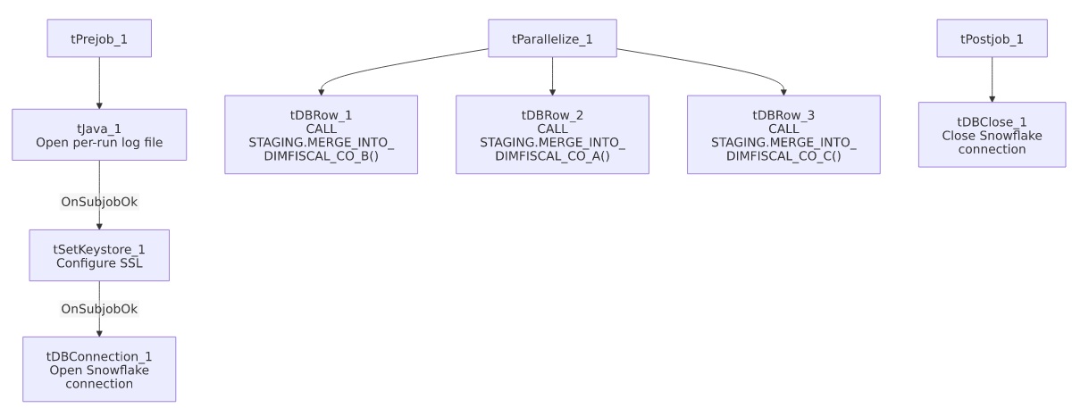

Settings tables

SSL setup: `tSetKeystore_1`
Setting | Value | What it means
SSL_TRUSTSERVER_TRUSTSTORE | "C:/clientTrustStore.trustStore" (hardcoded) | Same hardcoded truststore path used across all six DimFiscal_<SITE>_Load siblings.
SSL_KEYSTORE | context.keystorePath | Context-driven.

Merges: `tDBRow_1` / `tDBRow_2` / `tDBRow_3`
Setting | Value | What it means
Query 1 | CALL STAGING.MERGE_INTO_DIMFISCAL_CO_B(); | Merges the "B" fiscal sub-table for CO.
Query 2 | CALL STAGING.MERGE_INTO_DIMFISCAL_CO_A(); | Merges the "A" fiscal sub-table for CO.
Query 3 | CALL STAGING.MERGE_INTO_DIMFISCAL_CO_C(); | Merges the "C" fiscal sub-table for CO.
Result handling | None captured | No tJavaRow/tWarn/tDie downstream of any of the three — see Issues observed.

Dependencies & configuration
- Triggers/depends on other jobs: none itself, but this job is called by `CO_Master_Load` via tRunJob_5, as the fourth step in that orchestrator's client/debtor/reference-data chain (CUBS_Raw_CO_Client_Load → CUBS_Raw_CO_Debtor_Load → CUBS_Raw_CO_ETL_Load → `DimFiscal_CO_Load` → CUBS_Raw_DeskInfo_Load). Per job_CO_Master_Load.md, that tRunJob call is configured with USE_INDEPENDENT_PROCESS=false — the only one of CO_Master_Load's 10 sub-job calls set that way, meaning this job runs inside CO_Master_Load's own JVM rather than as a separate process.
- Context variables used: keystorePath, logDir.
- 1 hardcoded path finding: tSetKeystore_1.SSL_TRUSTSERVER_TRUSTSTORE = "C:/clientTrustStore.trustStore".

Glossary
Component type | Plain-English meaning
tJava | Runs custom Java code once — here, to redirect console output to a per-run log file.
tSetKeystore | Configures the SSL trust/keystore used for secure connections made later in the job.
tSnowflakeConnection / tSnowflakeClose / tSnowflakeRow | Open/close a Snowflake connection, or run an arbitrary SQL statement/procedure call against it.
tParallelize | Runs its downstream branches at the same time rather than one after another.

Issues observed
- No result-code checking on any of the three merge calls — same gap as its DimFiscal_CHI_Load sibling. A merge procedure returning a non-zero status without raising a SQL exception would go unnoticed.
- This job runs in-process (`USE_INDEPENDENT_PROCESS=false`) when called from `CO_Master_Load`, unlike the other 9 jobs that orchestrator calls. As flagged in job_CO_Master_Load.md, this may be intentional or an oversight — if this job's three parallel merges are resource-intensive, running them inside the parent orchestrator's JVM could affect CO_Master_Load's own memory footprint or error isolation.
- Family comparison — DimFiscal_CO_Load has 3 merge sub-tables (A, B, C), matching DC and TOL exactly, while CHI has only 2 and HH has 5; PRE nominally has 3 but one is disabled (see job_DimFiscal_PRE_Load.md). CO is the only sibling with a confirmed caller in this project's orchestration metadata.
- Same hardcoded truststore path issue documented across the whole DimFiscal_<SITE>_Load family (see 05_operational_runbook.md's hardcoded-path note) applies here.

