Talend Job: DimFiscal_DC_Load

Overview
A merge-only orchestrator for the "DC" site's fiscal/patient-billing dimension: it runs three Snowflake stored-procedure merges (DIMFISCAL_DC_A, _B, _C) in parallel to fold previously-staged DC fiscal data into its final tables. Functionally identical to DimFiscal_CO_Load and DimFiscal_TOL_Load (same three merge sub-tables), differing only in the site-specific procedure names and a cosmetic difference in wiring order (see Issues observed).

Detail table
Field | Value
Job name | DimFiscal_DC_Load
Version | 0.1
Project | EDW2SF
Author | jmach@harriscollect.com
Created | 2022-08-02T09:27:21.839-0700
Last Modified | 2025-11-04T11:08:09.761-0800

Step-by-step data flow
Setup subjob: tPrejob_1 → tJava_1 opens a per-run log file → on subjob success, tSetKeystore_1 configures SSL trust/keystore → on subjob success, tDBConnection_1 opens the Snowflake connection.
Main subjob: tParallelize_1 runs three branches at the same time (in this job, wired as tDBRow_2 first, then tDBRow_1, then tDBRow_3 — order has no practical effect since all three run in parallel regardless):
- tDBRow_2 runs CALL STAGING.MERGE_INTO_DIMFISCAL_DC_A();
- tDBRow_1 runs CALL STAGING.MERGE_INTO_DIMFISCAL_DC_B();
- tDBRow_3 runs CALL STAGING.MERGE_INTO_DIMFISCAL_DC_C();
No result-code checking is wired on any of the three merges.
Teardown subjob: tPostjob_1 → tDBClose_1 (Snowflake).
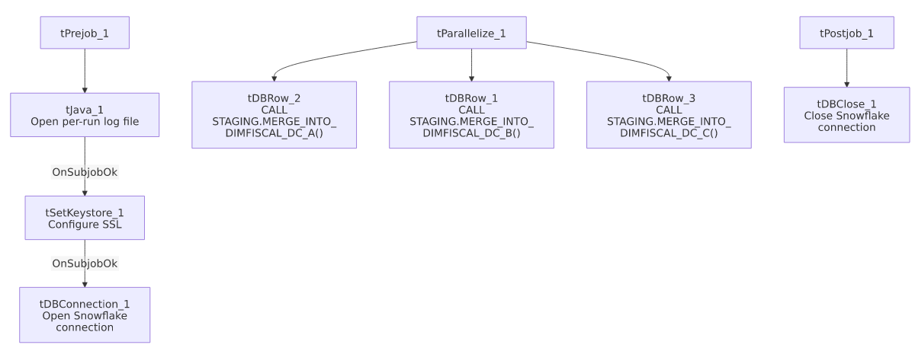

Settings tables

SSL setup: `tSetKeystore_1`
Setting | Value | What it means
SSL_TRUSTSERVER_TRUSTSTORE | "C:/clientTrustStore.trustStore" (hardcoded) | Same hardcoded truststore path used across all six DimFiscal_<SITE>_Load siblings.
SSL_KEYSTORE | context.keystorePath | Context-driven.

Merges: `tDBRow_1` / `tDBRow_2` / `tDBRow_3`
Setting | Value | What it means
Query (tDBRow_1) | CALL STAGING.MERGE_INTO_DIMFISCAL_DC_B(); | Merges the "B" fiscal sub-table for DC.
Query (tDBRow_2) | CALL STAGING.MERGE_INTO_DIMFISCAL_DC_A(); | Merges the "A" fiscal sub-table for DC.
Query (tDBRow_3) | CALL STAGING.MERGE_INTO_DIMFISCAL_DC_C(); | Merges the "C" fiscal sub-table for DC.
Result handling | None captured | No tJavaRow/tWarn/tDie downstream of any of the three.

Dependencies & configuration
- Triggers/depends on other jobs: none — no tRunJob links found, and no orchestrator in this project's captured metadata calls DimFiscal_DC_Load (only the CO sibling has a confirmed caller — see 06_dependency_matrix.md). How/when the DC pipeline (including this job) is triggered is not visible in this metadata.
- Context variables used: keystorePath, logDir.
- 1 hardcoded path finding: tSetKeystore_1.SSL_TRUSTSERVER_TRUSTSTORE = "C:/clientTrustStore.trustStore".

Glossary
Component type | Plain-English meaning
tJava | Runs custom Java code once — here, to redirect console output to a per-run log file.
tSetKeystore | Configures the SSL trust/keystore used for secure connections made later in the job.
tSnowflakeConnection / tSnowflakeClose / tSnowflakeRow | Open/close a Snowflake connection, or run an arbitrary SQL statement/procedure call against it.
tParallelize | Runs its downstream branches at the same time rather than one after another.

Issues observed
- No result-code checking on any of the three merge calls — same gap as the CHI/CO siblings.
- Family comparison — DimFiscal_DC_Load has 3 merge sub-tables (A, B, C), matching CO and TOL exactly; CHI has only 2, HH has 5, and PRE nominally has 3 but one is disabled. Unlike DimFiscal_CO_Load (called by CO_Master_Load), this job has no confirmed caller in the project's captured tRunJob orchestration — consistent with 05_operational_runbook.md's note that only the CO site has a documented _Master_Load orchestrator; if DC has an equivalent pipeline trigger, it's not visible in this metadata.
- Component wiring order in the PARALLELIZE connections is `A, B, C` (by tDBRow_2, tDBRow_1, tDBRow_3 unique names) rather than the B, A, C numbering seen in the CO/CHI siblings — purely a cosmetic difference in how the components were numbered/wired during development, with no functional effect since tParallelize runs all branches concurrently regardless of listed order.
- Same hardcoded truststore path issue documented across the whole DimFiscal_<SITE>_Load family applies here.

