Talend Job: DimFiscal_HH_B_TrueUp

Overview
Unlike every other job in the DimFiscal_* family (which are merge-only orchestrators calling STAGING.MERGE_INTO_DIMFISCAL_<SITE>_<LETTER>() stored procedures), this is a standalone data load job: it reads a wide (~100-column) patient/insurance/collections extract for the "HH" site directly from the "EDWProdHH" MSSQL database, encrypts the row with AES, and inserts it into a dedicated DIMFISCAL_HH_B_TRUEUP Snowflake table. The name suggests a one-off or periodic "true-up" (reconciliation) load of the HH "B" fiscal data set, run separately from the regular DimFiscal_HH_Load merge cycle.

Detail table
Field | Value
Job name | DimFiscal_HH_B_TrueUp
Version | 0.1
Project | EDW2SF
Author | jmach@harriscollect.com
Created | 2024-10-01T07:48:11.397-0700
Last Modified | 2025-09-24T11:01:02.206-0700

Step-by-step data flow
No `tPrejob`/`tPostjob`, connection-open/close, or logging setup components are present in this job's metadata — see Issues observed. The job's only visible flow is a single linear chain:
- tDBInput_1 (USE_EXISTING_CONNECTION=false, opens its own MSSQL connection using context.EDWProdHH_* variables) runs a large SELECT against the HH site's patient/billing source, returning ~100 columns: file date, logon (hardcoded literal 'HH'), debtor number, patient demographics (name, DOB, SSN, address, phone), admit/discharge/diagnosis fields, insurance/employer fields (many suffixed _F<number>, suggesting positional form-field origins), collection-history flags (bankruptcy possibility, bad/positive trade counts, 30/60/90-day past-due buckets), and an UpdateKey/PURGE_FLG pair.
- tDataEncrypt_1 encrypts the row using AES (secret type, key, and password all ***REDACTED***), writing a crypto-controller file reference to "C:/Data/dimdbtr.crypt" — a different hardcoded path from the similar tDataEncrypt step in DimDebtor_NewFields_Load (/home/talenduser/dimdbtr.crypt), even though both reference the same filename stem.
- tMap_1 maps the ~100 encrypted-passthrough columns to the target schema, adding three computed flag columns (LETTERABLE, EMAILABLE, TEXTABLE).
- tDBOutput_1 inserts the rows into Snowflake table DIMFISCAL_HH_B_TRUEUP (INSERT, tableAction=NONE — no truncate, so this table accumulates across runs; DIE_ON_ERROR=true on tMap_1, so a mapping failure fails the job outright).
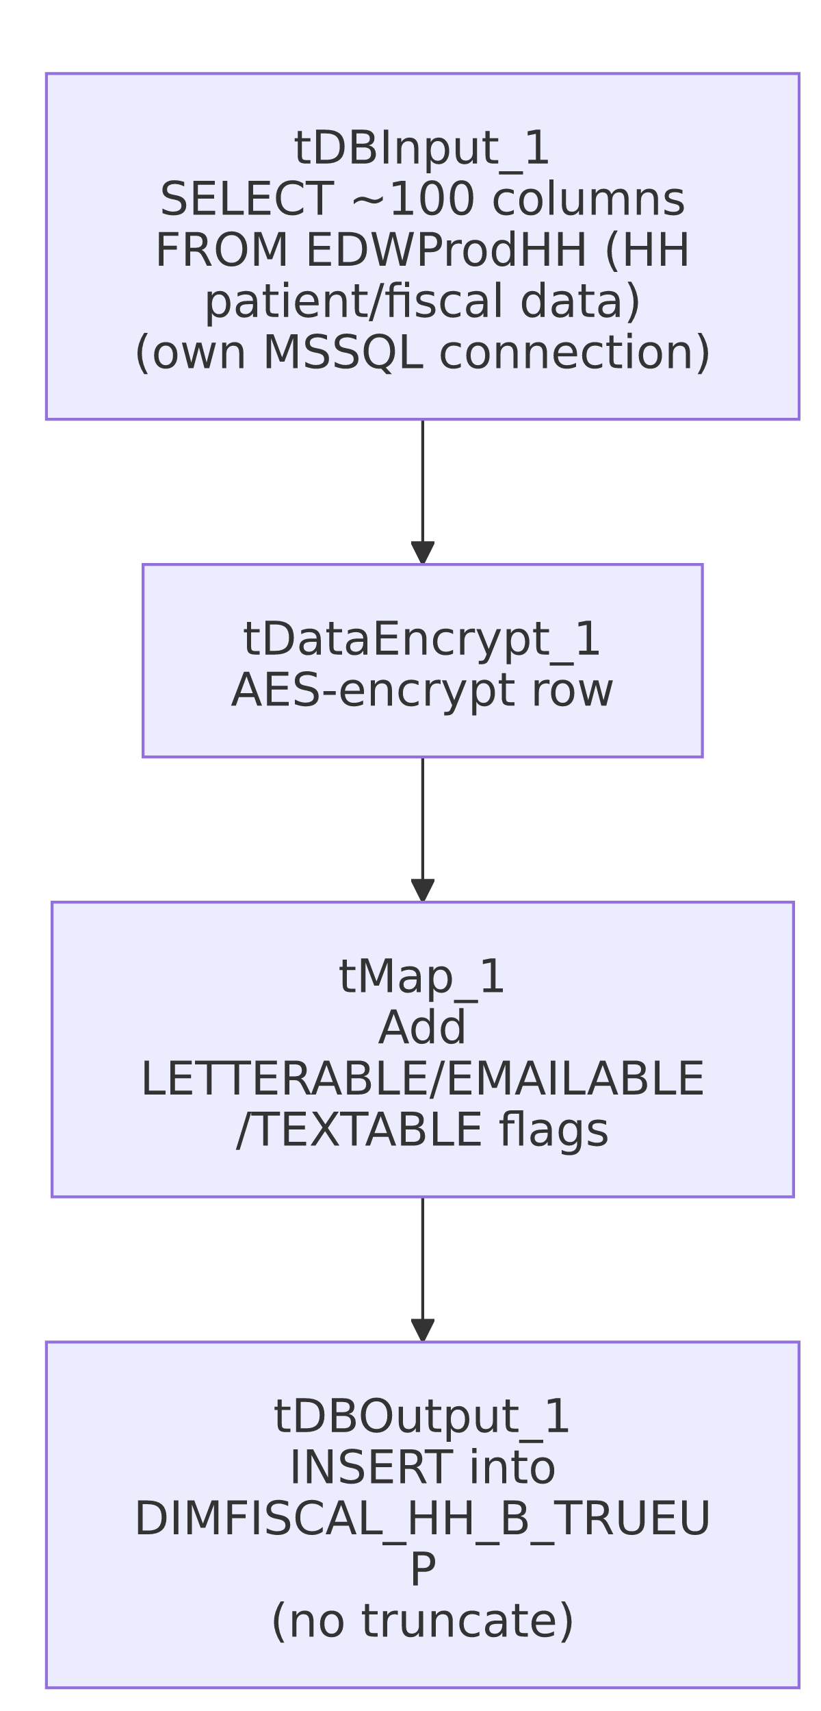

Settings tables

Source: `tDBInput_1` (`tMSSqlInput`)
Setting | Value | What it means
USE_EXISTING_CONNECTION | false | Opens its own dedicated MSSQL connection inline rather than sharing a tDBConnection component — unusual compared to the rest of this project's jobs.
Query (visible portion) | SELECT dd.[Date] AS FILEDATE, 'HH' AS LOGON, DebtorNumber AS DEBTOR_NUMBER, CAST(DimLogon AS NUMERIC(38,0)) AS DimLogon, DEBTOR_IDX, PAT_NAME_F258 AS PATIENT_NAME, ADMIT_DIAG_F259 AS ADMIT_DIAGNOSIS, TRY_CAST(ADMIT_DATE_F260 AS DATE... (truncated) | A hospital/patient-billing style extract — the _F<number> column suffixes throughout the schema (e.g. GROUP_F292, INS_NAME_F298) strongly suggest the source system uses numbered form fields.
Result columns of note | POSS_CH7/POSS_CH11/POSS_CH13 (bankruptcy chapter flags), BAD_TRADES/POS_TRADES, THIRTY_60_PAST/SIXTYONE_90_PAST/NINETYONE_PAST (aging buckets), PURGE_FLG | Credit/collections-history fields not present in the simpler DimFiscal_<SITE>_Load merge jobs, reinforcing that HH's fiscal data model is the most detailed of the six sites.

Transform: `tDataEncrypt_1`
Setting | Value | What it means
CRYPTO_METHOD | AES | Encrypts the row before it's written anywhere.
CRYPTO_FILE_PATH | "C:/Data/dimdbtr.crypt" | Hardcoded Windows path — see Issues observed.
SECRET_TYPE / SECRET_KEY / PASSWORD_M1 | ***REDACTED*** | Preserved as redacted.

Target: `tDBOutput_1` (`tSnowflakeOutput`)
Setting | Value | What it means
Table | DIMFISCAL_HH_B_TRUEUP | Destination table, distinct from the DIMFISCAL_HH_B table merged by DimFiscal_HH_Load.
Output action / Table action | INSERT / NONE | No truncate — accumulates across runs; see Issues observed.

Dependencies & configuration
- Triggers/depends on other jobs: none — no tRunJob links found, and this job does not appear as a target of any other job's tRunJob in this project's captured orchestration.
- Context variables used: EDWProdHH_Database, EDWProdHH_Login, EDWProdHH_Port, EDWProdHH_Schema, EDWProdHH_Server.
- No hardcoded developer-workstation (C:/Talend-Studio-...) paths were flagged by the extraction, but see Issues observed regarding tDataEncrypt_1's crypto file path.

Glossary
Component type | Plain-English meaning
tMSSqlInput | Runs a query against a Microsoft SQL Server source.
tDataEncrypt | Encrypts one or more columns (or the whole row) using a configured algorithm and key before it continues downstream.
tMap | Maps/transforms columns from one schema to another.
tSnowflakeOutput | Writes rows to a Snowflake table.

Issues observed
- This job has no `tPrejob`/`tPostjob`, no explicit Snowflake connection-open/close pair, and no per-run log file setup — a structural gap compared to every other job in this batch (and this project generally), which consistently wrap their main flow in prejob/postjob subjobs. tDBOutput_1 (a tSnowflakeOutput) must be using an implicit/default connection not captured as a separate component in this metadata. Unable to determine from metadata whether this reflects the job's actual design (e.g., built quickly as a one-off "true-up" utility rather than a production-pattern job) or an extraction gap — verify directly in Talend Studio.
- `DIMFISCAL_HH_B_TRUEUP` has no truncate before load (`tableAction=NONE`), and the source query has no visible incremental filter (no context.max* reference). Re-running this job would likely append duplicate rows unless the source query's WHERE clause (not fully visible in this metadata) already limits it to a specific date/batch — consistent with a "true-up" utility meant to be run deliberately for a specific reconciliation event rather than on an automated recurring schedule. Confirm with the team whether this job is scheduled or run manually.
- The crypto file path (`C:/Data/dimdbtr.crypt`) differs from the similar `tDataEncrypt` step in `DimDebtor_NewFields_Load` (/home/talenduser/dimdbtr.crypt), even though both reference the same "dimdbtr" filename stem and likely serve a related encryption purpose. This inconsistency (one Windows path, one Linux path, both hardcoded) suggests these two encryption steps were configured independently rather than sharing a common crypto-configuration source — worth confirming both point to a key/config that's still valid and consistent.
- Naming note: despite being grouped with the DimFiscal_<SITE>_Load family by name, this job's data (patient/insurance/collections detail) and structure (direct load + encrypt, no merge-procedure orchestration) make it a fundamentally different kind of job from its five DimFiscal_<SITE>_Load siblings — treat it as a related-but-distinct utility rather than a seventh site variant.

