Talend Job: DimFiscal_HH_Load

Overview
A merge-only orchestrator for the "HH" site's fiscal/patient-billing dimension: it runs five Snowflake stored-procedure merges (DIMFISCAL_HH_A through _E) in parallel to fold previously-staged HH fiscal data into its final tables. This is the largest member of the DimFiscal_<SITE>_Load family — HH is the only site with an _E sub-table, and (per DimScore_Load, documented elsewhere in this project) HH's fiscal data also feeds separate scoring outputs (FISCAL_HH_C, FISCAL_HH_E) not present for other sites.

Detail table
Field | Value
Job name | DimFiscal_HH_Load
Version | 0.1
Project | EDW2SF
Author | jmach@harriscollect.com
Created | 2022-07-08T11:08:14.057-0700
Last Modified | 2025-11-04T11:08:13.032-0800

Step-by-step data flow
Setup subjob: tPrejob_1 → tJava_1 opens a per-run log file → on subjob success, tSetKeystore_1 configures SSL trust/keystore → on subjob success, tDBConnection_1 opens the Snowflake connection.
Main subjob: tParallelize_1 runs five branches at the same time:
- tDBRow_1 runs CALL STAGING.MERGE_INTO_DIMFISCAL_HH_B();
- tDBRow_2 runs CALL STAGING.MERGE_INTO_DIMFISCAL_HH_A();
- tDBRow_3 runs CALL STAGING.MERGE_INTO_DIMFISCAL_HH_C();
- tDBRow_4 runs CALL STAGING.MERGE_INTO_DIMFISCAL_HH_D();
- tDBRow_5 runs CALL STAGING.MERGE_INTO_DIMFISCAL_HH_E();
No result-code checking is wired on any of the five merges.
Teardown subjob: tPostjob_1 → tDBClose_1 (Snowflake).
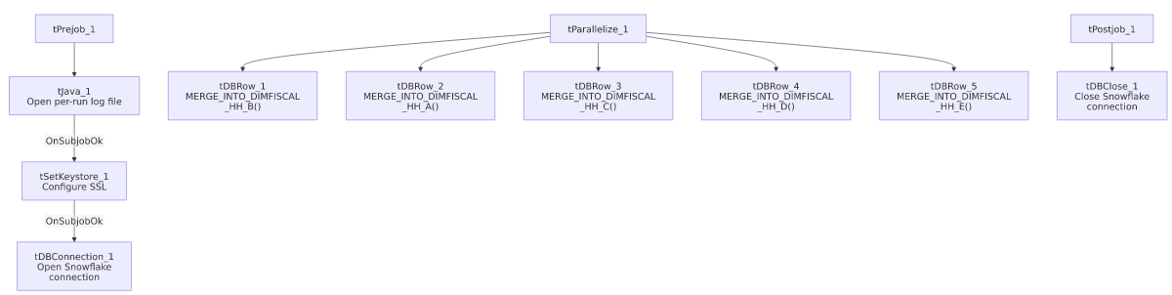

Settings tables

SSL setup: `tSetKeystore_1`
Setting | Value | What it means
SSL_TRUSTSERVER_TRUSTSTORE | "C:/clientTrustStore.trustStore" (hardcoded) | Same hardcoded truststore path used across all six DimFiscal_<SITE>_Load siblings.
SSL_KEYSTORE | context.keystorePath | Context-driven.

Merges: `tDBRow_1`–`tDBRow_5`
Setting | Value | What it means
Queries | CALL STAGING.MERGE_INTO_DIMFISCAL_HH_A(); through _E(); | Five separate fiscal sub-tables for the HH site — more than any other site in this family.
Result handling | None captured | No tJavaRow/tWarn/tDie downstream of any of the five.

Dependencies & configuration
- Triggers/depends on other jobs: none — no tRunJob links found, and no orchestrator in this project's captured metadata calls DimFiscal_HH_Load.
- Context variables used: keystorePath, logDir.
- 1 hardcoded path finding: tSetKeystore_1.SSL_TRUSTSERVER_TRUSTSTORE = "C:/clientTrustStore.trustStore".
- Related jobs: DimScore_Load (also in this batch) reads directly from dimfiscal_hh_c (joined to DimLogOn) to populate an Experian score table, and separately reads a fiscal query it labels "Fiscal_E" into a FISCAL_HH_E table — both presumably downstream consumers of the _C and _E merges this job performs. DimFiscal_HH_B_TrueUp (also in this batch) is a separate, differently-structured job that loads fresh HH fiscal "B" source data directly from MSSQL rather than merging already-staged data — it is not part of this job's tRunJob/merge chain but shares the "B" naming.

Glossary
Component type | Plain-English meaning
tJava | Runs custom Java code once — here, to redirect console output to a per-run log file.
tSetKeystore | Configures the SSL trust/keystore used for secure connections made later in the job.
tSnowflakeConnection / tSnowflakeClose / tSnowflakeRow | Open/close a Snowflake connection, or run an arbitrary SQL statement/procedure call against it.
tParallelize | Runs its downstream branches at the same time rather than one after another.

Issues observed
- No result-code checking on any of the five merge calls — same gap as every other sibling in this family.
- Family comparison — DimFiscal_HH_Load has 5 merge sub-tables (A–E), the most of any site: CO/DC/TOL have 3, CHI has 2, and PRE nominally has 3 but one is disabled. Unable to determine from metadata why HH's fiscal model is subdivided further than other sites — likely reflects a genuinely more complex HH billing/fiscal data model (consistent with DimFiscal_HH_B_TrueUp's much larger ~100-column patient/insurance schema compared to other sites' simpler fiscal loads), but worth confirming with the team.
- Running five parallel Snowflake procedure calls from one job increases the number of concurrent sessions/warehouse load at run time compared to the 2–3-way parallelism of its siblings — if Snowflake warehouse sizing or concurrency limits are a concern, this job is the heaviest of the family.
- Same hardcoded truststore path issue documented across the whole DimFiscal_<SITE>_Load family applies here.

