Talend Job: DimFiscal_PRE_Load

Overview
A merge-only orchestrator for the "PRE" site's fiscal/patient-billing dimension, structurally matching the CO/DC/TOL siblings with three merge sub-tables (A, B, C) — except that the "C" merge component is disabled (ACTIVATE=false) in this job's current configuration, meaning only two of the three merges (A, B) actually run. This is the one genuinely functional difference among the DimFiscal_<SITE>_Load family beyond site naming and sub-table count.

Detail table
Field | Value
Job name | DimFiscal_PRE_Load
Version | 0.1
Project | EDW2SF
Author | jmach@harriscollect.com
Created | 2022-08-09T17:06:18.134-0700
Last Modified | 2025-11-04T11:08:05.631-0800

Step-by-step data flow
Setup subjob: tPrejob_1 → tJava_1 opens a per-run log file → on subjob success, tSetKeystore_1 configures SSL trust/keystore → on subjob success, tDBConnection_1 opens the Snowflake connection.
Main subjob: tParallelize_1 runs three branches at the same time:
- tDBRow_2 runs CALL STAGING.MERGE_INTO_DIMFISCAL_PRE_A();
- tDBRow_1 runs CALL STAGING.MERGE_INTO_DIMFISCAL_PRE_B();
- tDBRow_3 runs CALL STAGING.MERGE_INTO_DIMFISCAL_PRE_C(); — but `tDBRow_3` has `ACTIVATE=false`, so this branch does not actually execute at run time even though it is still wired into tParallelize_1.
No result-code checking is wired on any of the three merges.
Teardown subjob: tPostjob_1 → tDBClose_1 (Snowflake).
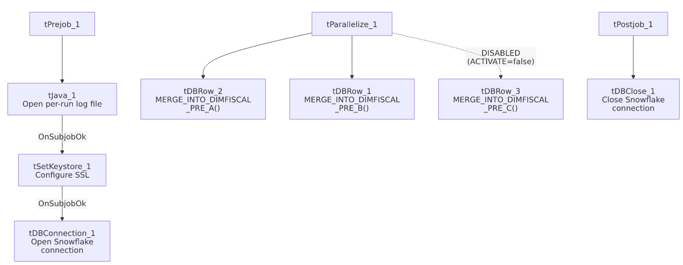

Settings tables

SSL setup: `tSetKeystore_1`
Setting | Value | What it means
SSL_TRUSTSERVER_TRUSTSTORE | "C:/clientTrustStore.trustStore" (hardcoded) | Same hardcoded truststore path used across all six DimFiscal_<SITE>_Load siblings.
SSL_KEYSTORE | context.keystorePath | Context-driven.

Merges: `tDBRow_1` / `tDBRow_2` / `tDBRow_3`
Setting | Value | What it means
Query (tDBRow_1) | CALL STAGING.MERGE_INTO_DIMFISCAL_PRE_B(); | Runs normally.
Query (tDBRow_2) | CALL STAGING.MERGE_INTO_DIMFISCAL_PRE_A(); | Runs normally.
Query (tDBRow_3) | CALL STAGING.MERGE_INTO_DIMFISCAL_PRE_C(); | `ACTIVATE=false` — this component is switched off in the job design and will not run, regardless of the tParallelize wiring shown in the canvas. See Issues observed.
Result handling | None captured | No tJavaRow/tWarn/tDie downstream of any of the three.

Dependencies & configuration
- Triggers/depends on other jobs: none — no tRunJob links found, and no orchestrator in this project's captured metadata calls DimFiscal_PRE_Load.
- Context variables used: keystorePath, logDir.
- 1 hardcoded path finding: tSetKeystore_1.SSL_TRUSTSERVER_TRUSTSTORE = "C:/clientTrustStore.trustStore".

Glossary
Component type | Plain-English meaning
tJava | Runs custom Java code once — here, to redirect console output to a per-run log file.
tSetKeystore | Configures the SSL trust/keystore used for secure connections made later in the job.
tSnowflakeConnection / tSnowflakeClose / tSnowflakeRow | Open/close a Snowflake connection, or run an arbitrary SQL statement/procedure call against it.
tParallelize | Runs its downstream branches at the same time rather than one after another.

Issues observed
- `tDBRow_3` (the "C" merge, `MERGE_INTO_DIMFISCAL_PRE_C()`) is disabled via `ACTIVATE=false`. This is the single clearest functional difference across the entire DimFiscal_<SITE>_Load family — every other sibling (CO, DC, TOL) that has an "A/B/C" structure runs all three merges; PRE's job still shows the "C" component wired into tParallelize_1 on the canvas, but it will not execute. This could mean either: (a) PRE genuinely has no "C" fiscal sub-table and the component was disabled rather than deleted, or (b) the "C" merge was intentionally turned off (e.g. due to a known data issue) and never re-enabled. Unable to determine which from metadata — this is worth explicitly confirming with the team, since a silently-disabled component is easy to miss when reviewing the job in Talend Studio's canvas view (it still appears in the flow).
- No result-code checking on the two active merge calls — same gap as every other sibling in this family.
- Same hardcoded truststore path issue documented across the whole DimFiscal_<SITE>_Load family applies here.

