Talend Job: DimFiscal_TOL_Load

Overview
A merge-only orchestrator for the "TOL" site's fiscal/patient-billing dimension: it runs three Snowflake stored-procedure merges (DIMFISCAL_TOL_A, _B, _C) in parallel to fold previously-staged TOL fiscal data into its final tables. Functionally identical to DimFiscal_CO_Load and DimFiscal_DC_Load (same three active merge sub-tables, same wiring order A, B, C), differing only in the site-specific procedure names.

Detail table
Field | Value
Job name | DimFiscal_TOL_Load
Version | 0.1
Project | EDW2SF
Author | jmach@harriscollect.com
Created | 2024-04-30T14:46:16.836-0700
Last Modified | 2025-11-04T11:08:04.890-0800

Step-by-step data flow
Setup subjob: tPrejob_1 → tJava_1 opens a per-run log file → on subjob success, tSetKeystore_1 configures SSL trust/keystore → on subjob success, tDBConnection_1 opens the Snowflake connection.
Main subjob: tParallelize_1 runs three branches at the same time:
- tDBRow_1 runs CALL STAGING.MERGE_INTO_DIMFISCAL_TOL_B();
- tDBRow_2 runs CALL STAGING.MERGE_INTO_DIMFISCAL_TOL_A();
- tDBRow_3 runs CALL STAGING.MERGE_INTO_DIMFISCAL_TOL_C();
No result-code checking is wired on any of the three merges.
Teardown subjob: tPostjob_1 → tDBClose_1 (Snowflake).
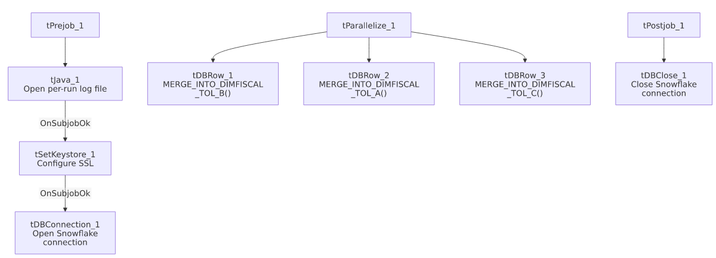

Settings tables

SSL setup: `tSetKeystore_1`
Setting | Value | What it means
SSL_TRUSTSERVER_TRUSTSTORE | "C:/clientTrustStore.trustStore" (hardcoded) | Same hardcoded truststore path used across all six DimFiscal_<SITE>_Load siblings.
SSL_KEYSTORE | context.keystorePath | Context-driven.

Merges: `tDBRow_1` / `tDBRow_2` / `tDBRow_3`
Setting | Value | What it means
Query (tDBRow_1) | CALL STAGING.MERGE_INTO_DIMFISCAL_TOL_B(); | Merges the "B" fiscal sub-table for TOL.
Query (tDBRow_2) | CALL STAGING.MERGE_INTO_DIMFISCAL_TOL_A(); | Merges the "A" fiscal sub-table for TOL.
Query (tDBRow_3) | CALL STAGING.MERGE_INTO_DIMFISCAL_TOL_C(); | Merges the "C" fiscal sub-table for TOL.
Result handling | None captured | No tJavaRow/tWarn/tDie downstream of any of the three.

Dependencies & configuration
- Triggers/depends on other jobs: none — no tRunJob links found, and no orchestrator in this project's captured metadata calls DimFiscal_TOL_Load.
- Context variables used: keystorePath, logDir.
- 1 hardcoded path finding: tSetKeystore_1.SSL_TRUSTSERVER_TRUSTSTORE = "C:/clientTrustStore.trustStore".

Glossary
Component type | Plain-English meaning
tJava | Runs custom Java code once — here, to redirect console output to a per-run log file.
tSetKeystore | Configures the SSL trust/keystore used for secure connections made later in the job.
tSnowflakeConnection / tSnowflakeClose / tSnowflakeRow | Open/close a Snowflake connection, or run an arbitrary SQL statement/procedure call against it.
tParallelize | Runs its downstream branches at the same time rather than one after another.

Issues observed
- No result-code checking on any of the three merge calls — same gap as every other sibling in this family.
- Family comparison — DimFiscal_TOL_Load has 3 merge sub-tables (A, B, C), matching CO and DC exactly (and identical wiring order); CHI has only 2, HH has 5, and PRE nominally has 3 but one is disabled. This job is the most recently created of the six siblings (2024-04-30, vs. 2022 for the other five), but its structure is otherwise a direct copy of the CO/DC template.
- Same hardcoded truststore path issue documented across the whole DimFiscal_<SITE>_Load family applies here.

