Talend Job: DimScore_Load

Overview
Loads three separate scoring/collections-analytics feeds from the "EDWProdHH" MSSQL database into Snowflake, all run in parallel: a general debtor scoring feed (Attune/Propensity/Decile/Dialer-group scores) into FISCAL_HH_E, an Experian credit score feed (joined from the HH site's fiscal "C" table) into FISCAL_HH_C, and a Sungard dollar-rate score feed (unioned across multiple sites' fiscal "C" tables) into SUNGARD_SCORE. After all three loads finish, it calls a Snowflake delta-load procedure (DELTA_LOAD_DIMSCORE) to merge the results into the final DIMSCORE dimension.

Detail table
Field | Value
Job name | DimScore_Load
Version | 0.1
Project | EDW2SF
Author | jmach@harriscollect.com
Created | 2022-01-31T08:46:42.016-0800
Last Modified | 2022-05-24T09:48:32.746-0700

Step-by-step data flow
Setup subjob: tPrejob_1 → tDBConnection_1 (Snowflake) → tDBConnection_3 (second Snowflake connection) → tDBConnection_2 (MSSQL, "EDWProdHH" context variables).
Main subjob — three independent read/transform/load chains, each triggering tParallelize_1 on its own subjob success; once all three have reported in, tParallelize_1 synchronizes and fires the final merge:
- Debtor scoring feed: tDBInput_1 runs a query joining logon/debtor/score fields (Attune Score, Propensity Score, Decile Trial Group, Dialer Group) → tMap_1 passes through, renaming DEBTOR to DEBTORNUMBER → tFlowMeter_9 counts rows → tDBOutput_2 truncates and inserts into Snowflake FISCAL_HH_E.
- Experian score feed: tDBInput_2 runs SELECT debtornumber, CAST(df.dimlogon...), L.Logon, COALESCE(TRY_CAST(df.ctrl_f499 AS numeric(10,0)), 0) AS experian_score FROM dimfiscal_hh_c df INNER JOIN DimLogOn L ON df.DimLogon = L.DimL... (truncated) → tFilterRow_7 applies a filter (condition truncated, appears to compare two columns) → tMap_2 passes through → tFlowMeter_6 counts rows → tDBOutput_1 truncates and inserts into Snowflake FISCAL_HH_C.
- Sungard score feed: tDBInput_3 runs a UNION ALL query pulling DOLLAR_RT (renamed SUNGARD_SCORE) from DimFiscal_CO_C, DimFiscal_CHI_C, and presumably other sites' _C fiscal tables (query truncated after two UNION ALL segments), filtered to non-blank DOLLAR_RT values → tMap_3 passes through → tFlowMeter_11 counts rows → tDBOutput_3 truncates and inserts into Snowflake SUNGARD_SCORE.
- Once all three source reads report OnSubjobOk to tParallelize_1, it synchronizes and fires tDBRow_1, which runs CALL DW.DELTA_LOAD_DIMSCORE(); to merge the three feeds into the final DIMSCORE dimension.
Teardown subjob: tPostjob_1 → tDBClose_1 (Snowflake) → tDBClose_2 (MSSQL) → tDBClose_3 (second Snowflake).
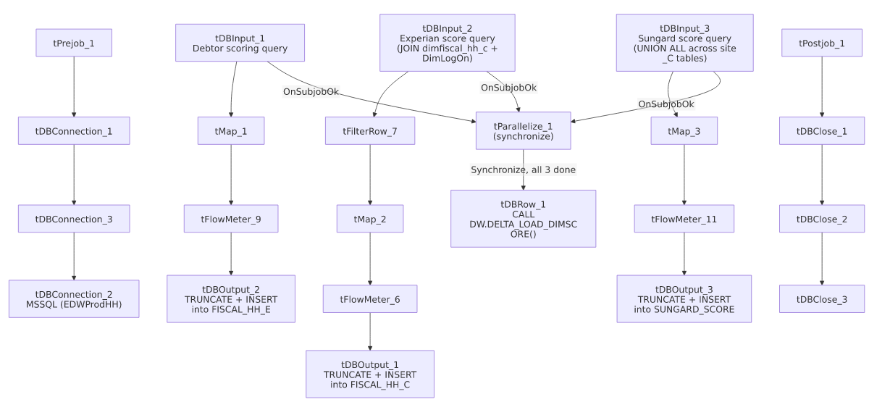

Settings tables

Feed 1: `tDBInput_1` / `tDBOutput_2`
Setting | Value | What it means
Query (visible) | SELECT E.[LOGON], CAST(L.DimLogon...), [DEBTOR], TRY_CAST([Attune Score]...), TRY_CAST([Propen Score]...), TRY_CAST([Decile Tri... (truncated) | Debtor-level scoring/analytics feed.
Target table | FISCAL_HH_E
Output action / Table action | INSERT / TRUNCATE | Full replace every run.

Feed 2: `tDBInput_2` / `tDBOutput_1`
Setting | Value | What it means
Query (visible) | SELECT debtornumber, CAST(df.dimlogon AS numeric(10,0)) AS DimLogon, L.Logon, COALESCE(TRY_CAST(df.ctrl_f499 AS numeric(10,0)), 0) AS experian_score FROM dimfiscal_hh_c df INNER JOIN DimLogOn L ON df.DimLogon = L.DimL... (truncated) | Derives an Experian credit score from a raw fiscal control field (ctrl_f499), defaulting to 0 when not castable.
Target table | FISCAL_HH_C
Output action / Table action | INSERT / TRUNCATE | Full replace every run.

Feed 3: `tDBInput_3` / `tDBOutput_3`
Setting | Value | What it means
Query (visible) | SELECT L.LOGON, CO.DimLogon, CO.DebtorNumber, DOLLAR_RT FROM DimFiscal_CO_C CO INNER JOIN DimLogOn L ON L.DimLogOn = CO.DimLogon WHERE RTRIM(COALESCE(DOLLAR_RT,'')) <> '' UNION ALL SELECT L.LOGON, CHI.DimLogon, CHI.DebtorNumber, DOLLA... (truncated after 2 of presumably more UNION ALL segments) | Combines a "dollar rate" score across multiple sites' fiscal "C" tables (CO and CHI visible; additional sites likely present but truncated) into one SUNGARD_SCORE feed.
Target table | SUNGARD_SCORE
Output action / Table action | INSERT / TRUNCATE | Full replace every run.

Final merge: `tDBRow_1`
Setting | Value | What it means
Query | CALL DW.DELTA_LOAD_DIMSCORE(); | Merges/consolidates the three freshly-truncated-and-reloaded feed tables into the DIMSCORE dimension. Only fires after all three feeds report success via tParallelize_1's synchronize behavior.

Dependencies & configuration
- Triggers/depends on other jobs: none — no tRunJob links found.
- Context variables used: EDWProdHH_Database, EDWProdHH_Login, EDWProdHH_Port, EDWProdHH_Schema, EDWProdHH_Server.
- Related jobs: reads from dimfiscal_hh_c and (via UNION ALL) DimFiscal_CO_C/DimFiscal_CHI_C — the same "_C" fiscal sub-tables merged by DimFiscal_HH_Load, DimFiscal_CO_Load, and DimFiscal_CHI_Load respectively, making this job a downstream consumer of those merges (though no formal tRunJob dependency exists — this job simply queries the resulting tables directly, so it must run after those merges complete for current data).
- No hardcoded developer-workstation paths found in this job.

Glossary
Component type | Plain-English meaning
tMSSqlInput / tMSSqlConnection / tMSSqlClose | Query a Microsoft SQL Server source / open and close that connection.
tFilterRow | Passes through only rows matching a configured condition, dropping the rest.
tMap | Maps/transforms columns from one schema to another.
tFlowMeter | Counts rows passing a point in the flow for logging/monitoring.
tSnowflakeOutput / tSnowflakeConnection / tSnowflakeClose / tSnowflakeRow | Write rows to Snowflake / open and close the Snowflake connection / run arbitrary SQL against it.
tParallelize | Runs its downstream branches at the same time; here used with SYNCHRONIZE to wait for all three feeds before firing the final merge.

Issues observed
- This job has an undeclared, implicit dependency on `DimFiscal_HH_Load`, `DimFiscal_CO_Load`, and `DimFiscal_CHI_Load` having already run and merged current data into dimfiscal_hh_c/DimFiscal_CO_C/DimFiscal_CHI_C — there is no tRunJob link enforcing that ordering. If DimScore_Load runs before those merges complete for a given cycle, its Experian and Sungard score feeds would reflect stale fiscal data with no error or warning raised. Verify the actual scheduling order with the team; this dependency is invisible from DimScore_Load's own metadata alone.
- The Sungard feed's `UNION ALL` query is truncated after two site segments (CO, CHI) in this metadata — unable to determine from the visible text how many sites are actually included (all six site codes, or only some). If a site is missing from the union, its debtors would simply be absent from SUNGARD_SCORE with no error raised. Verify the full query directly in Talend Studio.
- `tFilterRow_7`'s condition is truncated (input_row.columnName1.equals(input_row.columnNam...) — unable to determine what rows are being excluded from the Experian score feed before it reaches tMap_2/FISCAL_HH_C.
- No result-code checking is wired on the final DELTA_LOAD_DIMSCORE() merge call — a failure there would surface only as a generic Talend execution error, consistent with the pattern flagged project-wide in 05_operational_runbook.md.

