Talend Job: DimStatus_Load

Overview
An incremental loader for the account-status code dimension: it computes the current maximum InsertDate already loaded into Snowflake DIMSTATUSCODE, then pulls only newer rows from the "EDWProdHH" MSSQL DimStatusCode table and inserts them. A simple, low-volume reference-data job with no merge step — new rows are appended directly to the final table.

Detail table
Field | Value
Job name | DimStatus_Load
Version | 0.1
Project | EDW2SF
Author | jmach@harriscollect.com
Created | 2022-04-06T08:42:52.640-0700
Last Modified | 2025-09-24T11:00:15.394-0700

Step-by-step data flow
Setup subjob: tPrejob_1 → tDBConnection_1 (Snowflake) → tDBConnection_2 (MSSQL, "EDWProdHH" context variables).
Main subjob:
- tDBInput_2 runs SELECT CAST(MAX(INSERTDATE) AS VARCHAR(10)) AS MAX_DATE FROM DW.DIMSTATUSCODE; against Snowflake.
- tJavaRow_1 captures that value into context.maxUpdate.
- On success, tDBInput_1 runs SELECT [DimStatusKey],[StatusCode],[Description],[InsertDate] FROM [dbo].[DimStatusCode] WHERE InsertDate > + context.maxUpdate against MSSQL — an explicitly incremental filter, unlike some sibling jobs in this project where the filter's presence is unconfirmed.
- tMap_1 passes the row through to the target schema.
- tDBOutput_1 inserts the rows into Snowflake DIMSTATUSCODE (INSERT, tableAction=NONE — no truncate, consistent with an append-only incremental design).
Teardown subjob: tPostjob_1 → tDBClose_1 (Snowflake) → tDBClose_2 (MSSQL).
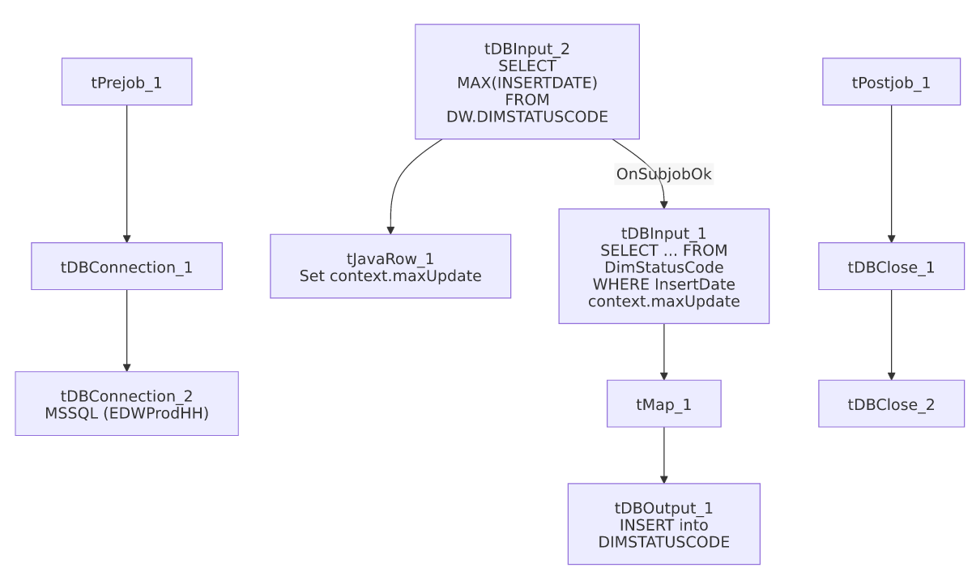

Settings tables

Source: `tDBInput_1` (`tMSSqlInput`)
Setting | Value | What it means
Table | DimStatusCode | Source status-code lookup table.
Query | SELECT [DimStatusKey],[StatusCode],[Description],[InsertDate] FROM [dbo].[DimStatusCode] WHERE InsertDate > + context.maxUpdate | Confirmed incremental filter — unlike i3_CallDetail_40_Load/DimDebtor_Load, this job's WHERE clause explicitly references the computed max value, so the incremental design is verifiably applied.

Target: `tDBOutput_1` (`tSnowflakeOutput`)
Setting | Value | What it means
Table | DIMSTATUSCODE | Destination table.
Output action / Table action | INSERT / NONE | Appends only new rows — no truncate, consistent with the incremental filter above.

Dependencies & configuration
- Triggers/depends on other jobs: none — no tRunJob links found.
- Context variables used: EDWProdHH_Database, EDWProdHH_Login, EDWProdHH_Port, EDWProdHH_Schema, EDWProdHH_Server, maxUpdate (computed internally).
- No hardcoded developer-workstation paths found in this job.

Glossary
Component type | Plain-English meaning
tMSSqlInput / tMSSqlConnection / tMSSqlClose | Query a Microsoft SQL Server source / open and close that connection.
tSnowflakeInput / tSnowflakeOutput / tSnowflakeConnection / tSnowflakeClose | Query, write to, connect to, or close a Snowflake connection.
tMap | Maps/transforms columns from one schema to another.
tJavaRow | Runs custom Java code once per input row — here used to unpack a single query result into a context variable.

Issues observed
- `InsertDate` is typed `id_BigDecimal` in the schema, not a date/timestamp type, and the incremental comparison (InsertDate > context.maxUpdate) is a numeric/string comparison built from a CAST(MAX(INSERTDATE) AS VARCHAR(10)) on the Snowflake side concatenated directly into the MSSQL query text. This works as a simple increasing-integer watermark, but it's worth confirming InsertDate values are genuinely monotonically increasing (e.g. a sequence or epoch-like value) rather than a true calendar date, since the column name could otherwise be misleading to someone unfamiliar with the source schema.
- Beyond that, this job has no other notable issues beyond the project-wide patterns already documented in 05_operational_runbook.md — it correctly implements the incremental-load pattern that several sibling jobs in this project (DimDebtor_Load, i3_CallDetail_40_Load) leave unconfirmed.

