Talend Job: DoNotCall_Load

Overview
Parses raw Do-Not-Call (DNC) list files (tab-delimited, containing a record date, phone number, and free-text content per line) from a source directory, standardizes/validates each phone number to US national format, filters out already-processed records using a max-timestamp watermark, writes the qualifying rows to an intermediate pipe-delimited file, then loads that file into Snowflake staging and merges it into the final EDWPRODHH.DW.DONOTCALL table with a "last write wins by timestamp" merge rule. This is the "parsed/standardized" sibling of DoNotCall_Load_Full, which instead loads DNC file content verbatim without phone-number parsing (see that job's doc for the comparison).

Detail table
Field | Value
Job name | DoNotCall_Load
Version | 0.1
Project | EDW2SF
Author | jmach@harriscollect.com
Created | 2024-12-04T08:26:03.441-0800
Last Modified | 2024-12-16T13:18:02.432-0800

Step-by-step data flow
Setup subjob: tPrejob_1 → tDBConnection_1 (Snowflake).
Watermark + staging-clear subjob:
- tDBRow_1 runs TRUNCATE TABLE DNC_DONOTCALL_STAGING; on Snowflake.
- On success, tDBRow_3 runs SELECT COALESCE(MAX(JAVA_TIMESTAMP),0) AS MAX_TIMESTAMP FROM DNC_DONOTCALL_STAGING WHERE SOURCE='DNC'; — note this queries the table that was just truncated, so it would always return 0 in the same run (see Issues observed) — → tJavaRow_2 captures the result into context.maxTimeStamp.
- On tDBRow_3's subjob success, tFileList_1 lists files in context.dncSourceDir (an EXCLUDEFILEMASK of *.txt is configured but IFEXCLUDE=false, so every file in the directory is actually picked up).
- For each file: tJava_1 sets context.dncFilePath/context.dncFileName → tFileInputDelimited_1 reads the file (tab-delimited, no header, DIE_ON_ERROR=false, using repository schema "...metadata" for both main and reject) → tJavaRow_1 reads the file's OS last-modified timestamp into FILE_DATE/JAVA_TIMESTAMP → tMap_1 maps to a PHONENUMBER/CONTENT/SOURCE schema → tFilterRow_10 keeps only rows where JAVA_TIMESTAMP > context.maxTimeStamp → tStandardizePhoneNumber_1 standardizes the phone number to US national format → tFilterRow_9 keeps only rows where IsValidPhoneNumberForRegion == true → tMap_2 maps to the final file-output schema → tFileOutputDelimited_1 appends the row to context.dncOutputDir + "dncout.csv" (pipe-delimited, no header).
- Once tFileList_1's subjob completes, tFileInputDelimited_2 reads the accumulated dncout.csv back in → feeds tDBOutput_1 (inserts into Snowflake DNC_DONOTCALL_STAGING).
- On that subjob's success, tDBRow_2 runs a MERGE INTO EDWPRODHH.DW.DONOTCALL statement (see Settings) → on success, tFileDelete_1 deletes dncout.csv (FAILON=true — a failed delete fails the job).
Teardown: no tPostjob component captured in this job's metadata (see Issues observed).
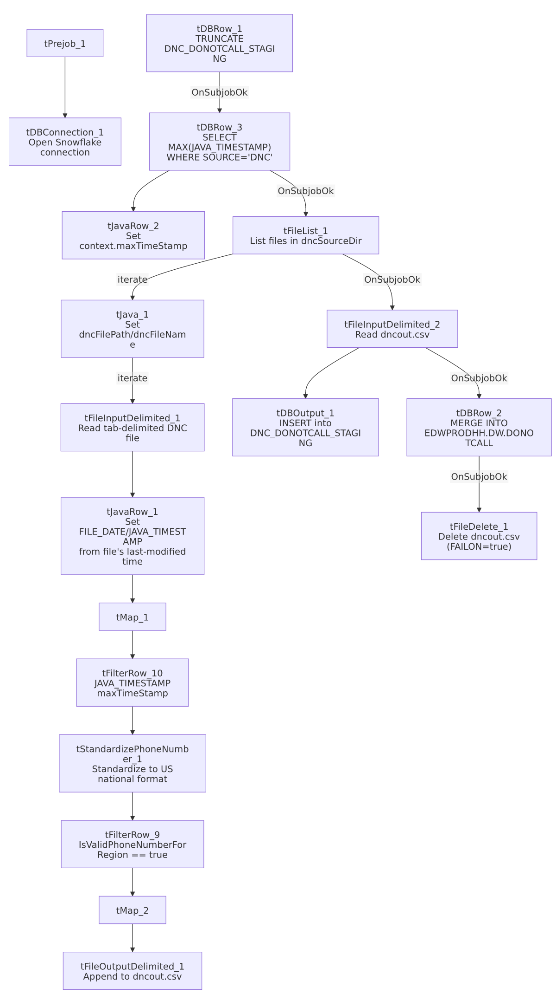

Settings tables

Source parsing: `tFileInputDelimited_1` / `tStandardizePhoneNumber_1`
Setting | Value | What it means
FIELDSEPARATOR / HEADER | \t / 0 (no header) | Tab-delimited raw DNC files.
DIE_ON_ERROR | false | Malformed rows don't fail the job; no reject flow is wired (rejected rows silently dropped, same pattern flagged elsewhere in this project).
PHONE_NUMBER_FORMAT / COUNTRY_CODE_CUSTOME | NATIONAL / "US" | All numbers standardized to US national format regardless of source formatting.
Filter after standardization | IsValidPhoneNumberForRegion == true | Numbers that don't validate as US numbers are dropped from the output file entirely — no record of how many or which ones.

Merge: `tDBRow_2`
Setting | Value | What it means
Query | MERGE INTO EDWPRODHH.DW.DONOTCALL AS tgt USING (SELECT ... FROM EDWPRODHH.STAGING.DNC_DONOTCALL_STAGING QUALIFY ROW_NUMBER() OVER (PARTITION BY PHONENUMBER ORDER BY RECORD_DATE DESC)=1) AS src ON (tgt.PHONENUMBER=src.PHONENUMBER) WHEN MATCHED AND (src.JAVA_TIMESTAMP > tgt.JAVA_TIMESTAMP) THEN UPDATE ... WHEN NOT MATCHED THEN INSERT ... | Deduplicates the staged batch to one row per phone number (latest RECORD_DATE), then upserts into the final table only when the new record's JAVA_TIMESTAMP is newer than what's already there — a "last write wins" merge, guarding against out-of-order file processing.

Cleanup: `tFileDelete_1`
Setting | Value | What it means
FILENAME | context.dncOutputDir+"dncout.csv" | Deletes the intermediate file after a successful merge.
FAILON | true | If the delete fails (e.g. file locked or already gone), this job fails — stricter than its DoNotCall_Load_Full sibling, which sets FAILON=false for the equivalent step.

Dependencies & configuration
- Triggers/depends on other jobs: none — no tRunJob links found.
- Context variables used: dncFileName, dncFilePath, dncOutputDir, dncSourceDir, maxTimeStamp (computed internally).
- 4 hardcoded developer-workstation paths: tFileInputDelimited_1.TEMP_DIR, tFileInputDelimited_2.TEMP_DIR, tFileDelete_1.DIRECTORY, tFileDelete_1.PATH (all C:/Talend-Studio-20211109_1610-V8.0.1/workspace/...) — same portability risk documented project-wide in 05_operational_runbook.md.

Glossary
Component type | Plain-English meaning
tFileList | Lists files in a directory for the job to iterate over one at a time.
tFileInputDelimited / tFileOutputDelimited | Read/write a delimited (CSV-style) text file according to a schema.
tJavaRow / tJava | Run custom Java code once per row / once overall.
tMap | Maps/transforms columns from one schema to another.
tFilterRow | Passes through only rows matching a configured condition.
tStandardizePhoneNumber | Normalizes a phone number to a standard format and flags whether it's a valid number for a given region.
tSnowflakeOutput / tSnowflakeConnection / tSnowflakeRow | Write rows to Snowflake / open the connection / run arbitrary SQL against it.
tFileDelete | Deletes a file from disk.

Issues observed
- The max-timestamp watermark query (`tDBRow_3`) runs against `DNC_DONOTCALL_STAGING` immediately after that same table was just truncated (`tDBRow_1`). Since DNC_DONOTCALL_STAGING is a staging table that's cleared every run, SELECT MAX(JAVA_TIMESTAMP) ... WHERE SOURCE='DNC' would always return 0 (via COALESCE) within the same execution, making context.maxTimeStamp effectively meaningless as an incremental filter unless the intent was actually to check the *final* EDWPRODHH.DW.DONOTCALL table instead. This looks like a logic bug: the watermark should likely be computed from the final table (as DimStatus_Load and others correctly do against their target dimension) rather than from a table this same job just emptied. Unable to confirm the intended behavior from metadata alone; verify with the team — if uncorrected, tFilterRow_10's JAVA_TIMESTAMP > context.maxTimeStamp filter would pass through every record in every source file every run, reprocessing files repeatedly.
- No reject flow is wired from `tFileInputDelimited_1`. DIE_ON_ERROR=false, so malformed rows don't fail the job, but there is also no connection carrying rejected rows anywhere — they are silently dropped with no record of how many or which ones failed to parse.
- Invalid phone numbers are silently dropped (tFilterRow_9) with no logging of how many records were excluded per file — if a source file's format changes and most/all numbers fail region validation, the job would still report success while loading few or zero DNC records.
- `tFileDelete_1` has `FAILON=true`, meaning if dncout.csv cannot be deleted after a successful merge (e.g. file lock, permissions), the whole job fails even though the DNC data was already correctly merged into the warehouse — a purely cosmetic cleanup failure would be indistinguishable from a data-load failure in the job's exit status.
- No `tPostjob` component is present in this job's metadata — unlike most other jobs in this project, there's no visible teardown subjob closing the Snowflake connection explicitly. Unable to determine whether this is an extraction gap or the job genuinely relies on implicit connection cleanup at job end.

