Talend Job: DoNotCall_Load_Full

Overview
Loads Do-Not-Call (DNC) list files verbatim — capturing each line's raw CONTENT, file name, and upload date, with no phone-number parsing or standardization — into Snowflake staging, then calls a stored procedure to merge the batch into the final DNC table. This is the "full/raw" sibling of DoNotCall_Load, which instead parses out a PHONE_NUMBER column and standardizes/validates it before loading (see that job's doc for the comparison). The version bump (0.2 vs. DoNotCall_Load's 0.1) and later creation date (2025-01-08 vs. 2024-12-04) suggest this is a newer variant built shortly after the original.

Detail table
Field | Value
Job name | DoNotCall_Load_Full
Version | 0.2
Project | EDW2SF
Author | jmach@harriscollect.com
Created | 2025-01-08T12:12:43.688-0800
Last Modified | 2025-11-12T07:14:01.539-0800

Step-by-step data flow
Setup subjob: tPrejob_1 → tSetKeystore_1 configures SSL trust/keystore → on subjob success, tDBConnection_1 opens the Snowflake connection.
Staging-clear + file-processing subjob:
- tDBRow_1 runs TRUNCATE TABLE DNC_DONOTCALL_STAGING;.
- On success, tFileList_1 lists files in context.dncSourceDir (same EXCLUDEFILEMASK/IFEXCLUDE=false non-exclusion pattern as DoNotCall_Load).
- For each file: tJava_1 sets context.dncFilePath/context.dncFileName → tFileInputDelimited_1 reads the file with no field separator configured (FIELDSEPARATOR=""), effectively treating each line as a single CONTENT value with no column splitting (DIE_ON_ERROR=false) → tJavaRow_1 reads the file's OS last-modified timestamp into FILE_DATE/JAVA_TIMESTAMP → tMap_1 maps to a schema of FILE_DATE, JAVA_TIMESTAMP, CONTENT, SOURCE, FILE_NAME, UPLOAD_DATE → tFileOutputDelimited_1 appends the row to context.dncOutputDir + "dncout.csv" (pipe-delimited, no header) — no phone-number extraction, standardization, or timestamp-based filtering happens in this job, unlike DoNotCall_Load.
- Once tFileList_1's subjob completes, tFileInputDelimited_2 reads dncout.csv back in → feeds tDBOutput_1 (inserts into Snowflake DNC_DONOTCALL_STAGING).
- On that subjob's success, tDBRow_2 runs CALL MERGE_DNC_INTO_DONOTCALL(); (a stored procedure call, unlike DoNotCall_Load's inline MERGE INTO statement) → on success, tFileDelete_1 deletes dncout.csv (FAILON=false — a failed delete does not fail the job here, unlike DoNotCall_Load).
Teardown: no tPostjob component captured in this job's metadata (same gap as DoNotCall_Load).
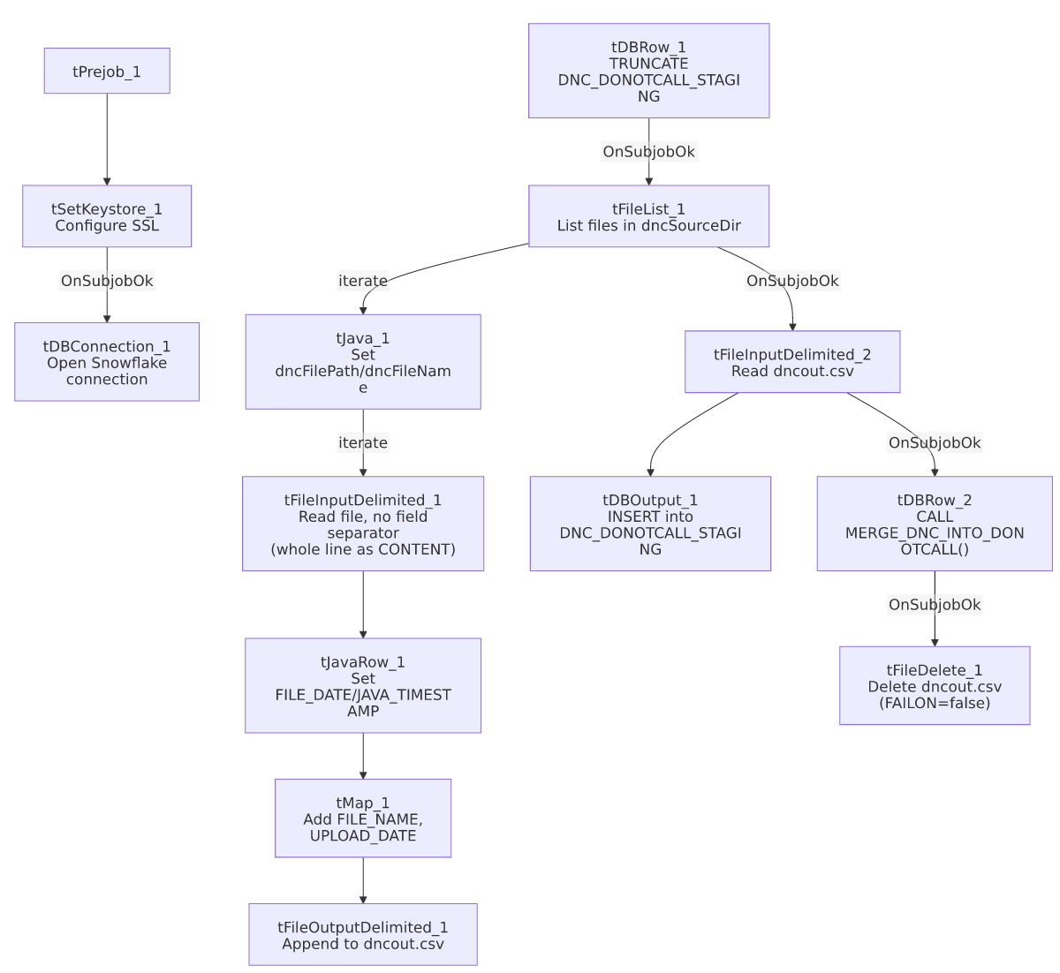

Settings tables

Source parsing: `tFileInputDelimited_1`
Setting | Value | What it means
FIELDSEPARATOR | "" (empty) | No column splitting — each line is captured whole as CONTENT. This is the key structural difference from DoNotCall_Load, which splits out a dedicated PHONE_NUMBER column.
DIE_ON_ERROR | false | Malformed rows don't fail the job; no reject flow wired (same gap as DoNotCall_Load).

Merge: `tDBRow_2`
Setting | Value | What it means
Query | CALL MERGE_DNC_INTO_DONOTCALL(); | A stored procedure, not an inline MERGE statement — its actual merge logic (dedup rule, matching key) is not visible in this job's own metadata, unlike DoNotCall_Load's fully inline MERGE INTO SQL.

Cleanup: `tFileDelete_1`
Setting | Value | What it means
FAILON | false | A failed delete does not fail this job — the opposite setting from DoNotCall_Load's equivalent step (FAILON=true).

Dependencies & configuration
- Triggers/depends on other jobs: none — no tRunJob links found.
- Context variables used: dncFileName, dncFilePath, dncOutputDir, dncSourceDir, keystorePath.
- 5 hardcoded developer-workstation paths: tFileInputDelimited_1.TEMP_DIR, tFileInputDelimited_2.TEMP_DIR, tFileDelete_1.DIRECTORY, tFileDelete_1.PATH (all C:/Talend-Studio-20211109_1610-V8.0.1/workspace/...), plus tSetKeystore_1.SSL_TRUSTSERVER_TRUSTSTORE ("C:/clientTrustStore.trustStore") — the SSL truststore path is not present in DoNotCall_Load's findings, since that job has no tSetKeystore component at all.

Glossary
Component type | Plain-English meaning
tFileList | Lists files in a directory for the job to iterate over one at a time.
tFileInputDelimited / tFileOutputDelimited | Read/write a delimited (CSV-style) text file according to a schema.
tJavaRow / tJava | Run custom Java code once per row / once overall.
tMap | Maps/transforms columns from one schema to another.
tSetKeystore | Configures the SSL trust/keystore used for secure connections.
tSnowflakeOutput / tSnowflakeConnection / tSnowflakeRow | Write rows to Snowflake / open the connection / run arbitrary SQL against it.
tFileDelete | Deletes a file from disk.

Issues observed
- This job performs no phone-number extraction, standardization, or region validation at all — every line of every source file is loaded as raw CONTENT with no PHONE_NUMBER column, unlike its DoNotCall_Load sibling. Whether DoNotCall_Load_Full is meant to be a raw-archive/audit-trail companion to the parsed DoNotCall_Load job, or a replacement for it, is unable to determine from metadata — the two jobs both write to the same DNC_DONOTCALL_STAGING table and presumably the same final DONOTCALL/DNC target, which raises the question of whether running both in the same cycle could double-process the same source files. Verify with the team whether these two jobs are meant to run against different source directories, on different schedules, or are mutually exclusive.
- No incremental/timestamp filtering is applied in this job (no tFilterRow equivalent to DoNotCall_Load's JAVA_TIMESTAMP > context.maxTimeStamp check) — every file in context.dncSourceDir is reprocessed on every run unless something external (e.g. file archival) removes already-processed files first. No tFileArchive/tFileDelete step removes the *source* files after processing in this job (only the intermediate dncout.csv is deleted) — unable to determine from metadata how re-processing of the same source file across runs is prevented, if at all.
- `tFileDelete_1.FAILON=false` here vs. `true` in `DoNotCall_Load` — an inconsistency between the two sibling jobs in how seriously a cleanup failure is treated. Neither is inherently wrong, but the difference suggests the two jobs weren't built with a shared, deliberate error-handling standard.
- The merge logic (`CALL MERGE_DNC_INTO_DONOTCALL()`) is opaque — unlike DoNotCall_Load's fully inline MERGE INTO SQL (visible in this metadata), this job calls a stored procedure whose actual matching/dedup logic isn't captured here. Verify directly against the Snowflake procedure definition if reconciling record counts between the two DNC jobs.
- Same reject-flow gap as DoNotCall_Load: DIE_ON_ERROR=false on tFileInputDelimited_1 with no wired reject output — malformed lines are silently dropped.

