Talend Job: EMail_Address_Load

Overview
A pure orchestrator with no data logic of its own: it calls the shared CUBS_Raw_EMail_Address_Load job six separate times in a mix of parallel and sequential chains, apparently once per client logon/site. It does not read or write any business data directly — every actual email-address load happens inside the repeatedly-invoked child job.

Detail table
Field | Value
Job name | EMail_Address_Load
Version | 0.1
Project | EDW2SF
Author | jmach@harriscollect.com
Created | 2023-02-06T15:12:15.148-0800
Last Modified | 2025-11-04T10:52:55.147-0800

Step-by-step data flow
- tJava_1 opens a per-run log file, then on subjob success tSystem_1 runs a shell command (echo 'Starting job EMail_Address_Load') purely for log visibility.
- On success, tParallelize_1 starts two independent chains:
- Chain A: tRunJob_1 (CUBS_Raw_EMail_Address_Load, USE_INDEPENDENT_PROCESS=true) → on success, tRunJob_2 (same target, but USE_CHILD_JVM_SETTING=false/USE_CUSTOM_JVM_SETTING=true — a different JVM sizing configuration than tRunJob_1) → on success, tRunJob_6 (same target, same custom-JVM configuration as tRunJob_2).
- Chain B: tRunJob_4 (CUBS_Raw_EMail_Address_Load) → on success, tRunJob_5 (same target) → on success, tRunJob_3 (same target).
- Both chains ultimately feed into tParallelize_2 (DIE_ON_ERROR=true, unlike tParallelize_1's DIE_ON_ERROR=false): tRunJob_6 and tRunJob_3 both connect into it.
- Once both chains report in, tParallelize_2 synchronizes and fires tSystem_2, which runs echo 'CUBS_Raw_Email_Address_Load complete' — a shell command purely for log visibility, marking overall completion.
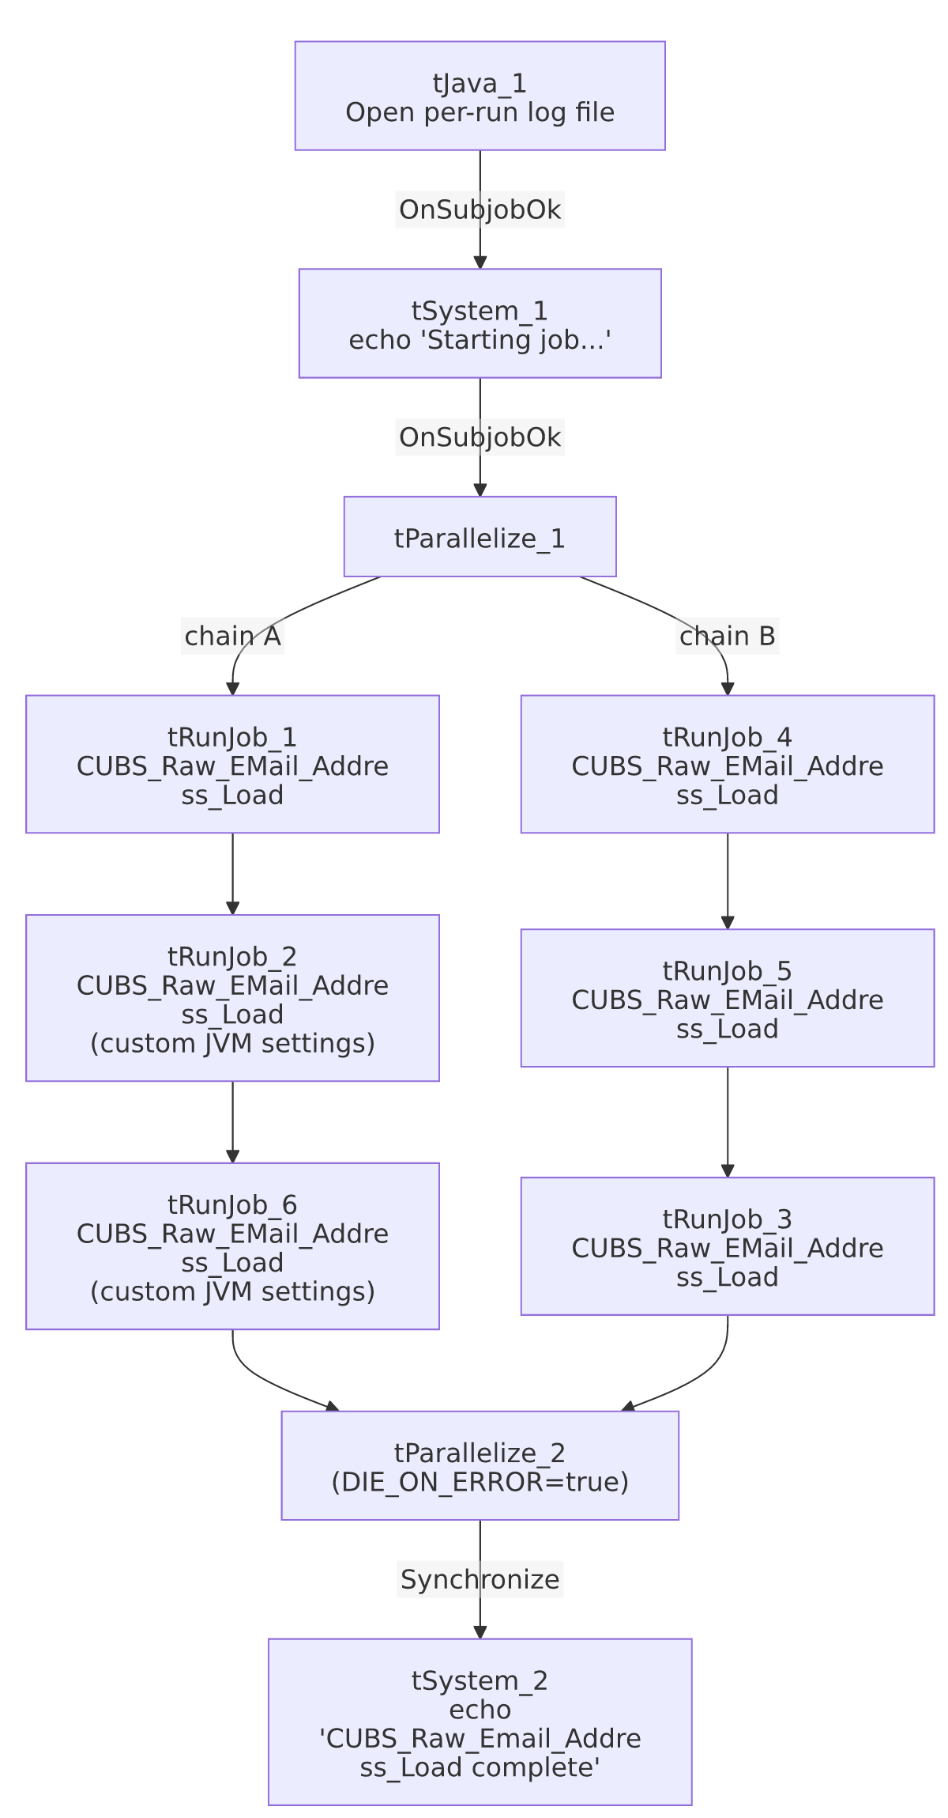

Settings tables

Orchestration: `tRunJob_1`–`tRunJob_6`
Setting | Value | What it means
PROCESS (all 6) | CUBS_Raw_EMail_Address_Load | The same shared job is called six times in this job, with no visible per-call context override in this metadata — see Issues observed.
USE_INDEPENDENT_PROCESS (all 6) | true | Each call runs as a separate process rather than sharing this job's JVM (contrast with DimFiscal_CO_Load's in-process pattern).
DIE_ON_CHILD_ERROR (all 6) | true | If any of the six calls fails, that chain (and ultimately this job) fails.
JVM setting (tRunJob_2, tRunJob_6) | USE_CHILD_JVM_SETTING=false, USE_CUSTOM_JVM_SETTING=true | These two calls use a custom JVM memory/sizing configuration, unlike the other four which use the default child-JVM setting — see Issues observed.

Shell commands: `tSystem_1` / `tSystem_2`
Setting | Value | What it means
COMMAND | "echo 'Starting job EMail_Address_Load'" / "echo 'CUBS_Raw_Email_Address_Load complete'" | Purely cosmetic log markers — no actual system effect beyond writing to console/log output.
DIRECTORY (both) | "C:/Talend-Studio-20211109_1610-V8.0.1/workspace" (hardcoded) | Working directory for the shell command — see Issues observed.

Dependencies & configuration
- Triggers/depends on other jobs: calls `CUBS_Raw_EMail_Address_Load` six times via tRunJob_1 through tRunJob_6 (see 06_dependency_matrix.md, which records this same 6x call pattern). No formal tRunJob link exists from any other job into EMail_Address_Load itself in this project's captured orchestration.
- Context variables used: logDir.
- 2 hardcoded developer-workstation paths (tSystem_1.DIRECTORY, tSystem_2.DIRECTORY, both C:/Talend-Studio-20211109_1610-V8.0.1/workspace).

Glossary
Component type | Plain-English meaning
tJava | Runs custom Java code once — here, to redirect console output to a per-run log file.
tSystem | Runs an OS-level shell command — here used only to print a marker message.
tParallelize | Runs its downstream branches at the same time; the second instance here also waits (SYNCHRONIZE) for both branches before continuing.
tRunJob | Runs another Talend job as a sub-process (or inline, if configured not to use an independent process).

Issues observed
- The same job (`CUBS_Raw_EMail_Address_Load`) is called six times with no per-call context distinction visible in this metadata. 06_dependency_matrix.md notes this exact pattern project-wide (EMail_Address_Load → CUBS_Raw_EMail_Address_Load, 6 times) and flags that confirming what differs per call "requires opening each tRunJob component's context settings individually." Each tRunJob here uses CONTEXT_NAME=Default with no visible per-call context override captured in this extraction — it's likely each call is meant to process a different client logon/site (similar to how Semaphore_Check's tForeach loops over a list this extraction also couldn't capture), but this cannot be confirmed from the JSON alone. Verify directly in Talend Studio which logon or parameter differs across the six calls; if none does, the six calls may be fully redundant.
- Two of the six calls (`tRunJob_2`, `tRunJob_6`) use a custom JVM setting while the other four use the default. Unable to determine from metadata why only these two calls need different JVM sizing — possibly because they process a larger site's email-address volume — worth confirming with the team.
- `tParallelize_1` has `DIE_ON_ERROR=false` while `tParallelize_2` has `DIE_ON_ERROR=true` — inconsistent error-handling posture between the two tParallelize components in the same job. A failure in one of the two parallel chains before reaching tParallelize_2 might not stop the job the same way a failure after that point would; verify the practical effect in Talend Studio if partial-chain failures are a concern.
- The two `tSystem` shell commands add no functional value beyond log markers, but each still requires the hardcoded workspace directory to exist as configured — a minor but real portability dependency for what is otherwise a purely cosmetic step.

