Talend Job: ERC_Event_Report_Load

Overview
Loads e-notice/e-communication event-report CSV files (letter code, letter ID, customer, email address, event type, comment, event date, account numbers) from a fixed network share into a Snowflake ERC_EVENT_REPORT staging table, truncating the table first. This is the newest job in this batch by creation date (January 2026), and its source directory is a hardcoded network path rather than a context variable — see Issues observed.

Detail table
Field | Value
Job name | ERC_Event_Report_Load
Version | 0.1
Project | EDW2SF
Author | jmach@harriscollect.com
Created | 2026-01-30T11:28:21.062-0800
Last Modified | 2026-02-04T09:45:08.090-0800

Step-by-step data flow
- tSetKeystore_1 configures SSL trust/keystore, both truststore and keystore paths set to context.keystorePath (unlike most other jobs in this project, which hardcode the truststore path — see Issues observed).
- On subjob success, tDBRow_1 runs TRUNCATE TABLE STAGING.ERC_EVENT_REPORT;.
- On success, tFileList_1 lists files in a hardcoded directory "G:/Analytics_Team/PROD/ENOTICE/", ordered by modified date ascending (an EXCLUDEFILEMASK of *.txt is configured but IFEXCLUDE=false, so it has no effect).
- For each file: tJava_1 sets context.fileName → tFileInputDelimited_1 reads the CSV (comma-delimited, header row present, DIE_ON_ERROR=false) using repository schema "...metadata" for both main and reject flows.
- tMap_1 maps the ~11 source columns through to the target schema, adding a FILE_NAME column.
- tDBOutput_1 inserts the rows into Snowflake ERC_EVENT_REPORT (INSERT, tableAction=NONE — relies on the earlier TRUNCATE for a clean load).
No tPrejob/tPostjob or explicit Snowflake connection-open/close components are present in this job's metadata — see Issues observed.
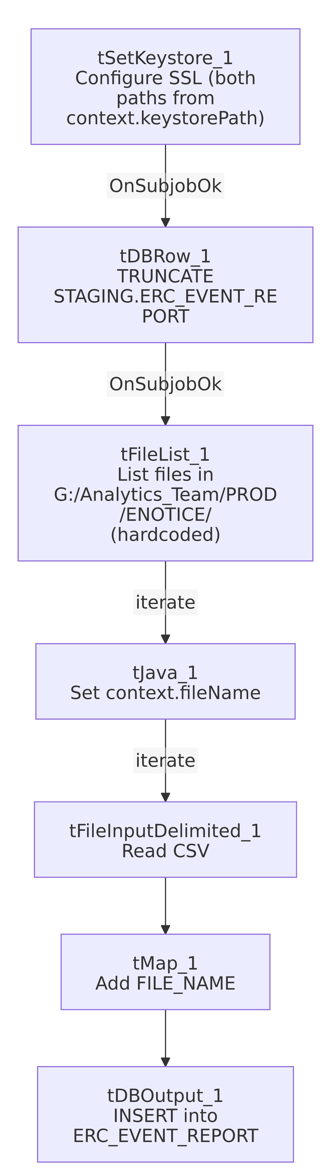

Settings tables

Source list: `tFileList_1`
Setting | Value | What it means
DIRECTORY | "G:/Analytics_Team/PROD/ENOTICE/" (hardcoded) | A fixed network-share path, not a context.* variable — unlike the context.sourceDir/StandardFolders_0.1 pattern used by most other jobs in this project. See Issues observed.
ORDER_BY_MODIFIEDDATE | true (ascending) | Files are processed oldest-first.

Source: `tFileInputDelimited_1`
Setting | Value | What it means
FIELDSEPARATOR / HEADER | , / 1 header row | Standard CSV with header.
Columns | LetterCode, Letter_ID, Customer, EmailAddress, Event, Comment, EventDate, Account_Number, Account_Number_2_w_Logon, VariableField5_FN, Extra_Info_rCID | An e-notice event-report extract — event type, comment, and account identifiers for a letter/communication tracking system.
DIE_ON_ERROR | false | Malformed rows don't fail the job; no reject flow wired (rejects silently dropped).

Target: `tDBOutput_1`
Setting | Value | What it means
Table | ERC_EVENT_REPORT | Destination staging table.
Output action / Table action | INSERT / NONE | Relies on the earlier explicit TRUNCATE TABLE STAGING.ERC_EVENT_REPORT; step rather than the component's own table-action setting.

Dependencies & configuration
- Triggers/depends on other jobs: none — no tRunJob links found.
- Context variables used: fileName, keystorePath.
- 1 hardcoded path flagged by the extraction: tFileInputDelimited_1.TEMP_DIR = "C:/Talend-Studio-20211109_1610-V8.0.1/workspace". Additionally observed directly in this job's own metadata but not flagged by the automated extraction: tFileList_1.DIRECTORY = "G:/Analytics_Team/PROD/ENOTICE/" — a hardcoded network-share source path (see Issues observed).

Glossary
Component type | Plain-English meaning
tSetKeystore | Configures the SSL trust/keystore used for secure connections made later in the job.
tFileList | Lists files in a directory for the job to iterate over one at a time.
tFileInputDelimited | Reads a delimited (CSV-style) text file according to a schema.
tMap | Maps/transforms columns from one schema to another.
tSnowflakeOutput / tSnowflakeRow | Write rows to Snowflake / run an arbitrary SQL statement against it.

Issues observed
- The source directory is hardcoded as `"G:/Analytics_Team/PROD/ENOTICE/"`, a Windows network-share path, rather than using context.sourceDir or another project-standard context variable as almost every other file-based job in this project does (see StandardFolders_0.1, used by 176 jobs per 06_dependency_matrix.md). This was not flagged in the automated hardcoded_path_findings list (which only caught the TEMP_DIR workstation path), but it is directly visible in tFileList_1's own configuration in this job's JSON. If this job is ever moved to a different environment or that network drive letter/mapping changes, this job would fail with no context-driven fallback, and it would not be caught by any project-wide "hardcoded path" remediation effort that only searches for the C:/Talend-Studio-... pattern.
- No `tPrejob`/`tPostjob` or explicit Snowflake connection-open/close components appear in this job's metadata — the same structural gap seen in DimFiscal_HH_B_TrueUp. tDBRow_1 and tDBOutput_1 (both Snowflake components) must be relying on an implicit/default connection not captured as a separate component here. Unable to determine from metadata whether this is intentional (e.g., a quickly-built utility job) or an extraction gap.
- No reject flow wired from `tFileInputDelimited_1` — malformed CSV rows are silently dropped (DIE_ON_ERROR=false), consistent with the project-wide pattern flagged in other jobs' docs, but worth noting since this job processes external partner/vendor-style files that may have inconsistent formatting.
- No result/row-count logging (no tWarn/tDie/tSendMail) — a load failure here would only surface as a generic Talend execution error.

