Talend Job: ETR_Load

Overview
Loads an "ETR" (estimated/expected transaction rate — exact meaning not defined in metadata) line-item file exported from a source labeled SNOWFLAKE_WCMC-ACCOUNTS_DATA.tsv into a Snowflake ETR table, then merges the loaded rows into a downstream table via a stored procedure, and finally archives and deletes the source file. Follows the same truncate-load-merge-archive shape used throughout this project (e.g. ADP_Payroll_Load), but with no TRUNCATE step before the insert — see Issues observed.

Detail table
Field | Value
Job name | ETR_Load
Version | 0.1
Project | EDW2SF
Author | jmach@harriscollect.com
Created | 2025-03-06T09:22:42.527-0800
Last Modified | 2025-09-24T11:06:50.143-0700

Step-by-step data flow
Setup subjob: tPrejob_1 → tJava_1 opens a per-run log file → on success, tDBConnection_1 opens the Snowflake connection.
Main subjob:
- tFileInputDelimited_1 reads context.sourceDir + "SNOWFLAKE_WCMC-ACCOUNTS_DATA.tsv" (tab-delimited, header row present, DIE_ON_ERROR=false) using repository schema "...etr" for both main and reject.
- tMap_1 maps the ~16 source columns (logon, debtor number, ETR ID, original/adjustment/payment/balance amounts, cancellation fields, assignment/service dates, location/department/provider fields) through to the same-shaped target schema.
- tDBOutput_1 inserts the rows into Snowflake ETR (INSERT, tableAction=NONE — no truncate before load, see Issues observed).
- On tFileInputDelimited_1's subjob success (in parallel with the load flow above), tDBRow_1 runs CALL STAGING.MERGE_INTO_ETR();.
- On that subjob's success, tFileArchive_1 archives the source file to context.archiveDir + <CCYYMMDD> + "/SNOWFLAKE_WCMC-ACCOUNTS_DATA.tsv.tar.gz" (.tgz format, OVERWRITE=true).
- On success, tFileDelete_1 deletes context.sourceDir + "SNOWFLAKE_WCMC-ACCOUNTS_DATA.tsv" (FAILON=false — a failed delete does not fail the job).
Teardown subjob: tPostjob_1 → tDBClose_1 (Snowflake).
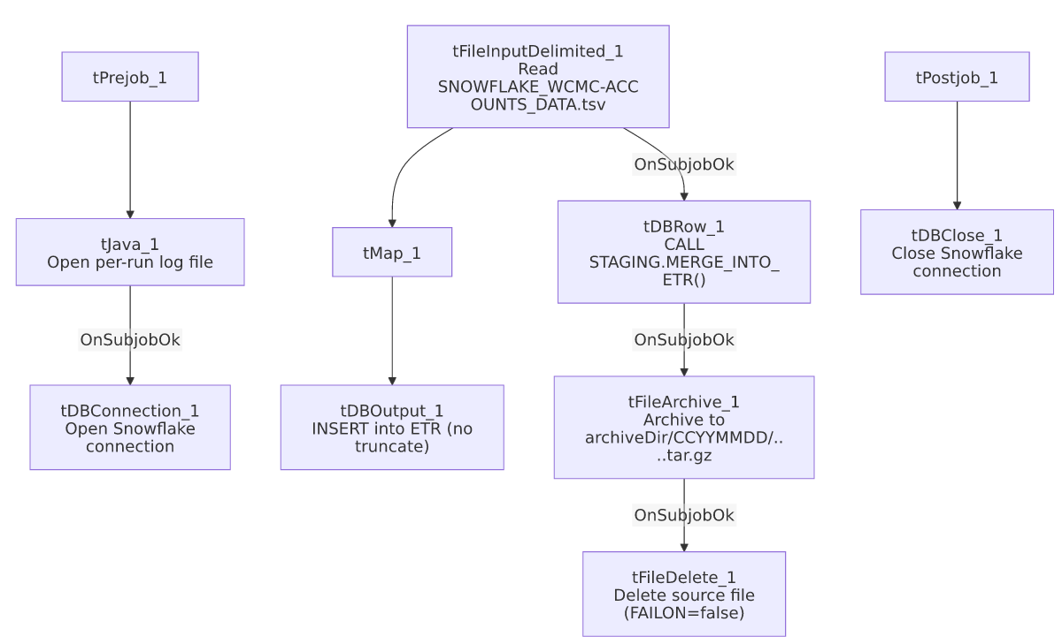

Settings tables

Source: `tFileInputDelimited_1`
Setting | Value | What it means
FILENAME | context.sourceDir+"SNOWFLAKE_WCMC-ACCOUNTS_DATA.tsv" | A fixed filename, not derived from a tFileList iteration — this job processes exactly one named file per run.
FIELDSEPARATOR / HEADER | \t / 1 header row | Tab-separated with header.
DIE_ON_ERROR | false | Malformed rows don't fail the job; no reject flow wired (rejects silently dropped).

Target: `tDBOutput_1`
Setting | Value | What it means
Table | ETR | Destination table.
Output action / Table action | INSERT / NONE | No truncate before insert — see Issues observed.

Merge: `tDBRow_1`
Setting | Value | What it means
Query | CALL STAGING.MERGE_INTO_ETR(); | Merges the freshly-inserted ETR rows into a downstream table (not shown in this metadata).

Archive: `tFileArchive_1`
Setting | Value | What it means
TARGET | context.archiveDir+TalendDate.getDate("CCYYMMDD")+"/SNOWFLAKE_WCMC-ACCOUNTS_DATA.tsv.tar.gz" | Archives into a date-stamped subfolder, .tgz format.
SOURCE_FILE | "C:/Talend-Studio-20211109_1610-V8.0.1/workspace/source.csv" (hardcoded) | A hardcoded, seemingly unrelated filename (source.csv, not the actual .tsv source) — see Issues observed.

Dependencies & configuration
- Triggers/depends on other jobs: none — no tRunJob links found.
- Context variables used: archiveDir, logDir, sourceDir.
- 4 hardcoded developer-workstation paths: tFileInputDelimited_1.TEMP_DIR, tFileDelete_1.DIRECTORY, tFileDelete_1.PATH, tFileArchive_1.SOURCE_FILE (all C:/Talend-Studio-20211109_1610-V8.0.1/workspace/...).

Glossary
Component type | Plain-English meaning
tFileInputDelimited | Reads a delimited (CSV/TSV-style) text file according to a schema.
tMap | Maps/transforms columns from one schema to another.
tSnowflakeOutput / tSnowflakeConnection / tSnowflakeClose / tSnowflakeRow | Write rows to Snowflake / open and close the connection / run arbitrary SQL against it.
tFileArchive / tFileDelete | Zip a processed file to an archive location, then delete the original from the source directory.

Issues observed
- `tDBOutput_1` has no `TRUNCATE` before the insert (`tableAction=NONE`), and the source file is read by a fixed filename rather than an incrementing/timestamped list — if this job is re-run (e.g. after a partial failure) without the source file having changed, the same rows would be inserted into ETR a second time, since there is no incremental filter or upsert key visible in this metadata. This differs from most other file-load jobs in this project (e.g. ADP_Payroll_Load), which explicitly TRUNCATE before inserting. Verify whether ETR is a true staging table that's expected to be cleared by the MERGE_INTO_ETR() procedure itself, or whether this is a gap.
- `tFileArchive_1.SOURCE_FILE` is hardcoded to `"C:/Talend-Studio-20211109_1610-V8.0.1/workspace/source.csv"` — a filename (source.csv) that doesn't match the actual source file this job processes (SNOWFLAKE_WCMC-ACCOUNTS_DATA.tsv). This looks like a leftover default value from the component's template that was never updated to reference the real source file; combined with the archive step's SOURCE parameter correctly using context.sourceDir, the practical archiving behavior may still work correctly (the SOURCE/TARGET pair appear to drive the actual archive operation), but the unused/stale SOURCE_FILE value is worth cleaning up to avoid confusion.
- No reject flow wired from `tFileInputDelimited_1` — malformed rows are silently dropped (DIE_ON_ERROR=false), consistent with the project-wide pattern.
- No result-code checking on the `MERGE_INTO_ETR()` call — a failure there would surface only as a generic Talend execution error, unlike ADP_Payroll_Load's explicit tDie-on-merge-failure pattern.
- The business meaning of "ETR" is not defined anywhere in this job's metadata — the column names (ETR, ETR_ADJ_AMT, ETR_PMT_AMT, ETR_BALANCE, ETR_CANCEL_DT, ETR_ASSIGN_DT) suggest some kind of billing/transaction-rate or extended-terms record tied to a debtor account, but the acronym itself is unexplained. Verify with the team.

