Talend Job: EmployeeHrsWorked_Load

Overview
An incremental loader for employee time/payroll hours: it computes the current maximum UpdateAuditKey already in Snowflake EMPLOYEEHRSWORKED, then pulls rows from the "EDWProdHH" MSSQL source (regular time, sick/PTO/unpaid time, dollars, employee name/description) and upserts them. Structurally near-identical to EmployeeRates_Load in this same batch — same connection pattern, same max-key watermark approach, same UPSERT target action — differing only in the specific columns and table names.

Detail table
Field | Value
Job name | EmployeeHrsWorked_Load
Version | 0.1
Project | EDW2SF
Author | jmach@harriscollect.com
Created | 2022-03-23T15:03:57.290-0700
Last Modified | 2025-09-24T11:01:04.121-0700

Step-by-step data flow
Setup subjob: tPrejob_1 → tDBConnection_1 (Snowflake) → tDBConnection_2 (MSSQL, "EDWProdHH" context variables).
Main subjob:
- tDBInput_2 runs SELECT CAST(COALESCE(MAX(UPDATEAUDITKEY),0) AS VARCHAR(10)) AS MAX_UPDATE_KEY FROM DW.EMPLOYEEHRSWORKED; against Snowflake.
- tJavaRow_1 captures the value into context.maxUpdateKey.
- On success, tDBInput_1 runs a SELECT against MSSQL pulling EmployeeHrsWorkedKey, EmployeeHrsWorkedID, PayrollID, TimeDate, RegTime, SPTO, UPTO, FirstName, LastName, Description, Dollars, UpdateAuditKey (query text truncated in this metadata — no visible WHERE clause referencing context.maxUpdateKey, see Issues observed).
- tMap_1 passes the row through.
- tFlowMeter_1 counts rows.
- tDBOutput_1 upserts the rows into Snowflake EMPLOYEEHRSWORKED (outputAction=UPSERT, tableAction=NONE).
Teardown subjob: tPostjob_1 → tDBClose_1 (Snowflake) → tDBClose_2 (MSSQL).
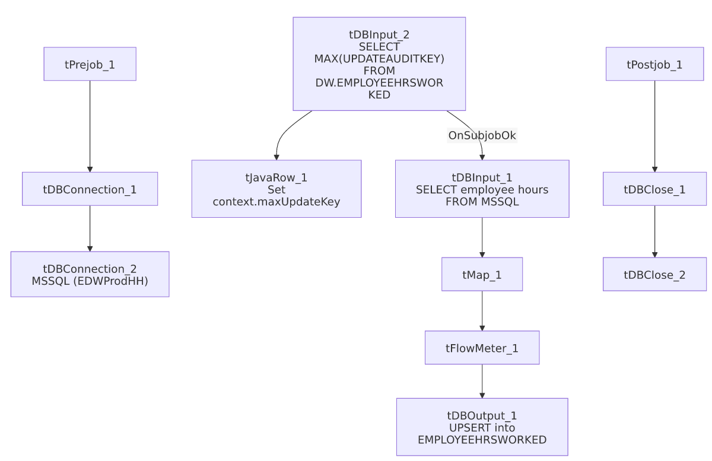

Settings tables

Source: `tDBInput_1`
Setting | Value | What it means
Query (visible) | SELECT CAST(EmployeeHrsWorkedKey AS NUMERIC(10,0)) AS EmployeeHrsWorkedKey, EmployeeHrsWorkedID, CAST(PayrollID AS NUMERIC(10,0)) AS PayrollID, TimeDate, RegTime, SPTO, UPTO, FirstName, LastName, Descript... (truncated) | Per-employee, per-date time entry: regular time, sick PTO, unpaid PTO, and dollar value.

Target: `tDBOutput_1`
Setting | Value | What it means
Table | EMPLOYEEHRSWORKED | Destination table.
Output action | UPSERT | Updates existing rows / inserts new ones by key — safe against duplication even if the source query's filter can't be confirmed.
Table action | NONE | No truncate — consistent with an incremental/upsert design.

Dependencies & configuration
- Triggers/depends on other jobs: none — no tRunJob links found.
- Context variables used: EDWProdHH_Database, EDWProdHH_Login, EDWProdHH_Port, EDWProdHH_Schema, EDWProdHH_Server, maxUpdateKey (computed internally).
- No hardcoded developer-workstation paths found in this job.

Glossary
Component type | Plain-English meaning
tMSSqlInput / tMSSqlConnection / tMSSqlClose | Query a Microsoft SQL Server source / open and close that connection.
tSnowflakeInput / tSnowflakeOutput / tSnowflakeConnection / tSnowflakeClose | Query, write to, connect to, or close a Snowflake connection.
tMap | Maps/transforms columns from one schema to another.
tFlowMeter | Counts rows passing a point in the flow for logging/monitoring.
tJavaRow | Runs custom Java code once per input row — here used to unpack a single query result into a context variable.

Issues observed
- Whether the source query actually filters on `context.maxUpdateKey` cannot be confirmed — the tDBInput_1.QUERY text is truncated in this metadata before any WHERE clause would appear, the same gap seen in i3_CallDetail_40_Load and DimDebtor_Load. Because tDBOutput_1 uses UPSERT rather than a plain INSERT, a full (unfiltered) re-read would not create duplicate rows in Snowflake even if the filter is missing — but it would mean every run re-reads and re-transmits the entire source table, which is a performance/cost concern rather than a correctness one. Verify the actual query text in Talend Studio.
- Beyond that, no other findings beyond the project-wide patterns already documented in 05_operational_runbook.md — this is a straightforward, low-risk incremental dimension/fact-style load.

