Talend Job: EmployeeRates_Load

Overview
An incremental loader for employee hourly-pay-rate records: it computes the current maximum UpdateKey already in Snowflake EMPLOYEERATES, then pulls only newer rows from the "EDWProdHH" MSSQL EmployeeRates table and upserts them. Structurally near-identical to EmployeeHrsWorked_Load in this same batch, but — unlike that sibling — this job's incremental WHERE clause is confirmed present in the captured metadata (see Settings table).

Detail table
Field | Value
Job name | EmployeeRates_Load
Version | 0.1
Project | EDW2SF
Author | jmach@harriscollect.com
Created | 2022-03-24T09:24:34.387-0700
Last Modified | 2025-09-24T10:59:37.877-0700

Step-by-step data flow
Setup subjob: tPrejob_1 → tDBConnection_1 (Snowflake) → tDBConnection_2 (MSSQL, "EDWProdHH" context variables).
Main subjob:
- tDBInput_2 runs SELECT CAST(COALESCE(MAX(UPDATEKEY),0) AS VARCHAR(10)) AS MAX_UPDATE_KEY FROM DW.EMPLOYEERATES; against Snowflake.
- tJavaRow_1 captures the value into context.maxUpdateKey.
- On success, tDBInput_1 runs SELECT CAST(PayrollId AS NUMERIC(10,0)) AS PayrollId, Field1, Field2, CAST(HourRate AS NUMERIC(16,2)) AS HourRate, CAST(COALESCE(UpdateKey,InsertKey,0) AS NUMERIC(10,0)) AS UpdateKey FROM EmployeeRates WHERE COALESCE(UpdateKey,InsertKey,0) > + (query truncated, but the WHERE clause referencing an incremental key is visible).
- tMap_1 passes the row through.
- tFlowMeter_1 counts rows.
- tDBOutput_1 upserts the rows into Snowflake EMPLOYEERATES (outputAction=UPSERT, tableAction=NONE).
Teardown subjob: tPostjob_1 → tDBClose_1 (Snowflake) → tDBClose_2 (MSSQL).
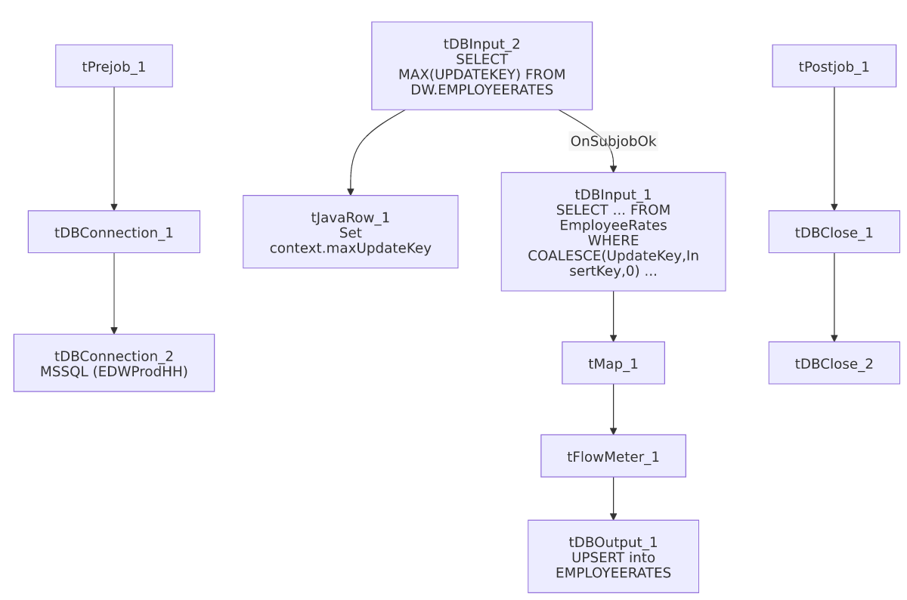

Settings tables

Source: `tDBInput_1`
Setting | Value | What it means
Query | SELECT CAST(PayrollId AS NUMERIC(10,0)) AS PayrollId, Field1, Field2, CAST(HourRate AS NUMERIC(16,2)) AS HourRate, CAST(COALESCE(UpdateKey,InsertKey,0) AS NUMERIC(10,0)) AS UpdateKey FROM EmployeeRates WHERE COALESCE(UpdateKey,InsertKey,0) > ... (truncated after the comparison operator, but the incremental filter itself is confirmed present) | Falls back to InsertKey when UpdateKey is null, so both newly-inserted and later-updated rate rows are captured by the same watermark.
Field1 / Field2 | Generic column names, no business label in this metadata | Unable to determine what these represent from the source schema alone — likely client/logon or rate-category identifiers given their position next to PayrollId; verify against the MSSQL source schema directly.

Target: `tDBOutput_1`
Setting | Value | What it means
Table | EMPLOYEERATES | Destination table.
Output action | UPSERT | Updates existing rows / inserts new ones by key.
Table action | NONE | No truncate — consistent with the incremental design.

Dependencies & configuration
- Triggers/depends on other jobs: none — no tRunJob links found.
- Context variables used: EDWProdHH_Database, EDWProdHH_Login, EDWProdHH_Port, EDWProdHH_Schema, EDWProdHH_Server, maxUpdateKey (computed internally).
- No hardcoded developer-workstation paths found in this job.

Glossary
Component type | Plain-English meaning
tMSSqlInput / tMSSqlConnection / tMSSqlClose | Query a Microsoft SQL Server source / open and close that connection.
tSnowflakeInput / tSnowflakeOutput / tSnowflakeConnection / tSnowflakeClose | Query, write to, connect to, or close a Snowflake connection.
tMap | Maps/transforms columns from one schema to another.
tFlowMeter | Counts rows passing a point in the flow for logging/monitoring.
tJavaRow | Runs custom Java code once per input row — here used to unpack a single query result into a context variable.

Issues observed
- `Field1` and `Field2` are unlabeled generic column names in both the source and target schema — unlike every other job in this batch, this table's business meaning for two of its five columns cannot be determined from the metadata at all. Verify against the MSSQL EmployeeRates table's actual column names/comments if this data needs to be interpreted.
- This job's incremental filter is confirmed present (WHERE COALESCE(UpdateKey,InsertKey,0) > ...), unlike its EmployeeHrsWorked_Load sibling where the equivalent WHERE clause is truncated out of the captured metadata — worth using this job's confirmed pattern as a reference point if verifying EmployeeHrsWorked_Load's actual query in Talend Studio.
- Beyond the unlabeled columns, no other findings beyond the project-wide patterns already documented in 05_operational_runbook.md.

