Talend Job: Employee_Collector_Load

Overview
Loads a collector/employee roster file (employee.csv: name, initials, desk, department, team, CUBS logon, payroll ID, start/end dates, supervisor/manager, alias, username, title, agent type, subgroup, director) into Snowflake EMPLOYEE_COLLECTOR, upserting by key. Before loading, it checks whether the source file exists at all; after loading, it separately checks existence again and — if present — copies (archives) the file to a dated backup name in an archive/ subfolder.

Detail table
Field | Value
Job name | Employee_Collector_Load
Version | 0.1
Project | EDW2SF
Author | jmach@harriscollect.com
Created | 2022-02-08T15:26:23.330-0700
Last Modified | 2025-11-12T07:21:17.902-0800

Step-by-step data flow
Setup subjob: tPrejob_1 → tSetKeystore_1 configures SSL trust/keystore (hardcoded truststore path, context.keystorePath for keystore) → on subjob success, tDBConnection_1 opens the Snowflake connection.
Main subjob:
- tFileExist_1 checks whether context.sourceDir + "employee.csv" exists.
- If it exists (RUN_IF), tFileInputDelimited_1 reads the file (pipe-delimited |, header row present, US-ASCII encoding, DIE_ON_ERROR=false) using repository schema "...empcol" for both main and reject.
- tMap_1 maps the ~19 source columns through to the target schema.
- tFlowMeter_4 counts rows.
- tDBOutput_1 upserts the rows into Snowflake EMPLOYEE_COLLECTOR (outputAction=UPSERT, tableAction=NONE).
- Separately, on tFileInputDelimited_1's subjob success, tFileExist_2 checks again whether context.sourceDir + "employee.csv" exists.
- If it exists (RUN_IF), tFileCopy_1 copies/renames the file to context.sourceDir + "archive/" + "employee_" + <CCYY-MM-DD> + ".csv" (REMOVE_FILE=true — deletes the original after copying, REPLACE_FILE=true, CREATE_DIRECTORY=true, FAILON=false).
Teardown subjob: tPostjob_1 → tDBClose_1 (Snowflake).
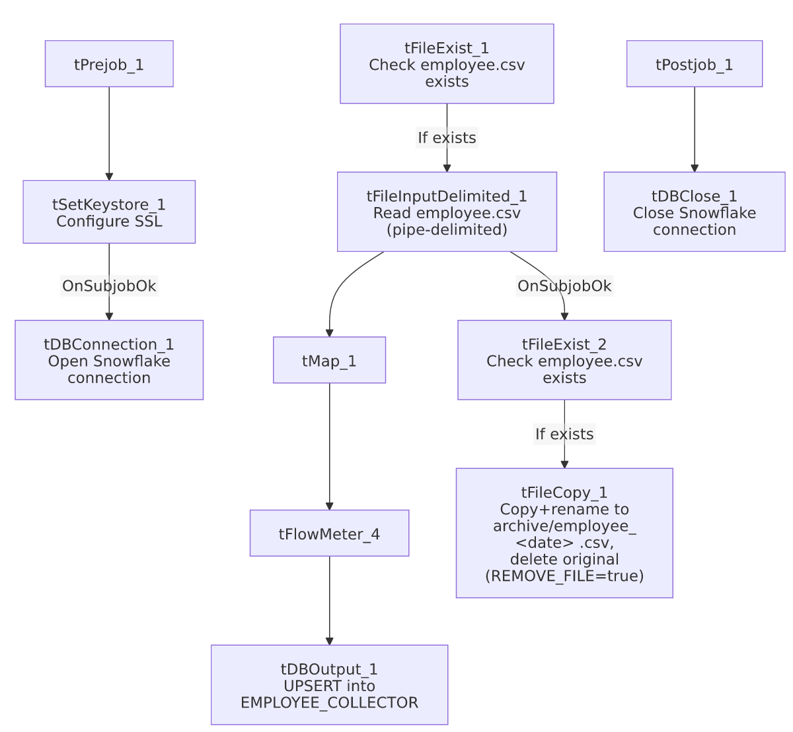

Settings tables

Source: `tFileInputDelimited_1`
Setting | Value | What it means
FILENAME | context.sourceDir+"employee.csv" | Fixed filename, no tFileList iteration.
FIELDSEPARATOR / HEADER | `\ | ` / 1 header row
DIE_ON_ERROR | false | Malformed rows don't fail the job; no reject flow wired (rejects silently dropped).

Target: `tDBOutput_1`
Setting | Value | What it means
Table | EMPLOYEE_COLLECTOR | Destination roster table.
Output action | UPSERT | Updates existing collector records / inserts new ones by key.
Table action | NONE | No truncate — consistent with an upsert design.

Archive: `tFileCopy_1`
Setting | Value | What it means
DESTINATION / DESTINATION_RENAME | context.sourceDir+"archive/" / "employee_"+<CCYY-MM-DD>+".csv" | Archives to a dated filename in an archive/ subfolder under the same source directory.
REMOVE_FILE | true | The original employee.csv is deleted after the copy — effectively a "move and rename" rather than a plain copy.
FAILON | false | A failed copy/archive does not fail the job.

Dependencies & configuration
- Triggers/depends on other jobs: none — no tRunJob links found.
- Context variables used: keystorePath, sourceDir.
- 3 hardcoded developer-workstation/config paths: tFileInputDelimited_1.TEMP_DIR (C:/Talend-Studio-20211109_1610-V8.0.1/workspace), tFileCopy_1.SOURCE_DERECTORY (same path — see Issues observed), tSetKeystore_1.SSL_TRUSTSERVER_TRUSTSTORE ("C:/clientTrustStore.trustStore").

Glossary
Component type | Plain-English meaning
tSetKeystore | Configures the SSL trust/keystore used for secure connections made later in the job.
tFileExist | Checks whether a specific file exists on disk, without reading its contents.
tFileInputDelimited | Reads a delimited (CSV/pipe-style) text file according to a schema.
tMap | Maps/transforms columns from one schema to another.
tFlowMeter | Counts rows passing a point in the flow for logging/monitoring.
tSnowflakeOutput / tSnowflakeConnection / tSnowflakeClose | Write rows to Snowflake / open and close the connection.
tFileCopy | Copies (and optionally renames, and optionally deletes the original from) a file.

Issues observed
- No "file does not exist" branch is wired from either `tFileExist_1` or `tFileExist_2`. Both tFileExist components only have a RUN_IF ("exists") branch connected — if employee.csv is missing when the job runs, the main load subjob and the archive subjob simply don't execute, with no tWarn/tSendMail/tDie to flag that nothing happened. This means a missing source file on a given run would produce a silently "successful" job with zero rows loaded and no record archived — unlike Semaphore_Check's explicit missing-file alerting pattern elsewhere in this project. Worth confirming whether a missing employee.csv should actually raise an alert.
- `tFileCopy_1.SOURCE_DERECTORY` is hardcoded to the workspace path (C:/Talend-Studio-20211109_1610-V8.0.1/workspace), but tFileCopy_1.ENABLE_COPY_DIRECTORY=false, meaning the actual source of the copy is driven by the FILENAME parameter (context.sourceDir + "employee.csv") instead. The SOURCE_DERECTORY value therefore appears to be an unused vestige of the component's default configuration rather than a live portability risk — but it's still worth cleaning up, since a future change to ENABLE_COPY_DIRECTORY would silently activate this stale hardcoded path.
- No reject flow wired from `tFileInputDelimited_1` — malformed rows are silently dropped (DIE_ON_ERROR=false), consistent with the project-wide pattern.
- No result/row-count logging (no tWarn/tDie/tSendMail) — a load failure or an unexpectedly empty file would only surface as a generic Talend execution error or a silent no-op, per the missing-file issue above.

