Talend Job: EncryptValue_ContextVariable

Overview
This is a developer utility/test job, not part of the production CUBS data pipeline: it demonstrates the encrypt/decrypt round-trip for a single hardcoded key/value pair using Talend's tDataEncrypt/tDataDecrypt components, writing and reading the result to/from a local Java .properties file. It moves no business data — it exists to verify that a chosen encryption password/algorithm produces a value that can be written to a properties file and correctly decrypted back, presumably as a template or test harness for other jobs (e.g. Encrypt_CHI_Fiscal_Tax_Code, Encrypt_CO_Fiscal_A_F18_A) that encrypt real fiscal/tax fields.

Detail table
Field | Value
Job name | EncryptValue_ContextVariable
Version | 0.1
Project | EDW2SF
Author | jmach@harriscollect.com
Created | 2019-06-13T02:47:34.093+0100
Last Modified | 2025-08-28T08:57:11.449-0700

Step-by-step data flow
Setup: tPrejob_1 → LoadContext_1 (a Joblets-family component that loads context, triggered OnComponentOk from the prejob).
Main subjob (two independent chains):
- Encrypt chain: tFixedFlowInput_3 emits a single hardcoded row with two columns (key, value) → tDataEncrypt_2 encrypts the row using a redacted password/secret type, reading its crypto file path from context.crytographicFilePath → tLogRow_4 prints the encrypted row to the log → tFileOutputProperties_1 writes it as a Java properties file (section "section") to the hardcoded path C:/Users/vmehra.TALEND/Documents/Project/MBO/MBO-DataPrivacy/test/global.properties.
- Decrypt chain (runs after the encrypt chain completes, `OnSubjobOk`): tFileInputProperties_1 reads the same properties file back in → tDataDecrypt_1 decrypts it (same redacted password/crypto file path) → tLogRow_1 prints the decrypted row to the log, to visually confirm the round-trip worked.
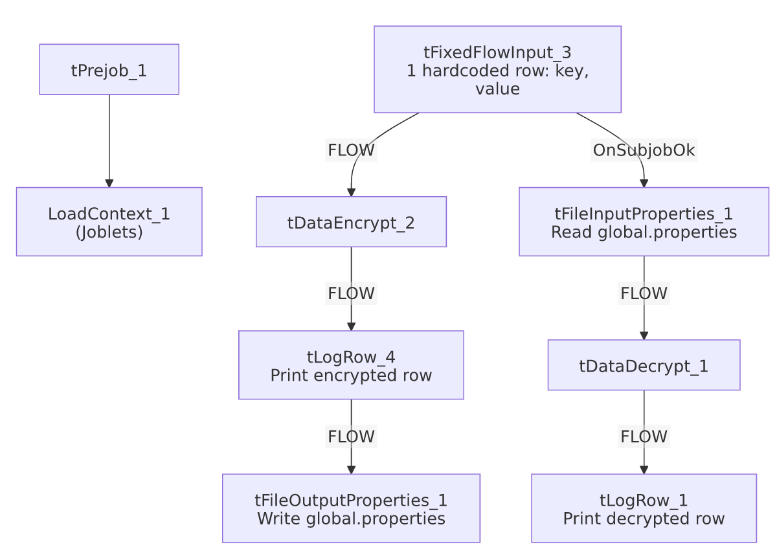

Settings tables

Encrypt path: `tDataEncrypt_2` / `tFileOutputProperties_1`
Setting | Value | What it means
PASSWORD_M1 | ***REDACTED*** | Encryption password — preserved as redacted, not guessable from metadata.
SECRET_TYPE | ***REDACTED*** | Also redacted.
CRYPTO_FILE_PATH | context.crytographicFilePath | Points to the cryptographic key file used for the encryption algorithm.
Output file | "C:/Users/vmehra.TALEND/Documents/Project/MBO/MBO-DataPrivacy/test/global.properties" | A hardcoded, individual developer's Windows user-profile path — see Issues observed.

Decrypt path: `tFileInputProperties_1` / `tDataDecrypt_1`
Setting | Value | What it means
Input file | Same hardcoded path as above | Reads back the file just written.
PASSWORD_M1 / SECRET_TYPE | ***REDACTED*** | Same redacted values, needed to successfully decrypt.

Dependencies & configuration
- Triggers/depends on other jobs: none — no tRunJob links found.
- Context variables used: crytographicFilePath — matches the variable name/comment in the ContextManagement_GlobalVariables_0.1 context group (crytographicFilePath?), whose default sample values in _shared_context.json are themselves individual-developer paths (e.g. C:/Users/vmehra.TALEND/..., C:/Temp/password).
- No entries in hardcoded_path_findings for this job specifically, but the tFileOutputProperties_1.FILENAME value is itself a hardcoded, non-context-driven Windows path under a named developer's user profile — functionally the same portability risk documented project-wide in 05_operational_runbook.md, just not flagged in that field.

Glossary
Component type | Plain-English meaning
LoadContext (Joblets) | A reusable sub-flow ("joblet") that loads context variables at the start of a job.
tFixedFlowInput | Emits a small number of hardcoded rows defined directly in the component, used here purely as test data.
tDataEncrypt / tDataDecrypt | Encrypts/decrypts row data using a password and crypto-file-based algorithm.
tFileOutputProperties / tFileInputProperties | Write/read a Java-style .properties file, organized into named sections.
tLogRow | Prints the rows passing through it to the job's console/log, for debugging or verification.

Issues observed
- This job's output path is a named individual developer's local Windows user profile (C:/Users/vmehra.TALEND/Documents/...), not a shared/context-driven location — if this job is ever run outside that developer's original workstation, both the encrypt write and the decrypt read will fail because the directory won't exist. This is the same class of risk as the project's widely documented C:/Talend-Studio-... hardcoded paths (see 05_operational_runbook.md), but tied to a specific person rather than the shared install path.
- This job appears to be a test/demo harness, not a production data-moving job — it operates on a single hardcoded row and writes into a path named .../test/global.properties. It's unclear from metadata whether it's still actively used, retained as a reference example, or effectively dead — verify with the team before assuming it needs the same operational monitoring as the project's real load jobs.
- The actual encryption password, secret type, and crypto file contents are `*REDACTED*` in this metadata, consistent with the strict grounding rule against reconstructing sensitive values — verify these directly in Talend Studio/the crypto key store if needed.

