Talend Job: Encrypt_CHI_Fiscal_Tax_Code

Overview
This job encrypts the fiscal tax code field for CHI-site debtors directly inside the Snowflake staging table STAGING.CUBS_DEBTOR_RAW, in place. It reads the debtor index and tax code (COL3/COL106) for rows where COL1='CHI' and the tax code is non-blank, encrypts the tax code, stages the encrypted values in a throwaway table, then runs an UPDATE to write the encrypted value back over the original plaintext column in CUBS_DEBTOR_RAW. This is a PII/tax-data protection step scoped specifically to the CHI site.

Detail table
Field | Value
Job name | Encrypt_CHI_Fiscal_Tax_Code
Version | 0.1
Project | EDW2SF
Author | jmach@harriscollect.com
Created | 2022-09-14T09:37:49.895-0700
Last Modified | 2025-09-24T11:01:05.192-0700

Step-by-step data flow
Setup subjob: tPrejob_1 → tDBConnection_1 opens the Snowflake connection.
Main subjob:
- tDBInput_1 runs SELECT COL3, COL106 FROM STAGING.CUBS_DEBTOR_RAW WHERE COL1='CHI' AND TRIM(COL106) <> '' — pulling only CHI-site rows (COL1='CHI') that actually have a tax code value, aliased in the output schema as DEBTOR_IDX/TAXCODE_F15.
- tDataEncrypt_1 encrypts TAXCODE_F15 (AES, redacted secret key/password/type), reading its crypto file path from context.cryptoPath.
- tDBOutput_1 writes the encrypted rows into TMP_CHI_TAXCODE, dropping and recreating the table each run (DROP_IF_EXISTS_AND_CREATE).
- Once tDBInput_1's subjob completes successfully (OnSubjobOk), tDBRow_1 runs UPDATE STAGING.CUBS_DEBTOR_RAW dbt SET COL106 = chi.TAXCODE_F15 FROM TMP_CHI_TAXCODE chi WHERE dbt.COL3 = chi.DEBTOR_IDX; — overwriting the plaintext tax code in the staging table with the encrypted value, joined back on the debtor index.
Teardown subjob: tPostjob_1 → tDBClose_1 closes the Snowflake connection.
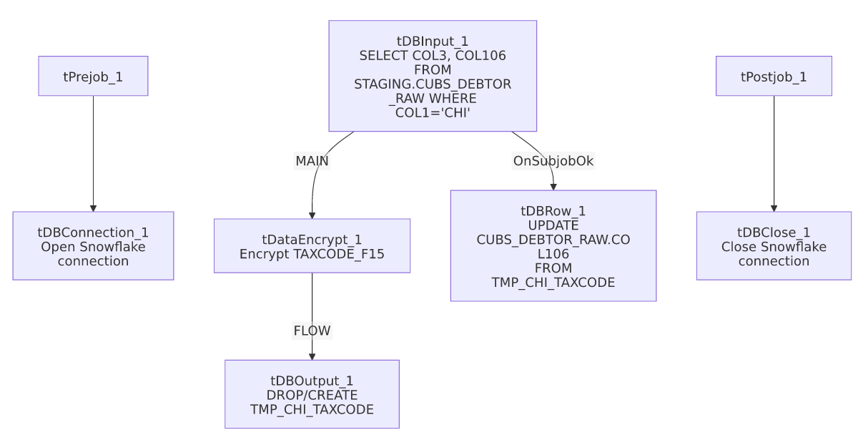

Settings tables

Source: `tDBInput_1` (`tSnowflakeInput`)
Setting | Value | What it means
Query | SELECT COL3, COL106 FROM STAGING.CUBS_DEBTOR_RAW WHERE COL1='CHI' AND TRIM(COL106) <> '' | Reads only CHI-site rows with a non-blank tax code; COL3/COL106 are generic staging-table column names aliased to DEBTOR_IDX/TAXCODE_F15 in the output schema.

Encrypt: `tDataEncrypt_1`
Setting | Value | What it means
SECRET_TYPE / SECRET_KEY / PASSWORD_M1 | ***REDACTED*** | Encryption credentials, preserved as redacted.
CRYPTO_METHOD | AES | Symmetric encryption algorithm.
CRYPTO_FILE_PATH | context.cryptoPath | Key/crypto file location.
ALGO_VERSION | 2 | Talend's internal encryption algorithm version.

Stage: `tDBOutput_1` (`tSnowflakeOutput`)
Setting | Value | What it means
Table | TMP_CHI_TAXCODE | A throwaway table holding the encrypted values before they're merged back.
Table action | DROP_IF_EXISTS_AND_CREATE | Table is fully rebuilt every run, so there's no risk of stale rows from a prior run.
Output action | INSERT | Simple append into the freshly recreated table.

Merge-back: `tDBRow_1` (`tSnowflakeRow`)
Setting | Value | What it means
Query | UPDATE STAGING.CUBS_DEBTOR_RAW dbt SET COL106 = chi.TAXCODE_F15 FROM TMP_CHI_TAXCODE chi WHERE dbt.COL3 = chi.DEBTOR_IDX;; | Overwrites the plaintext tax code column in place with the encrypted value, matched by debtor index. Note the trailing double semicolon (;;) — harmless in Snowflake SQL but a minor copy-paste artifact.

Dependencies & configuration
- Triggers/depends on other jobs: none — no tRunJob links found.
- Context variables used: cryptoPath (crypto key file location for tDataEncrypt_1).
- No hardcoded developer-workstation paths found in this job's own components.
- This job operates directly on STAGING.CUBS_DEBTOR_RAW, the same generic staging table referenced by the CO-site sibling Encrypt_CO_Fiscal_A_F18_A targets a different table (DIMFISCAL_CO_A) — the two encryption jobs are not simply the same template with a site code swapped; they operate on different tables and column structures entirely (see that job's own doc).

Glossary
Component type | Plain-English meaning
tSnowflakeConnection / tSnowflakeClose | Open/close the Snowflake connection shared by other components in the job.
tSnowflakeInput | Runs a query against Snowflake and returns its result rows.
tDataEncrypt | Encrypts row/column data using a password and crypto-file-based algorithm.
tSnowflakeOutput | Writes rows to a Snowflake table, optionally dropping/recreating it first.
tSnowflakeRow | Runs an arbitrary SQL statement (here, an UPDATE ... FROM ... merge-back) against Snowflake.

Issues observed
- `COL3` and `COL106` are generic, un-named staging columns (STAGING.CUBS_DEBTOR_RAW appears to be a wide, genericized raw-load table where business meaning is only assigned by position/alias). This job's own aliasing (DEBTOR_IDX, TAXCODE_F15) is the only place that meaning is documented — if the underlying CUBS_DEBTOR_RAW column layout ever changes, COL3/COL106 could silently start referring to different data with no compile-time warning.
- No error handling or row-count logging — no tWarn, tDie, or tSendMail. If the UPDATE in tDBRow_1 fails or matches zero rows (e.g., because the join on DEBTOR_IDX doesn't line up), the job would still report success with no indication that no tax codes were actually encrypted.
- Beyond the above, nothing else stands out in this job's own metadata beyond the project-wide patterns already documented in 05_operational_runbook.md.

