Talend Job: Encrypt_CO_Fiscal_A_F18_A

Overview
This job encrypts one fiscal field (F18_1) for CO-site debtors that have a non-blank value in that field, reading from DIMFISCAL_CO_A and writing the encrypted result into a new table DIMFISCAL_CO_A_UPDATE. Unlike its CHI counterpart (Encrypt_CHI_Fiscal_Tax_Code), which updates the source table in place, this job only produces a separate output table — it does not appear to write the encrypted value back into DIMFISCAL_CO_A itself within this job.

Detail table
Field | Value
Job name | Encrypt_CO_Fiscal_A_F18_A
Version | 0.1
Project | EDW2SF
Author | jmach@harriscollect.com
Created | 2023-03-16T09:22:48.373-0700
Last Modified | 2025-09-24T10:59:41.494-0700

Step-by-step data flow
Setup subjob: tPrejob_1 → tDBConnection_1 opens the Snowflake connection.
Main subjob:
- tDBInput_1 runs SELECT DEBTOR_IDX, F18_1 FROM DIMFISCAL_CO_A WHERE TRIM(COALESCE(F18_1,'')) <> ''; — pulling only CO debtors with a non-blank F18_1 value.
- tDataEncrypt_1 encrypts the row. Its own declared schema has 91 columns (a full DIMFISCAL_CO_A-shaped debtor/fiscal record — name, address, phone, judgment, bankruptcy, tax-window fields, etc.), even though only two columns (DEBTOR_IDX, F18_1) actually flow into it from tDBInput_1 — see Issues observed, this is very likely a copy-pasted component schema left over from another job.
- tMap_1 receives the row and maps it down to just DEBTOR_IDX/F18_1 (DIE_ON_ERROR=true).
- tDBOutput_1 writes the two-column result into DIMFISCAL_CO_A_UPDATE, dropping and recreating the table each run (DROP_IF_EXISTS_AND_CREATE).
Teardown subjob: tPostjob_1 → tDBClose_1 closes the Snowflake connection.
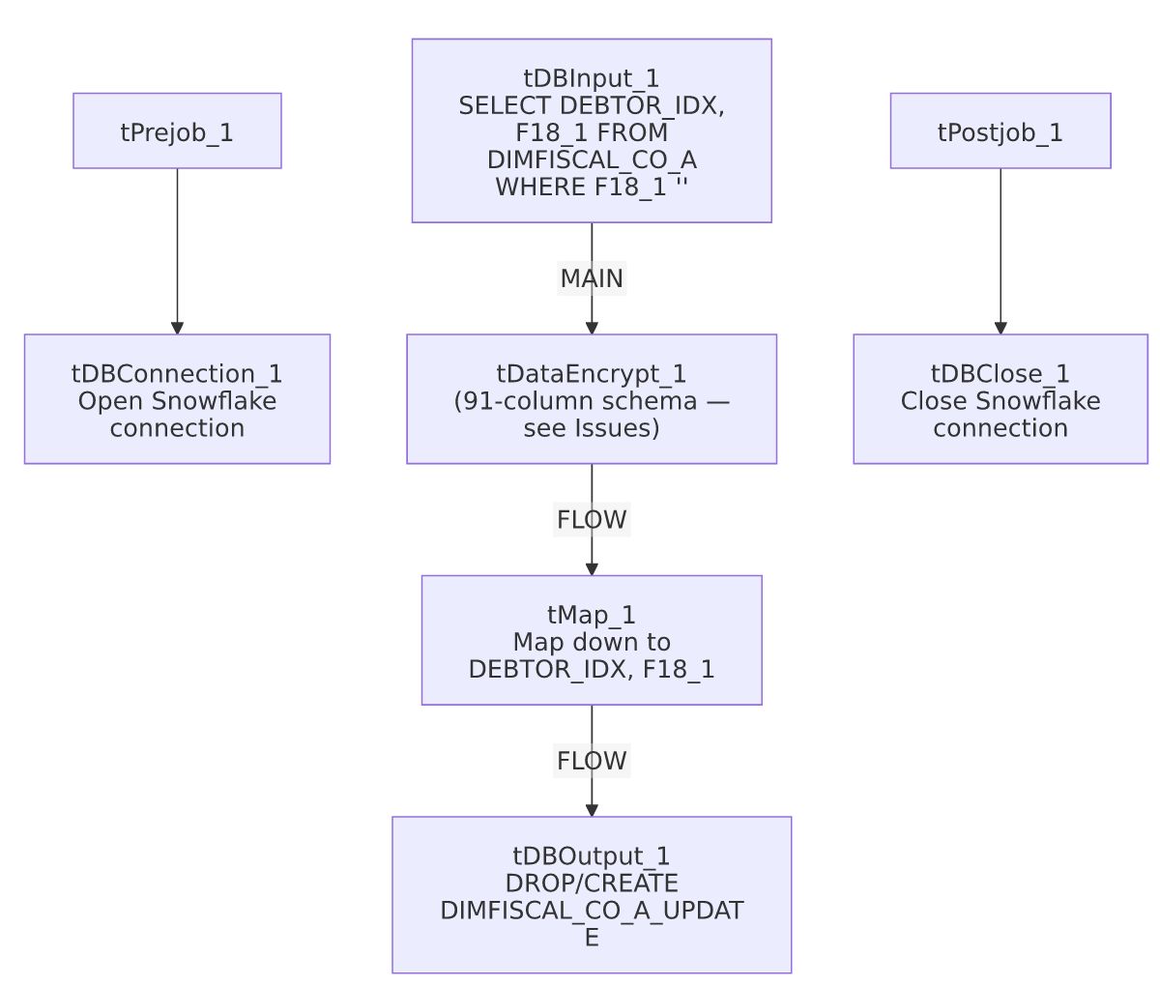

Settings tables

Source: `tDBInput_1` (`tSnowflakeInput`)
Setting | Value | What it means
Query | SELECT DEBTOR_IDX, F18_1 FROM DIMFISCAL_CO_A WHERE TRIM(COALESCE(F18_1,'')) <> ''; | Only CO debtors with a populated F18_1 value (an otherwise undocumented fiscal field — the field name gives no indication of its business meaning; unable to determine from metadata).

Encrypt: `tDataEncrypt_1`
Setting | Value | What it means
SECRET_TYPE / SECRET_KEY / PASSWORD_M1 | ***REDACTED*** | Encryption credentials, preserved as redacted.
CRYPTO_METHOD | AES | Symmetric encryption algorithm.
CRYPTO_FILE_PATH | context.cryptoPath | Key/crypto file location — same context variable name as Encrypt_CHI_Fiscal_Tax_Code.
ALGO_VERSION | 2 | Talend's internal encryption algorithm version.
Declared schema | 91 columns (full fiscal/debtor record shape) | Does not match the 2-column flow actually feeding this component — see Issues observed.

Target: `tDBOutput_1` (`tSnowflakeOutput`)
Setting | Value | What it means
Table | DIMFISCAL_CO_A_UPDATE | A separate table, not the original DIMFISCAL_CO_A — this job does not appear to merge the encrypted value back into the source table.
Table action | DROP_IF_EXISTS_AND_CREATE | Rebuilt fresh every run.
Output action | INSERT | Simple append into the freshly recreated table.

Dependencies & configuration
- Triggers/depends on other jobs: none — no tRunJob links found.
- Context variables used: cryptoPath (same variable name/purpose as in Encrypt_CHI_Fiscal_Tax_Code, though there is no evidence in either job's metadata that they share a literal value — each job references its own context.cryptoPath).
- No hardcoded developer-workstation paths found in this job's own components.
- No downstream step in this job writes the encrypted `F18_1` value back into `DIMFISCAL_CO_A` — unlike the CHI tax-code job's UPDATE ... FROM merge-back step, this job stops at producing DIMFISCAL_CO_A_UPDATE. Whether a separate job (not in this batch) consumes that table to complete the update is unable to determine from metadata; verify with the team.

Glossary
Component type | Plain-English meaning
tSnowflakeConnection / tSnowflakeClose | Open/close the Snowflake connection shared by other components in the job.
tSnowflakeInput | Runs a query against Snowflake and returns its result rows.
tDataEncrypt | Encrypts row/column data using a password and crypto-file-based algorithm.
tMap | Maps/transforms columns from one schema to another — here used to narrow a wide schema down to the two columns actually needed.
tSnowflakeOutput | Writes rows to a Snowflake table, optionally dropping/recreating it first.

Issues observed
- `tDataEncrypt_1`'s own declared schema (91 columns, matching a full debtor/fiscal record — names, addresses, phone numbers, bankruptcy/judgment fields, tax-window dates, etc.) does not match the 2-column flow (`DEBTOR_IDX`, `F18_1`) that actually feeds it from `tDBInput_1`. This is the same class of issue as ADP_Payroll_Load's mismatched reject schema — a strong signal that this component's schema was copied from another job (likely one that encrypts/handles the full DIMFISCAL_CO_A-style record) and not cleaned up when this narrower 2-column job was built from it. It does not appear to break the job (the following tMap_1 correctly narrows to 2 columns and the pipeline is functional per the connections), but it makes the job's internal metadata misleading if inspected in Talend Studio.
- The encrypted result is written only to `DIMFISCAL_CO_A_UPDATE`, not merged back into `DIMFISCAL_CO_A` itself, unlike the parallel CHI tax-code job which does perform that merge-back in the same job. If a separate merge step is expected to run afterward, it isn't visible in this job's own metadata or in 06_dependency_matrix.md's tRunJob list — verify with the team whether this is a two-step process (with the second step undocumented/out of scope here) or an intentionally different, read-only-output design.
- No error handling or row-count logging — no tWarn, tDie, or tSendMail; a failed or zero-row run would only surface as a generic Talend execution error.

