Talend Job: Equibli_Extract

Overview
A minimal, one-off extract job: it reads debtor_idx and netcash_localrank from a specifically-dated Snowflake table (edwprodhh.pub_jchang.temp_csv_equabli_20220308_clean) and writes the result straight to a hardcoded local CSV file. Every identifying detail — the source table name and the output filename — is baked in with the same date (220308 / 20220308), strongly suggesting this was built to run exactly once for a specific one-time data pull related to the "Equabli" (also spelled "Equibli" elsewhere in this project) scoring/prediction system, rather than as a recurring scheduled job.

Detail table
Field | Value
Job name | Equibli_Extract
Version | 0.1
Project | EDW2SF
Author | jmach@harriscollect.com
Created | 2022-03-18T10:20:37.247-0700
Last Modified | 2025-09-24T10:59:38.994-0700

Step-by-step data flow
This job has no tPrejob/tPostjob, no explicit connection-open/close components, and no context variables at all — just a single two-component flow:
- tDBInput_2 runs select debtor_idx, netcash_localrank from edwprodhh.pub_jchang.temp_csv_equabli_20220308_clean; against Snowflake.
- tFileOutputDelimited_1 writes the result directly to "C:/Data/Equibli_220308.csv" (comma-delimited, no header row, ISO-8859-15 encoding).
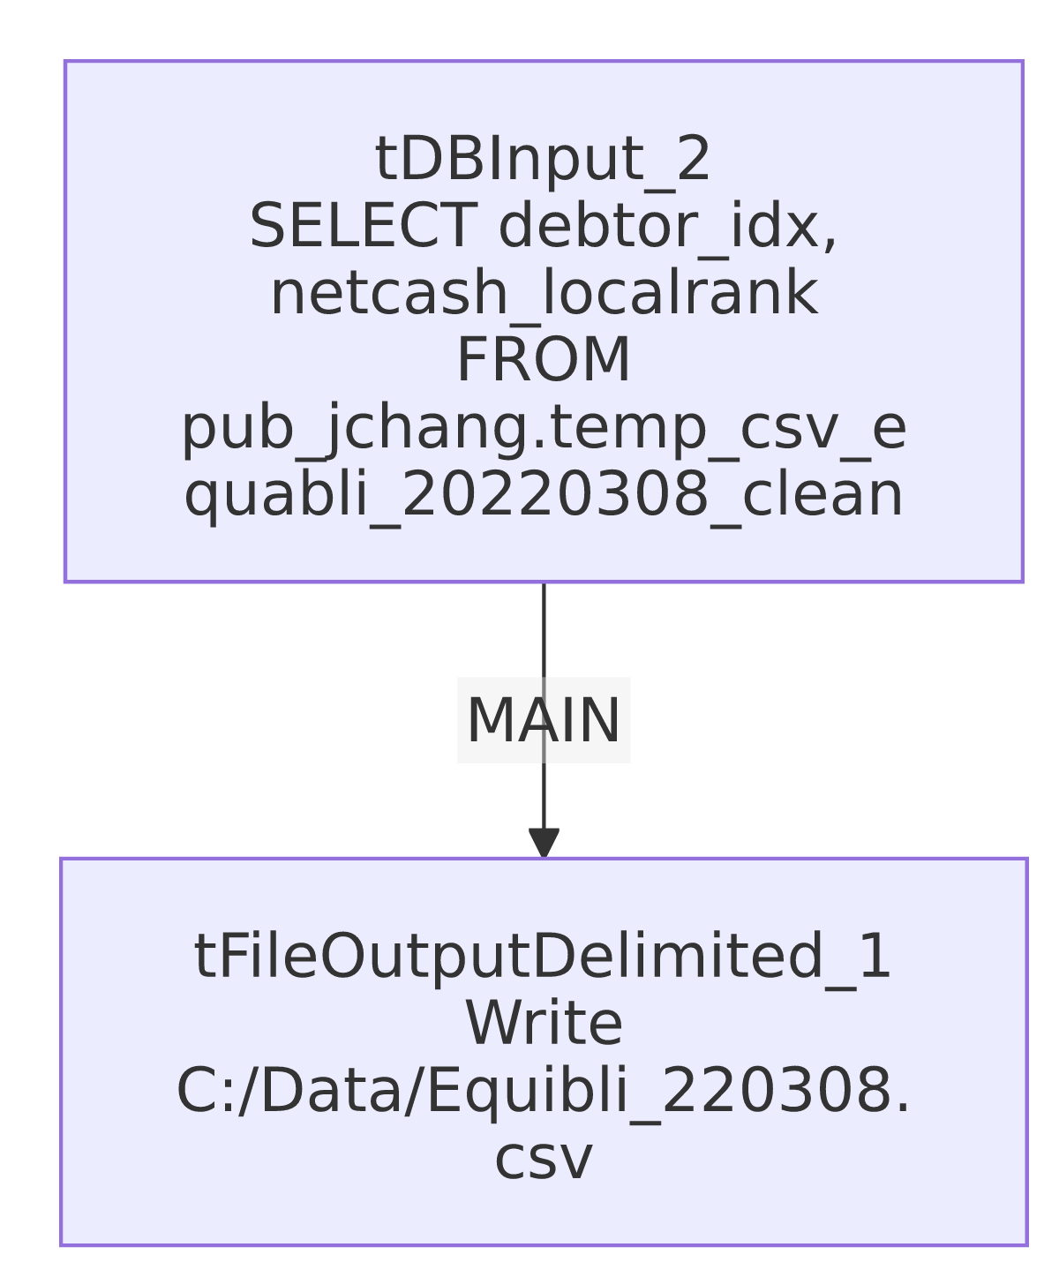

Settings tables

Source: `tDBInput_2` (`tSnowflakeInput`)
Setting | Value | What it means
Query | select debtor_idx, netcash_localrank from edwprodhh.pub_jchang.temp_csv_equabli_20220308_clean; | Reads from a table under the pub_jchang schema — flagged project-wide in 01_system_architecture.md as looking like an individually-owned schema (initials-based name) rather than shared infrastructure. The table name itself (temp_csv_equabli_20220308_clean) reads as a one-time, manually prepared staging table for a specific date.

Target: `tFileOutputDelimited_1`
Setting | Value | What it means
FILENAME | "C:/Data/Equibli_220308.csv" | Hardcoded absolute Windows path with no context. variable — not portable, and the filename itself is dated 220308 (March 8, 2022).
INCLUDEHEADER | false | No header row in the output CSV.
FIELDSEPARATOR | , | Standard CSV.

Dependencies & configuration
- Triggers/depends on other jobs: none — no tRunJob links found.
- Context variables used: none — this job uses no context.* variables anywhere, unusual for this project (most jobs use at least StandardFolders_0.1's shared path variables).
- Hardcoded path: C:/Data/Equibli_220308.csv is a fixed local path, not flagged in this job's hardcoded_path_findings array (that field only tracks the specific C:/Talend-Studio-... pattern used elsewhere), but it is functionally the same portability risk — this job cannot run correctly on any machine without a C:/Data/ directory.

Glossary
Component type | Plain-English meaning
tSnowflakeInput | Runs a query against Snowflake and returns its result rows. Notably, no tSnowflakeConnection/tSnowflakeClose components exist in this job — it must rely on Talend Studio's ability to open an implicit/default connection configured on the component itself, or an external connection context not captured here.
tFileOutputDelimited | Writes rows to a delimited (CSV-style) text file.

Issues observed
- This entire job is hardcoded end-to-end for a single date (March 8, 2022) — the source table name, the output filename, and the destination directory are all fixed literals with no context. variables. It cannot be re-run for a different date or environment without editing the job itself. This strongly suggests it was a one-time ad hoc extract that was saved into the repository rather than deleted — worth confirming with the team whether it's still needed or safe to retire.
- No `tPrejob`/`tPostjob` or explicit Snowflake connection component — every other job in this batch opens and closes its Snowflake connection explicitly via tDBConnection/tDBClose; this job has neither, meaning tDBInput_2 must be using an implicit/default connection not visible in this metadata. Unable to determine from metadata which connection that resolves to; verify directly in Talend Studio.
- No error handling of any kind (no tDie/tWarn/tSendMail), consistent with this being a disposable, manually-run job rather than a monitored production pipeline component.

