Talend Job: Extract_CHI_Hermes_Decile

Overview
Extracts the CHI-site "Hermes"/Equabli prediction decile assignment (logon, packet, debtor number, local/global score, treatment group, dialer group) from a Snowflake transformation table scoped to CHI, and writes it to a dated CSV file. This is one of a family of near-identical per-site decile extract jobs (Extract_CO_Hermes_Decile, Extract_DC_Hermes_Decile, Extract_HH_Hermes_Decile) — this one is internally consistent: its query, table name, and output filename all correctly reference CHI.

Detail table
Field | Value
Job name | Extract_CHI_Hermes_Decile
Version | 0.1
Project | EDW2SF
Author | jmach@harriscollect.com
Created | 2023-08-13T21:08:44.369-0700
Last Modified | 2025-11-05T09:09:24.534-0800

Step-by-step data flow
Setup subjob: tPrejob_1 → tJava_1 opens a per-run log file → tSetKeystore_1 configures SSL trust/keystore from context.keystorePath (passwords redacted) → tDBConnection_1 opens the Snowflake connection.
Main subjob:
- tDBInput_1 runs SELECT LOGON, PACKET, DEBTORNUMBER, PL_GROUP, "LOCAL", "GLOBAL", EQUABLI_TREATMENT_GROUP, DIALERGRP FROM MASTER_PREDICTION_SCORES_TRANSFORMATION_CUBS_DEBTOR_CHI; — a fixed, unfiltered read of the entire CHI-scoped transformation table.
- tFileOutputDelimited_1 writes the result to context.outputDir + "CHI_HERMES_DECILE_" + <CCYYMMDD> + ".csv" (comma-delimited, header included).
Teardown subjob: tPostjob_1 → tDBClose_1 closes the Snowflake connection.
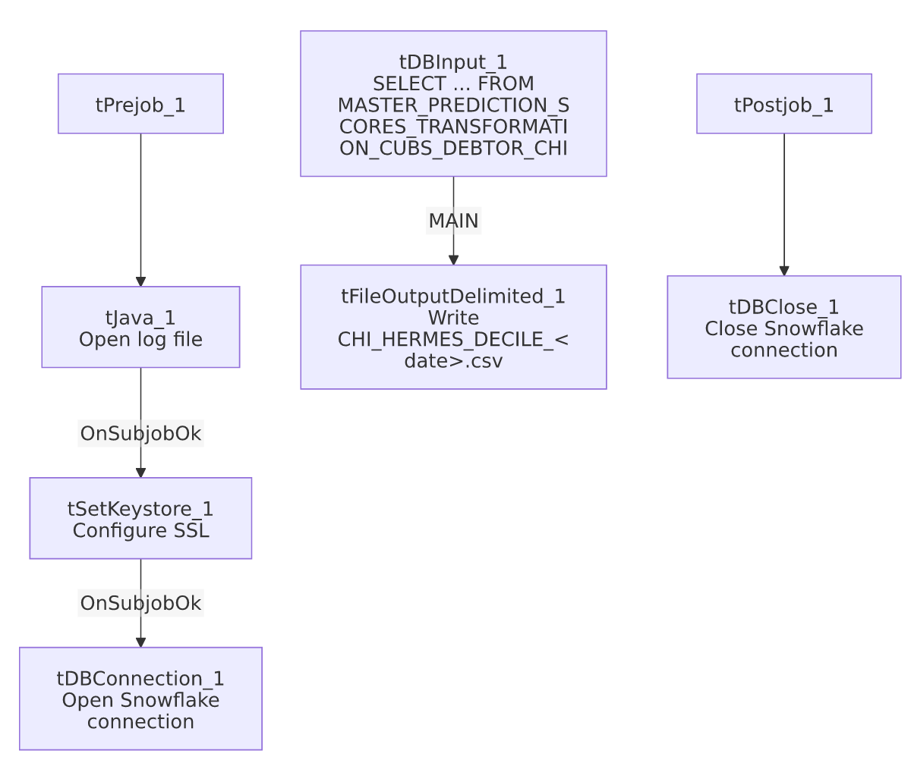

Settings tables

Source: `tDBInput_1` (`tSnowflakeInput`)
Setting | Value | What it means
Query | SELECT LOGON, PACKET, DEBTORNUMBER, PL_GROUP, "LOCAL", "GLOBAL", EQUABLI_TREATMENT_GROUP, DIALERGRP FROM MASTER_PREDICTION_SCORES_TRANSFORMATION_CUBS_DEBTOR_CHI; | No WHERE clause — the source table itself is already scoped to CHI by name; the entire table is exported every run.

Target: `tFileOutputDelimited_1`
Setting | Value | What it means
FILENAME | context.outputDir+"CHI_HERMES_DECILE_"+TalendDate.getDate("CCYYMMDD")+".csv" | Correctly labeled CHI_ — consistent with both the job name and the source table.
INCLUDEHEADER | true | CSV includes a header row (differs from Equibli_Extract's no-header convention).

SSL setup: `tSetKeystore_1`
Setting | Value | What it means
SSL_TRUSTSERVER_TRUSTSTORE | "C:/clientTrustStore.trustStore" | Hardcoded local path, not context-driven — see Issues observed.
SSL_KEYSTORE | context.keystorePath | Client keystore path is context-driven, unlike the trust store above.
SSL_TRUSTSERVER_PASSWORD / SSL_KEYSTORE_PASSWORD / NEED_CLIENT_AUTH | ***REDACTED*** | Preserved as redacted.

Dependencies & configuration
- Triggers/depends on other jobs: none — no tRunJob links found.
- Context variables used: keystorePath, logDir, outputDir.
- 1 hardcoded path finding: tSetKeystore_1.SSL_TRUSTSERVER_TRUSTSTORE = "C:/clientTrustStore.trustStore" — a fixed local path rather than a context. variable, present identically across the whole *_Hermes_Decile family.

Glossary
Component type | Plain-English meaning
tSetKeystore | Configures SSL/TLS trust and client keystore settings for secure connections made later in the job.
tSnowflakeConnection / tSnowflakeClose | Open/close the Snowflake connection shared by other components.
tSnowflakeInput | Runs a query against Snowflake and returns its result rows.
tFileOutputDelimited | Writes rows to a delimited (CSV-style) text file.

Issues observed
- This job is one of a near-identical family (Extract_CHI_Hermes_Decile, Extract_CO_Hermes_Decile, Extract_DC_Hermes_Decile, Extract_HH_Hermes_Decile) sharing the same component structure, SSL setup, and query shape, differing only in the site-code suffix on the source table and the output filename prefix. Unlike the `Extract_No_Dialer_Test_*` family (see those jobs' docs), this one is internally consistent — its job name, query table (..._CHI), and output filename (CHI_HERMES_DECILE_...) all agree.
- The query has no `WHERE` clause and no incremental filter — every run exports the entire MASTER_PREDICTION_SCORES_TRANSFORMATION_CUBS_DEBTOR_CHI table fresh. This is presumably intentional (a full daily snapshot), but there's no visible mechanism to detect if the underlying transformation table is empty or stale before export.
- `SSL_TRUSTSERVER_TRUSTSTORE` is a hardcoded local path (C:/clientTrustStore.trustStore) rather than driven by a context variable like the paired SSL_KEYSTORE setting is — inconsistent within the same component, and a portability risk consistent with 05_operational_runbook.md's hardcoded-path findings, though this specific path isn't the commonly-cited C:/Talend-Studio-... one.
- No error/row-count logging or reject handling — no tWarn/tDie/tSendMail; a failed extract would only surface as a generic Talend execution error.

