Talend Job: Extract_CO_Hermes_Decile

Overview
Extracts the CO-site "Hermes"/Equabli prediction decile assignment (logon, packet, debtor number, local/global score, treatment group, dialer group) from a Snowflake transformation table scoped to CO, and writes it to a dated CSV file. Part of the same per-site decile extract family as Extract_CHI_Hermes_Decile, Extract_DC_Hermes_Decile, and Extract_HH_Hermes_Decile — this one is internally consistent: its query, table name, and output filename all correctly reference CO.

Detail table
Field | Value
Job name | Extract_CO_Hermes_Decile
Version | 0.1
Project | EDW2SF
Author | jmach@harriscollect.com
Created | 2023-08-13T21:07:58.507-0700
Last Modified | 2025-11-05T09:11:55.167-0800

Step-by-step data flow
Setup subjob: tPrejob_1 → tJava_1 opens a per-run log file → tSetKeystore_1 configures SSL trust/keystore from context.keystorePath (passwords redacted) → tDBConnection_1 opens the Snowflake connection.
Main subjob:
- tDBInput_1 runs SELECT LOGON, PACKET, DEBTORNUMBER, PL_GROUP, "LOCAL", "GLOBAL", EQUABLI_TREATMENT_GROUP, DIALERGRP FROM MASTER_PREDICTION_SCORES_TRANSFORMATION_CUBS_DEBTOR_CO; — a fixed, unfiltered read of the entire CO-scoped transformation table.
- tFileOutputDelimited_1 writes the result to context.outputDir + "CO_HERMES_DECILE_" + <CCYYMMDD> + ".csv" (comma-delimited, header included).
Teardown subjob: tPostjob_1 → tDBClose_1 closes the Snowflake connection.
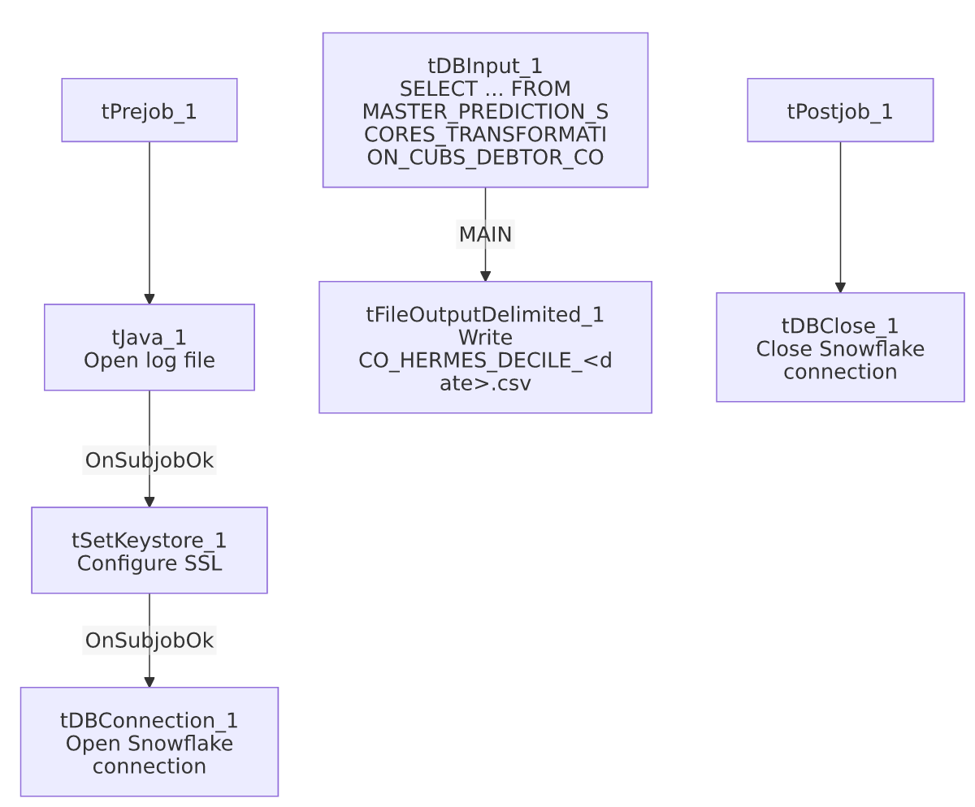

Settings tables

Source: `tDBInput_1` (`tSnowflakeInput`)
Setting | Value | What it means
Query | SELECT LOGON, PACKET, DEBTORNUMBER, PL_GROUP, "LOCAL", "GLOBAL", EQUABLI_TREATMENT_GROUP, DIALERGRP FROM MASTER_PREDICTION_SCORES_TRANSFORMATION_CUBS_DEBTOR_CO; | No WHERE clause — the source table is already scoped to CO by name; the entire table is exported every run.

Target: `tFileOutputDelimited_1`
Setting | Value | What it means
FILENAME | context.outputDir+"CO_HERMES_DECILE_"+TalendDate.getDate("CCYYMMDD")+".csv" | Correctly labeled CO_ — consistent with both the job name and the source table.
INCLUDEHEADER | true | CSV includes a header row.

SSL setup: `tSetKeystore_1`
Setting | Value | What it means
SSL_TRUSTSERVER_TRUSTSTORE | "C:/clientTrustStore.trustStore" | Hardcoded local path, not context-driven — see Issues observed.
SSL_KEYSTORE | context.keystorePath | Client keystore path is context-driven, unlike the trust store above.
SSL_TRUSTSERVER_PASSWORD / SSL_KEYSTORE_PASSWORD / NEED_CLIENT_AUTH | ***REDACTED*** | Preserved as redacted.

Dependencies & configuration
- Triggers/depends on other jobs: none — no tRunJob links found.
- Context variables used: keystorePath, logDir, outputDir.
- 1 hardcoded path finding: tSetKeystore_1.SSL_TRUSTSERVER_TRUSTSTORE = "C:/clientTrustStore.trustStore" — identical across the whole *_Hermes_Decile family.

Glossary
Component type | Plain-English meaning
tSetKeystore | Configures SSL/TLS trust and client keystore settings for secure connections made later in the job.
tSnowflakeConnection / tSnowflakeClose | Open/close the Snowflake connection shared by other components.
tSnowflakeInput | Runs a query against Snowflake and returns its result rows.
tFileOutputDelimited | Writes rows to a delimited (CSV-style) text file.

Issues observed
- This job is one of a near-identical family (Extract_CHI_Hermes_Decile, Extract_CO_Hermes_Decile, Extract_DC_Hermes_Decile, Extract_HH_Hermes_Decile), sharing the same component structure, SSL setup, and query shape, differing only in the site-code suffix on the source table and the output filename prefix. This one is internally consistent — job name, query table (..._CO), and output filename (CO_HERMES_DECILE_...) all agree, unlike the Extract_No_Dialer_Test_* family where CHI and DC are swapped internally (see those jobs' docs).
- The query has no `WHERE` clause and no incremental filter — every run exports the entire MASTER_PREDICTION_SCORES_TRANSFORMATION_CUBS_DEBTOR_CO table. Presumably a full daily snapshot by design, but there's no visible check for an empty/stale source table before export.
- `SSL_TRUSTSERVER_TRUSTSTORE` is a hardcoded local path rather than context-driven like the paired SSL_KEYSTORE — inconsistent within the same component, and a minor portability risk.
- No error/row-count logging or reject handling — no tWarn/tDie/tSendMail; a failed extract would only surface as a generic Talend execution error.

