Talend Job: Extract_DDNPII

Overview
This job does not move data directly through Talend components at all — it shells out to two external Python scripts. The first (dnpii_extract.py) presumably builds a Tableau Hyper extract file at /output/dnpii.hyper (the "DDNPII" naming — unable to determine the exact business meaning of this acronym from metadata; likely a debtor/data "Do Not..." PII-related extract, verify with the team). The second (publish_tableau_datasource.py) publishes that Hyper file to a Tableau Server as a datasource named "DDNPII".

Detail table
Field | Value
Job name | Extract_DDNPII
Version | 0.1
Project | EDW2SF
Author | jmach@harriscollect.com
Created | 2022-04-04T10:25:42.661-0700
Last Modified | 2025-08-28T08:57:16.418-0700

Step-by-step data flow
This job has no tPrejob/tPostjob and no database connection components — it's purely a shell-command wrapper:
- tJava_1 builds a command string into context.pyCmd: "python3 " + context.pyScriptDir + "dnpii_extract.py --file /output/dnpii.hyper".
- On success (OnSubjobOk), tSystem_1 executes that command, with its working directory set to a hardcoded path, output/error streamed to the Talend console.
- On success (OnSubjobOk), tJava_2 builds a second command into context.pyCmd: "python3 " + context.pyScriptDir + "publish_tableau_datasource.py --server " + context.tabServer + " --user " + context.tabUser + " --password " + context.tabPass + " --file /output/dnpii.hyper --name DDNPII --project " + context.tabPro... (the code text is truncated in this metadata at tabPro..., almost certainly context.tabProject).
- On component completion (OnComponentOk), tSystem_2 executes the second command, same working directory and console output settings as tSystem_1.
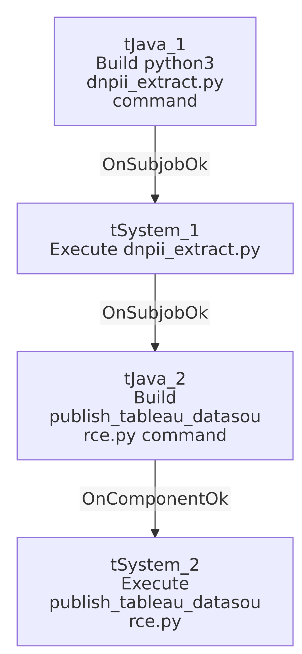

Settings tables

`tSystem_1` / `tSystem_2`
Setting | Value | What it means
DIRECTORY | "C:/Talend-Studio-20211109_1610-V8.0.1/workspace" (both) | Hardcoded developer-workstation working directory — the same pattern flagged project-wide in 05_operational_runbook.md, present twice in this job.
COMMAND | context.pyCmd (built by the preceding tJava component) | The actual Python invocation, assembled dynamically rather than fixed.
OUTPUT / ERROROUTPUT | OUTPUT_TO_CONSOLE (both) | stdout/stderr from the Python scripts are streamed into the Talend job log, not captured separately.

`tJava_1` — dnpii_extract command
Setting | Value | What it means
Command built | "python3 " + context.pyScriptDir + "dnpii_extract.py --file /output/dnpii.hyper" | Calls a Python script (not part of this Talend metadata) to build a Tableau Hyper file at a fixed container/server path /output/dnpii.hyper.

`tJava_2` — publish command
Setting | Value | What it means
Command built (truncated) | "python3 " + context.pyScriptDir + "publish_tableau_datasource.py --server " + context.tabServer + " --user " + context.tabUser + " --password " + context.tabPass + " --file /output/dnpii.hyper --name DDNPII --project " + context.tabPro... | Publishes the Hyper file to Tableau Server under the name "DDNPII"; the project ID argument is cut off in this metadata but almost certainly continues with context.tabProject (matching the TableauVariables_0.1 context group's tabProject variable seen in _shared_context.json).

Dependencies & configuration
- Triggers/depends on other jobs: none — no tRunJob links found.
- Context variables used: pyCmd, pyScriptDir, tabPass, tabProject, tabServer, tabUser — all consistent with the TableauVariables_0.1 context group documented in 06_dependency_matrix.md/_shared_context.json.
- 2 hardcoded developer-workstation paths, both tSystem_1.DIRECTORY and tSystem_2.DIRECTORY = "C:/Talend-Studio-20211109_1610-V8.0.1/workspace" — the project-wide risk pattern from 05_operational_runbook.md, occurring twice in this one job.

Glossary
Component type | Plain-English meaning
tJava | Runs custom Java code — here used only to build a shell command string into a context variable, not to process any row data.
tSystem | Executes an OS-level shell command from within the Talend job and streams its output to the log.

Issues observed
- This job's actual business logic (what "DDNPII" data is extracted and how) lives entirely in an external Python script (`dnpii_extract.py`) that is outside the scope of this Talend metadata — this doc can only describe the Talend-side orchestration (build command, run it, build the next command, run it), not what the script itself queries or computes. Unable to determine from metadata what "DDNPII" stands for or what data it contains; verify with the team or by reading the script directly.
- The Tableau publish command text is truncated in the extracted metadata (cuts off mid-argument at context.tabPro...) — while the continuation is almost certainly context.tabProject, this cannot be fully confirmed from the data provided.
- Both `tSystem` components run with the same hardcoded Windows developer-workstation working directory — if this job is ever run from a different machine or a non-Windows execution environment (e.g., a Linux-based Talend Runtime), both shell-outs would likely fail to resolve that directory, in addition to the python3 command needing to be on the executing host's PATH.
- The Tableau server password (`context.tabPass`) is passed as a plaintext command-line argument to the Python script via tSystem. Depending on the host OS, command-line arguments can be visible to other processes/users on the same machine (e.g., via ps on Linux) — this is a potential credential-exposure risk worth flagging to the security team, even though the actual password value itself is appropriately redacted in this metadata.

