Talend Job: Extract_Equabli_GOV

Overview
Extracts the "GOV" (government-sector, presumably) Equabli test-assignment data — logon, packet, debtor number, group, local/global scores, treatment group, dialer group — from a Snowflake table under the EQUABLI schema, and writes it to a dated CSV file. It shares an identical filename-building step with Extract_Equibli_Test (see Issues observed) that computes both an "HC" and a "GOV" filename even though this job only ever uses the GOV one.

Detail table
Field | Value
Job name | Extract_Equabli_GOV
Version | 0.1
Project | EDW2SF
Author | jmach@harriscollect.com
Created | 2022-07-27T10:57:47.386-0700
Last Modified | 2025-09-24T11:00:08.028-0700

Step-by-step data flow
Setup subjob: tPrejob_1 → tDBConnection_1 opens the Snowflake connection → on success, tJava_1 computes both context.HCfileName ("EQB_HH_" + <CCYYMMDD> + ".csv") and context.GOVfileName ("EQB_GOV_" + <CCYYMMDD> + ".csv") — only the latter is used in this job.
Main subjob:
- tDBInput_2 runs SELECT LOGON, PACKET, DEBTORNUMBER, PL_GROUP, "LOCAL", "GLOBAL", EQUABLI_TREATMENT_GROUP, DIALERGRP FROM EDWPRODHH.EQUABLI.INCREMENTAL_TEST_ASSIGNMENT_CUBS_GOV;.
- tFileOutputDelimited_2 writes the result to context.filePath + context.GOVfileName.
Teardown subjob: tPostjob_1 → tDBClose_1 closes the Snowflake connection.
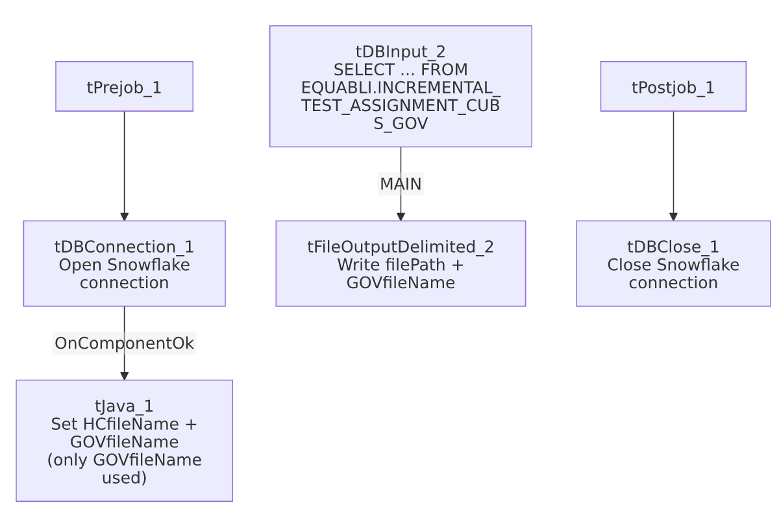

Settings tables

Filename setup: `tJava_1`
Setting | Value | What it means
Code | context.HCfileName="EQB_HH_" + TalendDate.getDate("CCYYMMDD")+".csv"; context.GOVfileName="EQB_GOV_" + TalendDate.getDate("CCYYMMDD") + ".csv"; | Computes both an "HC" (health-system) and "GOV" filename every run, but this job's flow only ever wires up GOVfileName — see Issues observed.

Source: `tDBInput_2` (`tSnowflakeInput`)
Setting | Value | What it means
Query | SELECT LOGON, PACKET, DEBTORNUMBER, PL_GROUP, "LOCAL", "GLOBAL", EQUABLI_TREATMENT_GROUP, DIALERGRP FROM EDWPRODHH.EQUABLI.INCREMENTAL_TEST_ASSIGNMENT_CUBS_GOV; | Fully-qualified source table (EDWPRODHH.EQUABLI...), scoped to the "GOV" test-assignment group.

Target: `tFileOutputDelimited_2`
Setting | Value | What it means
FILENAME | context.filePath+context.GOVfileName | Resolves to <filePath>/EQB_GOV_<date>.csv.
INCLUDEHEADER | true | CSV includes a header row.

Dependencies & configuration
- Triggers/depends on other jobs: none — no tRunJob links found.
- Context variables used: GOVfileName, HCfileName (computed but unused here), filePath.
- No hardcoded developer-workstation paths found in this job's own components.

Glossary
Component type | Plain-English meaning
tSnowflakeConnection / tSnowflakeClose | Open/close the Snowflake connection shared by other components.
tJava | Runs custom Java code — here used only to compute dated filenames into context variables.
tSnowflakeInput | Runs a query against Snowflake and returns its result rows.
tFileOutputDelimited | Writes rows to a delimited (CSV-style) text file.

Issues observed
- `tJava_1` computes an unused `context.HCfileName` alongside the `GOVfileName` this job actually needs. The exact same two-line code block appears verbatim in Extract_Equibli_Test (which, conversely, computes both names but only uses HCfileName). This strongly suggests both jobs were built from a shared template that originally handled both HC and GOV outputs, and each was subsequently narrowed to a single output without removing the now-dead filename computation — a harmless but recurring copy-paste artifact across this small job family.
- No error/row-count logging or reject handling — no tWarn/tDie/tSendMail; a failed extract would only surface as a generic Talend execution error.
- No incremental filter or row-count check — the query reads the entire INCREMENTAL_TEST_ASSIGNMENT_CUBS_GOV table every run despite "INCREMENTAL" appearing in the table's own name, suggesting the incremental logic (if any) lives upstream in how that table itself is populated, not in this extract job.

