Talend Job: Extract_Equabli_HC_Validation_Score

Overview
Extracts the health-system ("HC") Equabli validation-score test assignment — logon, packet, debtor number, group, local/global scores, validation treatment group, and validation expiration date — from a Snowflake table under the EQUABLI schema, and writes it to a dated CSV file. Unlike Extract_Equabli_GOV/Extract_Equibli_Test, this job computes only the single filename it needs, with no unused sibling variable.

Detail table
Field | Value
Job name | Extract_Equabli_HC_Validation_Score
Version | 0.1
Project | EDW2SF
Author | jmach@harriscollect.com
Created | 2022-12-09T08:36:14.177-0800
Last Modified | 2025-09-24T10:59:34.269-0700

Step-by-step data flow
Setup subjob: tPrejob_1 → tDBConnection_1 opens the Snowflake connection → on success, tJava_1 computes context.HCfileName = "HH_EQB_VALIDATIONSCORE_" + <CCYYMMDD> + ".csv".
Main subjob:
- tDBInput_2 runs SELECT LOGON, PACKET, DEBTORNUMBER, PL_GROUP, "LOCAL", "GLOBAL", EQUABLI_VALIDATION_TREATMENT_GROUP, EQUABLI_VALIDATION_EXPIRATION_DATE FROM EQUABLI.INCREMENTAL_TEST_ASSIGNMENT_CUBS_HC_VALIDATION;.
- tFileOutputDelimited_2 writes the result to context.filePath + context.HCfileName.
Teardown subjob: tPostjob_1 → tDBClose_1 closes the Snowflake connection.
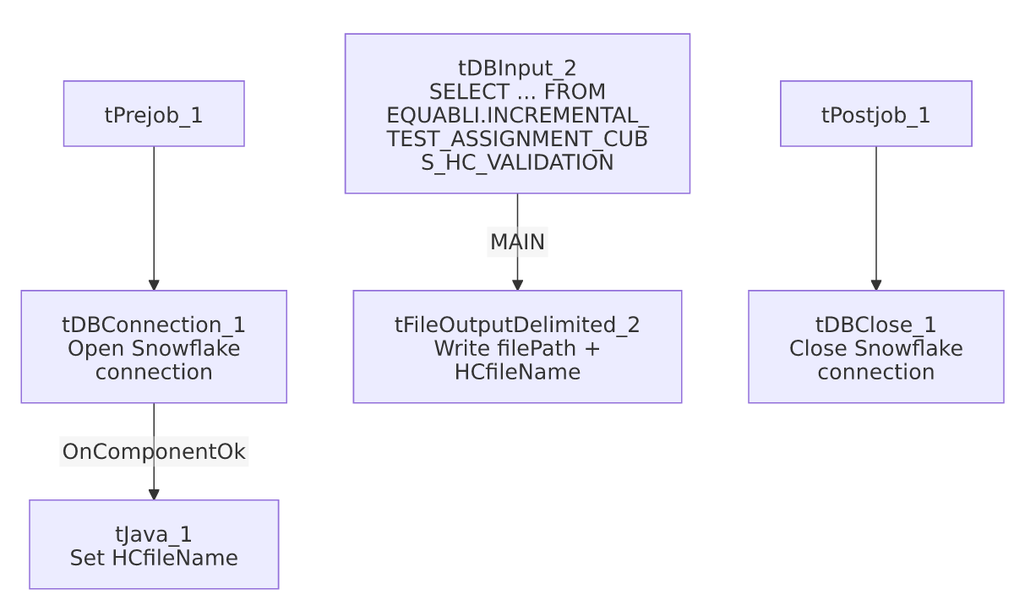

Settings tables

Filename setup: `tJava_1`
Setting | Value | What it means
Code | context.HCfileName="HH_EQB_VALIDATIONSCORE_" + TalendDate.getDate("CCYYMMDD")+".csv"; | Computes only the single filename this job uses — note the HH_ prefix embedded in the filename literal, which appears to tie this "HC" job to the "HH" site code (see 01_system_architecture.md for site codes) even though the job name itself says "HC," not "HH." Unable to determine from metadata whether "HC" (health-system) and "HH" (a site code) are being used interchangeably here or refer to different things — verify with the team.

Source: `tDBInput_2` (`tSnowflakeInput`)
Setting | Value | What it means
Query | SELECT LOGON, PACKET, DEBTORNUMBER, PL_GROUP, "LOCAL", "GLOBAL", EQUABLI_VALIDATION_TREATMENT_GROUP, EQUABLI_VALIDATION_EXPIRATION_DATE FROM EQUABLI.INCREMENTAL_TEST_ASSIGNMENT_CUBS_HC_VALIDATION; | Scoped to the "HC_VALIDATION" test-assignment table — a different table from the plain "HC" table used by Extract_Equibli_Test.

Target: `tFileOutputDelimited_2`
Setting | Value | What it means
FILENAME | context.filePath + context.HCfileName | Resolves to <filePath>/HH_EQB_VALIDATIONSCORE_<date>.csv.
INCLUDEHEADER | true | CSV includes a header row.

Dependencies & configuration
- Triggers/depends on other jobs: none — no tRunJob links found.
- Context variables used: HCfileName, filePath.
- No hardcoded developer-workstation paths found in this job's own components.

Glossary
Component type | Plain-English meaning
tSnowflakeConnection / tSnowflakeClose | Open/close the Snowflake connection shared by other components.
tJava | Runs custom Java code — here used only to compute a dated filename into a context variable.
tSnowflakeInput | Runs a query against Snowflake and returns its result rows.
tFileOutputDelimited | Writes rows to a delimited (CSV-style) text file.

Issues observed
- The output filename literal uses an `HH_` prefix while the job and context variable are both named "HC" (context.HCfileName = "HH_EQB_VALIDATIONSCORE_...") — this could be an intentional convention (site code HH = the health-system portfolio referred to elsewhere as "HC") or a naming inconsistency; unable to determine which from metadata. Worth confirming with the team, especially since 01_system_architecture.md documents HH specifically as one of the project's site codes, distinct from any "HC" abbreviation.
- No error/row-count logging or reject handling — no tWarn/tDie/tSendMail; a failed extract would only surface as a generic Talend execution error.
- No incremental filter visible in the query despite "INCREMENTAL" in the source table's own name — as with Extract_Equabli_GOV, any incrementality is presumably handled upstream in how the source table itself is populated, not in this extract job.

