Talend Job: Extract_Equabli_Reports

Overview
Extracts four independent Equabli/dialer-group reporting tables from Snowflake and writes each to its own CSV file — an industry/segment yield lookup, a dialer-group score-threshold lookup, an observed dialer-group distribution report, and an EQB-score distribution report. Unlike the site-scoped *_Hermes_Decile jobs, this job is not scoped to any single site — it appears to be a general-purpose reporting extract for whoever consumes the Equabli dialer-grouping model's output tables.

Detail table
Field | Value
Job name | Extract_Equabli_Reports
Version | 0.1
Project | EDW2SF
Author | jmach@harriscollect.com
Created | 2022-09-20T09:16:19.388-0700
Last Modified | 2025-09-24T11:09:12.724-0700

Step-by-step data flow
Setup subjob: tPrejob_1 → tDBConnection_1 opens the Snowflake connection.
Main subjob — four independent, parallel read/write pairs, all sharing the same connection:
- tDBInput_1 reads EQUABLI.DIALERGRP_TRANSFORM_LOOKUP_EQBSCORE (industry, PL_GROUP, team, netcash rank, packet/call/commission counts, segment yield percentiles, dialer group number) → tFileOutputDelimited_1 writes context.targetFolder + "report_dialergrp_transform_lookup_eqbscore.csv".
- tDBInput_2 reads EQUABLI.DIALERGRP_TRANSFORM_AGG_PROPOSED (PL_GROUP plus 4 pairs of min/max group thresholds) → tFileOutputDelimited_2 writes context.targetFolder + "report_dialergrp_transform_agg_proposed.csv".
- tDBInput_3 reads EQUABLI.REPORT_DIALERGRP_DISTRIBUTION_OBSERVED (team, PL_GROUP, dialer group, target/observed packet percentages and counts) → tFileOutputDelimited_3 writes context.targetFolder + "report_dialergrp_distribution_observed.csv".
- tDBInput_4 reads EQUABLI.REPORT_DIALERGRP_DISTRIBUTION_EQB (industry, team, PL_GROUP, EQB score, packet count) → tFileOutputDelimited_4 writes context.targetFolder + "report_dialergrp_distribution_eqb.csv".
Teardown subjob: tPostjob_1 → tDBClose_1 closes the Snowflake connection.
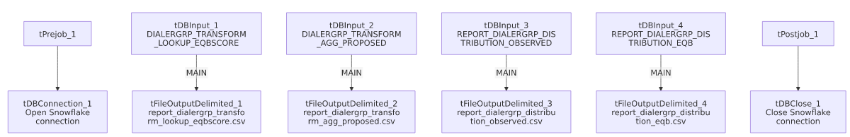

Settings tables

Sources and targets (all 4 pairs share the same shape)
Setting | Value | What it means
Source tables | EQUABLI.DIALERGRP_TRANSFORM_LOOKUP_EQBSCORE, EQUABLI.DIALERGRP_TRANSFORM_AGG_PROPOSED, EQUABLI.REPORT_DIALERGRP_DISTRIBUTION_OBSERVED, EQUABLI.REPORT_DIALERGRP_DISTRIBUTION_EQB | Four distinct tables, no WHERE clauses on any — full-table exports every run.
Output directory | context.targetFolder (all 4) | Same shared output folder for all four report files, each with a fixed descriptive filename.
INCLUDEHEADER | true (all 4) | All four CSVs include a header row.

Dependencies & configuration
- Triggers/depends on other jobs: none — no tRunJob links found.
- Context variables used: targetFolder only.
- No hardcoded developer-workstation paths found in this job's own components.

Glossary
Component type | Plain-English meaning
tSnowflakeConnection / tSnowflakeClose | Open/close the single Snowflake connection shared across all four read/write pairs in this job.
tSnowflakeInput | Runs a query against Snowflake and returns its result rows.
tFileOutputDelimited | Writes rows to a delimited (CSV-style) text file.

Issues observed
- All four extracts are full-table reads with no `WHERE` clause or incremental filter — every run re-exports the entirety of all four Equabli reporting tables. If any of these tables grows large over time, this could become a slow, unnecessary full-scan job; unable to determine current table sizes from metadata.
- No error/row-count logging or reject handling — no tWarn/tDie/tSendMail anywhere in the job; a failure in any one of the four independent read/write pairs would only surface as a generic Talend execution error, and it's not obvious from the wiring alone whether one pair failing would abort the other three or let them complete (there are no explicit OnSubjobOk/RUN_IF links between the four pairs — each appears to run as its own independent parallel branch off the shared connection).
- Beyond the above, nothing else stands out in this job's own metadata beyond the project-wide patterns already documented in 05_operational_runbook.md.

