Talend Job: Extract_Equibli_Test

Overview
Extracts the "HC" (health-system) Equabli test-assignment data — logon, packet, debtor number, group, local/global scores, treatment group, dialer group — from a Snowflake table under the EQUABLI schema, and writes it to a dated CSV file. Note the job name spells the vendor "Equibli" while its query and context variables spell it "Equabli," consistent with an inconsistent spelling used throughout this job family (see Issues observed). This job shares the identical filename-computation code with Extract_Equabli_GOV but, in a mirror-image of that job, uses the "HC" filename and leaves the "GOV" one unused.

Detail table
Field | Value
Job name | Extract_Equibli_Test
Version | 0.1
Project | EDW2SF
Author | jmach@harriscollect.com
Created | 2022-04-26T08:44:18.939-0700
Last Modified | 2025-09-24T11:00:36.561-0700

Step-by-step data flow
Setup subjob: tPrejob_1 → tDBConnection_1 opens the Snowflake connection → on success, tJava_1 computes both context.HCfileName ("EQB_HH_" + <CCYYMMDD> + ".csv") and context.GOVfileName ("EQB_GOV_" + <CCYYMMDD> + ".csv") — only the former is used in this job.
Main subjob:
- tDBInput_1 runs SELECT LOGON, PACKET, DEBTORNUMBER, PL_GROUP, "LOCAL", "GLOBAL", EQUABLI_TREATMENT_GROUP, DIALERGRP FROM EDWPRODHH.EQUABLI.INCREMENTAL_TEST_ASSIGNMENT_CUBS_HC;.
- tFileOutputDelimited_1 writes the result to context.filePath + context.HCfileName.
Teardown subjob: tPostjob_1 → tDBClose_1 closes the Snowflake connection.
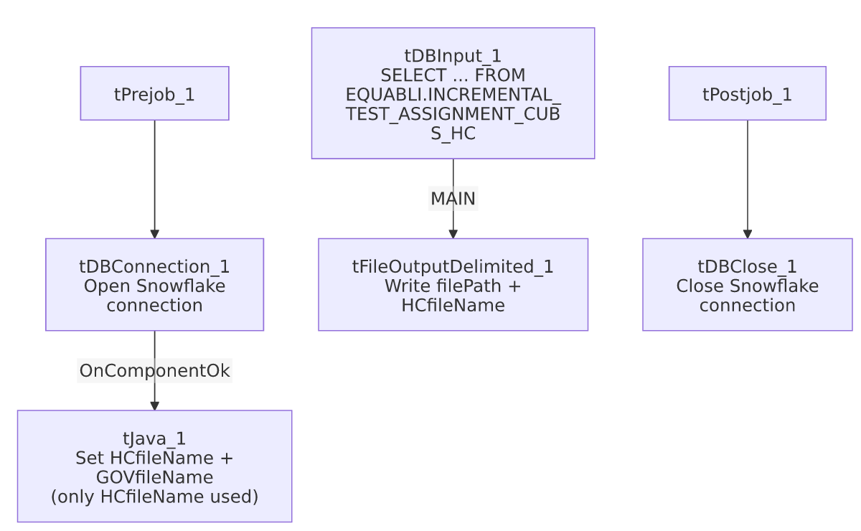

Settings tables

Filename setup: `tJava_1`
Setting | Value | What it means
Code | context.HCfileName="EQB_HH_" + TalendDate.getDate("CCYYMMDD")+".csv"; context.GOVfileName="EQB_GOV_" + TalendDate.getDate("CCYYMMDD") + ".csv"; | Identical code to Extract_Equabli_GOV's tJava_1 — computes both names, but this job only wires up HCfileName.

Source: `tDBInput_1` (`tSnowflakeInput`)
Setting | Value | What it means
Query | SELECT LOGON, PACKET, DEBTORNUMBER, PL_GROUP, "LOCAL", "GLOBAL", EQUABLI_TREATMENT_GROUP, DIALERGRP FROM EDWPRODHH.EQUABLI.INCREMENTAL_TEST_ASSIGNMENT_CUBS_HC; | Fully-qualified source table scoped to the plain "HC" test-assignment group (not the "HC_VALIDATION" table used by Extract_Equabli_HC_Validation_Score).

Target: `tFileOutputDelimited_1`
Setting | Value | What it means
FILENAME | context.filePath+context.HCfileName | Resolves to <filePath>/EQB_HH_<date>.csv — note the filename literal itself says EQB_HH_, not EQB_HC_, mirroring the same HC/HH naming ambiguity seen in Extract_Equabli_HC_Validation_Score.
INCLUDEHEADER | true | CSV includes a header row.

Dependencies & configuration
- Triggers/depends on other jobs: none — no tRunJob links found.
- Context variables used: GOVfileName (computed but unused here), HCfileName, filePath.
- No hardcoded developer-workstation paths found in this job's own components.

Glossary
Component type | Plain-English meaning
tSnowflakeConnection / tSnowflakeClose | Open/close the Snowflake connection shared by other components.
tJava | Runs custom Java code — here used only to compute dated filenames into context variables.
tSnowflakeInput | Runs a query against Snowflake and returns its result rows.
tFileOutputDelimited | Writes rows to a delimited (CSV-style) text file.

Issues observed
- The job name spells the vendor "Equibli" while every other reference in this job (context variables, the source schema `EQUABLI`, the query) spells it "Equabli." This inconsistent spelling recurs across the batch (compare Equibli_Extract, which also uses "Equibli" in its name against an "Equabli"-spelled source), suggesting the two spellings have been used interchangeably by whoever authored these jobs rather than referring to two different systems — worth confirming with the team which spelling is authoritative.
- `tJava_1` computes an unused `context.GOVfileName` — identical dead-code pattern to Extract_Equabli_GOV's unused HCfileName, confirming both jobs were built from the same two-output template and each narrowed down without removing the leftover computation.
- The output filename literal is `EQB_HH_...`, not `EQB_HC_...`, despite the job/variable naming saying "HC" — same HC/HH naming ambiguity flagged in Extract_Equabli_HC_Validation_Score; unable to determine from metadata whether this is intentional (site code HH) or a typo carried through the template.
- No error/row-count logging or reject handling — no tWarn/tDie/tSendMail; a failed extract would only surface as a generic Talend execution error.

