Talend Job: Extract_HH_Hermes_ValDecile

Overview
Extracts the HH-site "Hermes"/Equabli validation decile assignment — a distinct table from the regular decile assignment in Extract_HH_Hermes_Decile — including a validation treatment group and a validation expiration date, and writes it to a dated CSV file. Structurally this job is built from the exact same template as the *_Hermes_Decile family (same SSL setup, same connection pattern), but its source table and output columns are specific to score *validation* rather than the primary decile scores.

Detail table
Field | Value
Job name | Extract_HH_Hermes_ValDecile
Version | 0.1
Project | EDW2SF
Author | jmach@harriscollect.com
Created | 2023-08-13T21:49:55.516-0700
Last Modified | 2025-11-05T09:26:23.975-0800

Step-by-step data flow
Setup subjob: tPrejob_1 → tJava_1 opens a per-run log file → tSetKeystore_1 configures SSL trust/keystore from context.keystorePath (passwords redacted) → tDBConnection_1 opens the Snowflake connection.
Main subjob:
- tDBInput_1 runs SELECT LOGON, PACKET, DEBTORNUMBER, PL_GROUP, "LOCAL", "GLOBAL", EQUABLI_VALIDATION_TREATMENT_GROUP, TO_VARCHAR(EQUABLI_VALIDATION_EXPIRATION_DATE,'MM/DD/YYYY') FROM MASTER_PREDICTION_SCORES_TRANSFORMATION_CUBS_DEBTORVAL_HH; — note the source table name has DEBTORVAL (debtor validation) in place of the plain decile job's DEBTOR, and the expiration date is explicitly cast to a MM/DD/YYYY string in-query.
- tFileOutputDelimited_1 writes the result to context.outputDir + "HH_HERMES_VALDECILE_" + <CCYYMMDD> + ".csv" (comma-delimited, header included).
Teardown subjob: tPostjob_1 → tDBClose_1 closes the Snowflake connection.
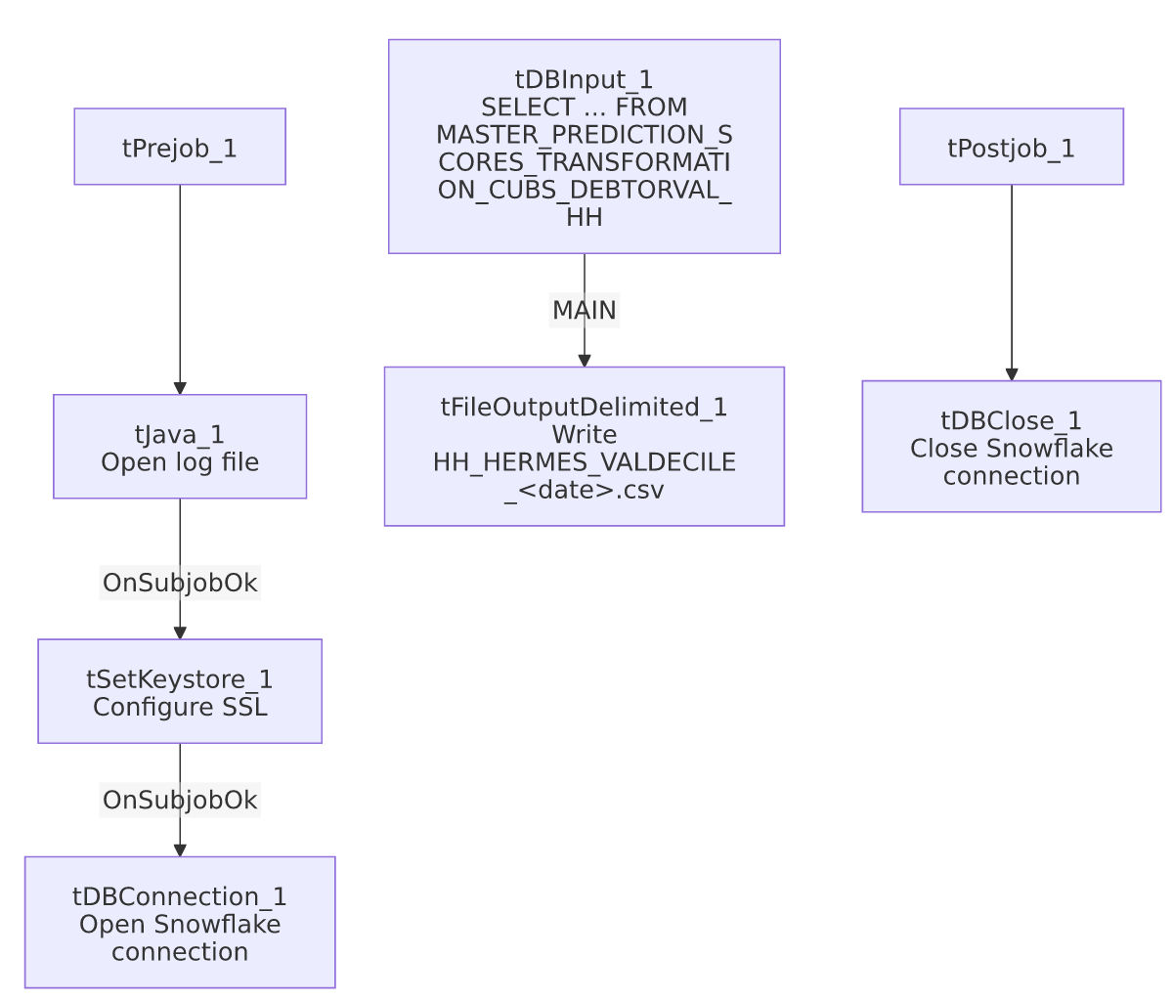

Settings tables

Source: `tDBInput_1` (`tSnowflakeInput`)
Setting | Value | What it means
Query | SELECT LOGON, PACKET, DEBTORNUMBER, PL_GROUP, "LOCAL", "GLOBAL", EQUABLI_VALIDATION_TREATMENT_GROUP, TO_VARCHAR(EQUABLI_VALIDATION_EXPIRATION_DATE,'MM/DD/YYYY') FROM MASTER_PREDICTION_SCORES_TRANSFORMATION_CUBS_DEBTORVAL_HH; | Reads from the DEBTORVAL (validation) transformation table, distinct from Extract_HH_Hermes_Decile's DEBTOR table. The expiration date is pre-formatted to a string in-query rather than left as a native date type.

Target: `tFileOutputDelimited_1`
Setting | Value | What it means
FILENAME | context.outputDir+"HH_HERMES_VALDECILE_"+TalendDate.getDate("CCYYMMDD")+".csv" | Correctly labeled HH_..._VALDECILE_ — consistent with the job name and the validation-specific source table.
INCLUDEHEADER | true | CSV includes a header row.

SSL setup: `tSetKeystore_1`
Setting | Value | What it means
SSL_TRUSTSERVER_TRUSTSTORE | "C:/clientTrustStore.trustStore" | Hardcoded local path, not context-driven — same as the sibling decile jobs.
SSL_KEYSTORE | context.keystorePath | Client keystore path is context-driven.
SSL_TRUSTSERVER_PASSWORD / SSL_KEYSTORE_PASSWORD / NEED_CLIENT_AUTH | ***REDACTED*** | Preserved as redacted.

Dependencies & configuration
- Triggers/depends on other jobs: none — no tRunJob links found.
- Context variables used: keystorePath, logDir, outputDir.
- 1 hardcoded path finding: tSetKeystore_1.SSL_TRUSTSERVER_TRUSTSTORE = "C:/clientTrustStore.trustStore" — identical to the plain decile jobs' setting.

Glossary
Component type | Plain-English meaning
tSetKeystore | Configures SSL/TLS trust and client keystore settings for secure connections made later in the job.
tSnowflakeConnection / tSnowflakeClose | Open/close the Snowflake connection shared by other components.
tSnowflakeInput | Runs a query against Snowflake and returns its result rows.
tFileOutputDelimited | Writes rows to a delimited (CSV-style) text file.

Issues observed
- This job is not a duplicate of `Extract_HH_Hermes_Decile` — despite sharing the same component pattern, connection setup, and site scope (HH), it reads a genuinely different source table (DEBTORVAL vs. DEBTOR) with different business columns (validation treatment group and expiration date instead of the standard treatment group and dialer group). No CO/CHI/DC counterpart of this "ValDecile" job appears in this batch — unable to determine from metadata whether validation deciles are only produced for the HH site or whether equivalent jobs for other sites exist outside this batch; verify with the team.
- The output schema's `EQUABLI_VALIDATION_EXPIRATION_DATE` column is typed `id_String` in this job, even though the underlying Snowflake column is presumably a native date type — the query explicitly converts it with TO_VARCHAR(...,'MM/DD/YYYY'). This is a deliberate formatting choice for the output file, not a bug, but worth noting since it differs from Extract_HH_Hermes_Decile's untouched id_Double/id_String column types.
- `SSL_TRUSTSERVER_TRUSTSTORE` is a hardcoded local path rather than context-driven like the paired SSL_KEYSTORE — same minor portability inconsistency as the rest of the Hermes Decile family.
- No error/row-count logging or reject handling — no tWarn/tDie/tSendMail; a failed extract would only surface as a generic Talend execution error.

