Talend Job: Extract_Hermes_Master_Prediction

Overview
This is the earlier sibling of Export_Hermes_APC_Master_Prediction (created 2023-05-17, over a year before that job's 2024-11-03 creation date): a file-intake orchestrator for the "Hermes"/Equabli prediction-scoring pipeline that watches an import directory, archives incoming files, then fires 5 parallel copies of the shared sub-job master_prediction_proposal_cubs_extract. The two jobs are functionally identical in every component and parameter observed in this metadata — see Issues observed for the one cosmetic difference found.

Detail table
Field | Value
Job name | Extract_Hermes_Master_Prediction
Version | 0.1
Project | EDW2SF
Author | jmach@harriscollect.com
Created | 2023-05-17T13:26:24.494-0700
Last Modified | 2024-06-05T11:56:00.200-0700

Step-by-step data flow
Setup subjob: tPrejob_1 → tJava_1 opens a per-run log file at context.logDir + jobName + "_" + <timestamp> + ".log" and redirects System.out/System.err to it.
Main subjob:
- tFileList_1 lists files in context.importDir (the *.txt EXCLUDEFILEMASK is configured but IFEXCLUDE=false, so it has no effect).
- For each file found (ITERATE), tJava_2 captures the current file path into context.sourceFile, then tFileCopy_1 copies/moves it to context.archiveDir (REMOVE_FILE=true).
- Once tFileList_1's subjob completes (OnSubjobOk), tParallelize_1 fires all 5 tRunJob components at once, each calling master_prediction_proposal_cubs_extract (DIE_ON_CHILD_ERROR=true, USE_INDEPENDENT_PROCESS=true, TRANSMIT_ORIGINAL_CONTEXT=true).
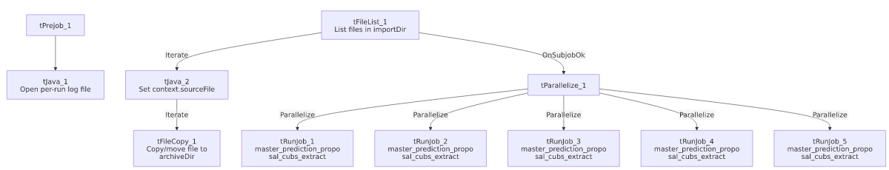

Settings tables

File intake: `tFileList_1` / `tFileCopy_1`
Setting | Value | What it means
DIRECTORY | context.importDir | Source directory being watched for incoming files.
EXCLUDEFILEMASK / IFEXCLUDE | "*.txt" / false | Configured but inactive — all files are processed.
tFileCopy_1 SOURCE_DERECTORY | "C:/Talend-Studio-20211109_1610-V8.0.1/workspace" | Hardcoded developer-workstation path — see Issues observed.
tFileCopy_1 DESTINATION / REMOVE_FILE | context.archiveDir / true | Files are moved, not just copied.

Orchestration: `tRunJob_1`–`tRunJob_5`
Setting | Value | What it means
PROCESS | master_prediction_proposal_cubs_extract (all 5) | All 5 call the exact same sub-job.
USE_INDEPENDENT_PROCESS | true (all 5) | Each runs in its own JVM process.
DIE_ON_CHILD_ERROR | true (all 5) | Any of the 5 failing fails this orchestrator too.
TRANSMIT_ORIGINAL_CONTEXT | true (all 5) | Each call inherits this job's own context values.

Dependencies & configuration
- This job calls `master_prediction_proposal_cubs_extract` 5 times in parallel — per 06_dependency_matrix.md, what differs between the 5 calls (most likely one per site/partner) is not visible without opening each tRunJob's own context overrides.
- Context variables used: archiveDir, importDir, logDir, sourceFile.
- 1 hardcoded developer-workstation path: tFileCopy_1.SOURCE_DERECTORY = "C:/Talend-Studio-20211109_1610-V8.0.1/workspace".

Glossary
Component type | Plain-English meaning
tFileList | Lists files in a directory for the job to iterate over one at a time.
tFileCopy | Copies (and optionally deletes the original of, i.e. moves) a file to another location.
tParallelize | Runs its downstream branches at the same time instead of one after another.
tRunJob | Runs another Talend job as a sub-process, optionally waiting for it to finish.

Issues observed
- This job is functionally identical to `Export_Hermes_APC_Master_Prediction` — same components, same parameter values (including the identical hardcoded tFileCopy_1 path), same 5x parallel call to master_prediction_proposal_cubs_extract. The only difference found is the internal firing order of the tParallelize_1 branches (tRunJob_1 first here vs. tRunJob_2 first in the other job), which has no functional effect. As the older of the two (created 2023-05-17 vs. 2024-11-03), this may be the original job that Export_Hermes_APC_Master_Prediction was cloned from — unable to determine from metadata whether both are still actively scheduled or whether one has been superseded; verify with the team to avoid double-running the same 5-way extract.
- The `*.txt` exclusion filter is configured but inactive (IFEXCLUDE=false) — every file in importDir is processed regardless.
- The 5 parallel `tRunJob` calls fire unconditionally after `tFileList_1` completes, even with zero files found — there is no visible gating tying the sub-job calls to whether new source files actually arrived.
- No error/row-count logging specific to this job's business outcome beyond the child-job failure propagation (DIE_ON_CHILD_ERROR).

