Talend Job: Extract_Letter_Count

Overview
Computes a per-print-date, per-client letter/email/text communication summary — joining PCI letter records, letter-code-to-collection-type mappings, debtor and client dimension tables — and publishes the result directly to a Tableau Server datasource named LETTER_EXTRACT_SF (no intermediate CSV file). It classifies each letter as "Letter," "Email," or "Text" based on the letter code prefix, and reclassifies late "Validation" letters (sent more than 10 days after the batch date) as "Validation on Contact."

Detail table
Field | Value
Job name | Extract_Letter_Count
Version | 0.1
Project | EDW2SF
Author | jmach@harriscollect.com
Created | 2022-01-10T14:56:48.226-0800
Last Modified | 2025-09-24T11:00:59.061-0700

Step-by-step data flow
Setup subjob: tPrejob_1 → tDBConnection_1 opens the Snowflake connection.
Main subjob:
- tDBInput_1 runs a multi-join query: edwprodhh.dw.pci_letters (letter print date, raw letter code, mail disposition) left-joined to a distinct edwprodhh.dw.dimlettercode lookup (excluding the HHPIFS code and CLOSED collection type) to classify collection type, then left-joined to edwprodhh.dw.dimdebtor (for batch/assignment date and client), then left-joined to edwprodhh.pub_jchang.master_client (for industry, party, PL_GROUP). It computes LETTERS_SENT (1 if the mail disposition contains "included" or "mailed"), COLLECTION_TYPE_CLEAN (reclassifies late Validation letters), and COMMUNICATION_TYPE (Text/Email/Letter based on the letter code prefix).
- tTableauOutput_1 writes the result directly to a Tableau Server datasource — serverUrl=http://mp-tab-v01, project Dim, datasource name LETTER_EXTRACT_SF, output action OVERWRITE.
Teardown subjob: tPostjob_1 → tDBClose_1 closes the Snowflake connection.
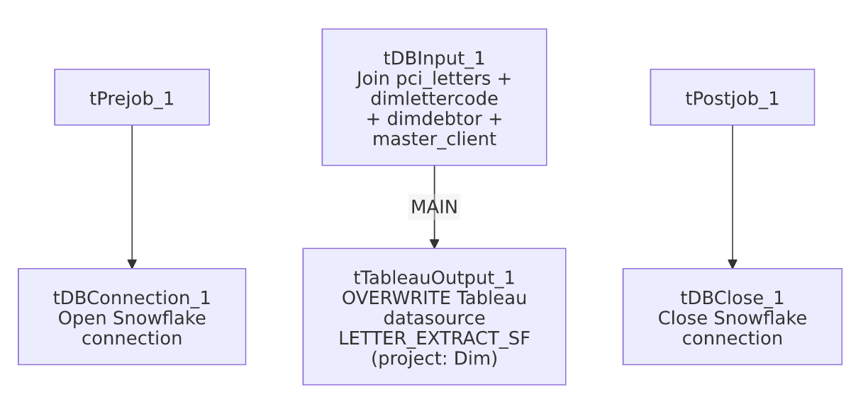

Settings tables

Source: `tDBInput_1` (`tSnowflakeInput`)
Setting | Value | What it means
Query (summarized) | Joins pci_letters → dimlettercode (excludes HHPIFS/CLOSED) → dimdebtor → pub_jchang.master_client; derives LETTERS_SENT flag, COLLECTION_TYPE_CLEAN, COMMUNICATION_TYPE | A denormalized, business-logic-bearing extract rather than a plain table dump — the classification logic (late-Validation reclassification, letter-code-prefix-based channel typing) lives entirely in this SQL, not in Talend components.
Source schema note | Joins against pub_jchang.master_client | Same individually-owned-looking schema (pub_jchang) flagged in 01_system_architecture.md and used by Equibli_Extract — this job also depends on it.

Target: `tTableauOutput_1` (`TableauOutput`)
Setting | Value | What it means
serverUrl | http://mp-tab-v01 | Matches the TableauVariables_0.1 context group's tabServer value seen in _shared_context.json, though here it's hardcoded directly on the component rather than via context.tabServer.
Auth / password | ***REDACTED*** | Preserved as redacted.
projectName / dataSourceName | Dim / LETTER_EXTRACT_SF | Publishes into the "Dim" Tableau project as a datasource named LETTER_EXTRACT_SF — matches the tabFile/tabName naming convention in TableauVariables_0.1 (LETTERS_EXTRACT_SF), though pluralization differs slightly (LETTER_ vs LETTERS_).
outputAction | OVERWRITE | Each run fully replaces the datasource's prior contents — no incremental append.

Dependencies & configuration
- Triggers/depends on other jobs: none — no tRunJob links found.
- Context variables used: none — all connection and Tableau publishing details in this job are hardcoded directly on the components rather than via context.* variables, unlike Extract_DDNPII's equivalent Tableau-publish flow which is fully context-driven.
- No hardcoded developer-workstation paths found in this job's own components (the Tableau server URL is hardcoded but is not a filesystem path).

Glossary
Component type | Plain-English meaning
tSnowflakeConnection / tSnowflakeClose | Open/close the Snowflake connection used by the query.
tSnowflakeInput | Runs a query against Snowflake and returns its result rows.
TableauOutput | Publishes a Talend data flow directly to a Tableau Server datasource (via Tableau's Hyper API), without an intermediate file — a different mechanism from Extract_Letter_Count_to_Hyper's local-file-then-separate-publish approach.

Issues observed
- This job hardcodes its Tableau server URL and connection details directly on `tTableauOutput_1`, rather than via the project's existing `TableauVariables_0.1` context group (which supplies tabServer, tabUser, tabPass, etc. and is used by 3 jobs per 06_dependency_matrix.md). This means changing the Tableau server address in the future would require editing this job directly rather than updating a shared context value — an inconsistency worth flagging alongside the project's other context-vs-hardcoded patterns.
- `outputAction=OVERWRITE` means every run fully replaces the `LETTER_EXTRACT_SF` datasource — there is no incremental/append mode and no validation step confirming the new data looks reasonable before overwriting; a bad run (e.g., a broken join producing zero or garbage rows) would silently replace good data with bad in the Tableau-facing datasource, with no tWarn/tDie safety net in this job.
- This job's business logic (the letter-code-prefix channel classification and the 10-day late-Validation reclassification) is significant and lives entirely inside the SQL query text, not in any Talend component that would be visible in a canvas review — anyone auditing this job's logic needs to read the full query text, not just the component diagram.
- This job and `Extract_Letter_Count_to_Hyper` cover overlapping ground (both summarize letter counts) but are not the same job — they use different source-table joins, different derived columns, and different publishing mechanisms (direct Tableau publish here vs. a local Hyper file build there). See that job's own doc for its specific differences; unable to determine from metadata whether both are still actively used or one has superseded the other.

